**eyeTube**

Project Lab and Research Lab

University of Koblenz-Landau, WS 2016/17





**Supervisors:** Dr. Chandan Kumar, Korok Sengupta, Raphael Menges

**Participants:** Denise Dünnebier, Mariya Chkalova, Min Ke, Yessika Legat, Arsenii Smyrnov, Benjamin Becker, Daniyal Akbari, Matthias Greber, Ramin Hedeshy, Steven Timothy Schürstedt, Jannis Eisenmenger

**Table of Contents**

[1. Introduction 5](#_Toc487807568)

[2. Background 6](#_Toc487807569)

[2.1. Web application development 6](#_Toc487807570)

[2.1.1. Frontend 6](#_Toc487807571)

[2.1.1.1. Bootstrap 6](#_Toc487807572)

[2.1.1.2. HTML5 6](#_Toc487807573)

[2.1.1.3. CSS 6](#_Toc487807574)

[2.1.1.4. JavaScript 7](#_Toc487807575)

[2.1.1.5. Ajax 7](#_Toc487807576)

[2.1.1.6. YouTube API 7](#_Toc487807577)

[2.1.1.7. JQuery 7](#_Toc487807578)

[2.1.2. Backend 7](#_Toc487807579)

[2.1.2.1. Python 7](#_Toc487807580)

[2.1.2.2. Django 8](#_Toc487807581)

[2.1.2.3. MySQL 8](#_Toc487807582)

[2.1.2.4. Lab streaming layer 8](#_Toc487807583)

[2.2. User interaction 8](#_Toc487807584)

[2.2.1. Eye tracking 9](#_Toc487807585)

[2.2.2. Technology overview 11](#_Toc487807586)

[3. EyeTube Development 13](#_Toc487807587)

[3.1. Challenges 13](#_Toc487807588)

[3.1.1. Data-Structures 13](#_Toc487807589)

[3.1.2. Proposals for usage of data 16](#_Toc487807590)

[3.1.2.1. Retrieving information about videos 16](#_Toc487807591)

[3.1.2.2. Similarities between users 18](#_Toc487807592)

[3.1.2.3. Analyzing the design of the web-page 19](#_Toc487807593)

[3.2. Architecture 19](#_Toc487807594)

[3.2.1. Django framework infrastructure 20](#_Toc487807595)

[3.2.2. MVC application “player” 21](#_Toc487807596)

[3.2.3. Database access 24](#_Toc487807597)

[3.3. UI Design and Functionality 26](#_Toc487807598)

[3.3.1. General design ideas 26](#_Toc487807599)

[3.3.2. Logo 26](#_Toc487807600)

[3.3.3. Web Pages 27](#_Toc487807601)

[3.3.4. Navigation Bars 27](#_Toc487807602)

[3.3.5. Login Page 29](#_Toc487807603)

[3.3.5.1. Design 29](#_Toc487807604)

[3.3.5.2. Functionality 29](#_Toc487807605)

[3.3.6. Main Page 31](#_Toc487807606)

[3.3.6.1. Design 31](#_Toc487807607)

[3.3.6.2. Functionality 32](#_Toc487807608)

[3.3.7. Search Page 32](#_Toc487807609)

[3.3.7.1. Design 32](#_Toc487807610)

[3.3.7.2. Functionality 33](#_Toc487807611)

[3.3.8. Player Page 34](#_Toc487807612)

[3.3.8.1. Design 34](#_Toc487807613)

[3.3.8.2. Functionality 35](#_Toc487807614)

[3.3.9. Special Functions 35](#_Toc487807615)

[3.3.9.1. Browser 35](#_Toc487807616)

[3.3.9.2. Hover-Effect 35](#_Toc487807617)

[3.3.9.3. Star Rating 36](#_Toc487807618)

[3.3.9.4. Functionality 37](#_Toc487807619)

[3.3.9.5. Full Screen Mode 37](#_Toc487807620)

[4. User Interaction and similarity measures 38](#_Toc487807621)

[4.1. Eye Tracking and fixations of gaze points 38](#_Toc487807622)

[4.1.1. Calculation of User Similarity based on Eye Tracking data 38](#_Toc487807623)

[4.1.2. Visualization of Fixation Points 48](#_Toc487807624)

[4.2. BCI and emotion detection 49](#_Toc487807625)

[4.2.1. Emotion recognition 49](#_Toc487807626)

[4.2.2. EmoEngine and Emotiv SDK 50](#_Toc487807627)

[4.2.3. Accuracy issues 50](#_Toc487807628)

[4.2.4. Calculation of User Similarity based on emotions 51](#_Toc487807629)

[5. Experimental Analyses 52](#_Toc487807630)

[5.1. Introduction 52](#_Toc487807631)

[5.1.1. Goal of the experiment 52](#_Toc487807632)

[5.1.2. Relevant points 52](#_Toc487807633)

[5.2. Formulation of the Hypothesis 53](#_Toc487807634)

[5.3. Experimental Set-Up 53](#_Toc487807635)

[5.3.1. Setup steps 57](#_Toc487807636)

[5.4. Procedure 57](#_Toc487807637)

[5.4.1. Latin Square Design 59](#_Toc487807638)

[5.4.2. Questionnaires 60](#_Toc487807639)

[5.4.2.1. Demographic Questionnaire 60](#_Toc487807640)

[5.4.2.2. Post-Task Questionnaire 60](#_Toc487807641)

[5.4.3. Likert-Scale 61](#_Toc487807642)

[5.5. Data Evaluation / Results 61](#_Toc487807643)

[5.5.1. Evaluation of the Eye Tracking Data 63](#_Toc487807644)

[5.5.2. Analysis of Genres 66](#_Toc487807645)

[5.5.3. Analysis of Genders 68](#_Toc487807646)

[5.5.4. Evaluation of the BCI data 69](#_Toc487807647)

[5.5.4.1. Accuracy of emotion recognition 70](#_Toc487807648)

[5.5.4.2. Emotion-based similarity 71](#_Toc487807649)

[5.5.5. Evaluation of the Demographic Questionnaire 79](#_Toc487807650)

[5.6. Discussion 84](#_Toc487807651)

[5.7. Further Improvements 86](#_Toc487807652)

[6. Conclusion 87](#_Toc487807653)

[7. List of Figures 88](#_Toc487807654)

[8. List of Tables 90](#_Toc487807655)

[9. List of References 91](#_Toc487807656)

[10. Appendix 93](#_Toc487807657)

[10.1. Demographic Questionnaire 93](#_Toc487807658)

[10.2. Post-Task Questionnaire 94](#_Toc487807659)



# Introduction



Eye and brain computer interfaces (EBCIs) can provide new ways of non-muscular communication and control for people with severe motor disabilities. These interfaces are also a valuable source of additional user-context for currently spreading ubiquitous (context aware) computer systems. Current EBCIs use a variety of methods to record signals of human body and a variety of methods for better user-computer interaction. In an effort to understand these methods as well as to implement them in a real use-case this research project was conducted.

The research lab was focused on two major goals. The first was to design and implement a web-application, optimized for control only with the eye-tracking without standard interfaces (mouse and keyboard). Second – the opportunity to extract more targeted metrics for enhancing the retrieval and content recommendation performance. In particular, fixation points detected by the eye-tracker and the emotions recognized by the electrophysiological (EEG) brain-computer interface were used as metrics to define the user-similarity. These metrics were compared to more conventional method of similarity measurement which is based on a rating provided by users. As a subsection of this part the accuracy of emotion recognition is evaluated during the experiment.

Since a video currently is one of the most popular types of content distributed over the web for this research lab it was decided to design the application based on YouTube - one of the most popular video hosting services. The developed web-application (working title – “eyeTube”) allows the end users to conduct the necessary operations such as browsing, watching, stopping and searching videos via eye movements. Since the standard websites, including YouTube, are not originally designed to be controlled with eyes only, the optimized graphical user interface was created for that purpose.

At the final stage of the project the experiment was conducted to collect process and evaluate the user data. During this phase test subjects used the developed website to watch the videos while their gaze and EEG metrics were collected and processed by EBCIs and respective software.

This report contains six major chapters. The introduction provides the general description of the project. Second part gives an overview of EBCIs and technologies used for the development of the website. In the third part the development of the web-application, its’ architecture and user interface optimizations for control via eye movements are described. The fourth section represents the theoretical background for the analysis of data collected via EBCI and similarity models based on this data. The fifth chapter is a description of conducted experiment and the analysis of collected data. The last section contains the concluding remarks and the outlook. Attachments are the list of figures, the list of references and the appendix with the questionnaires which were used during the experiment.



# Background



## Web application development

### Frontend

The following technologies are used in the web application to reach specific aims, which will be described in the lower sections.

##### Bootstrap

Bootstrap[[1]](#footnote-1) is a free and open-source front-end web framework for developing and designing websites and web applications. It contains HTML- and CSS-based design templates for buttons, navigation, and other interface components. Furthermore, it contains JavaScript extensions. Because of this helpful variety, it was decided to use Bootstrap. The navigation bars and the layout were implemented with Bootstrap.

##### HTML5

HTML5[[2]](#footnote-2) (Hypertext Markup Language)is a markup language used for structuring and presenting content on the World Wide Web. It is the fifth and current version of the HTML standard. Project web application exists of three main websites. HTML5 was used for the structure and presentation of all web pages.

##### CSS

CSS[[3]](#footnote-3) (Cascading Style Sheets) is a language that describes the style of an HTML document. It describes how HTML elements should be displayed. The whole design of the web applications has been done with CSS. For each website exists an own CSS-file. In addition, there is another file for the upper navigation bar, which is included in every HTML-file to avoid redundant style and improve the performance.

##### JavaScript

JavaScript[[4]](#footnote-4) is the programming language of HTML and the Web. It was used to save important data for the backend (e. g. to access the video id). One instance of JavaScript application is the star rating to enable a half star rating which can be filled dynamically in the backend.

##### Ajax

In order to send asynchronous requests to the server-side, was used the XMLHttpRequest which provided the application to keep a record of user actions on the web application without blocking the execution of code which creates freezing on the screen and an unresponsive user experience[[5]](#footnote-5). This technology is used in star rating section as well as in the process of collecting fixation point while users are watching a video.

##### YouTube API

YouTube iframe API[[6]](#footnote-6) is providing the data of the video for the web application. It also allows the system to query and search through the available videos base on a keyword. Communication with the YouTube API is possible using both JavaScript and [Python](#_fwqsqiz8by8y).

Since the custom visualization for the player control buttons had to be developed, were used the YouTube JavaScript event handler functions to change the state of the player whenever the user triggers an event. An event could be playing, stopping, pausing a video, changing the volume etc.

##### JQuery

jQuery is a JavaScript based frontend web application framework which greatly simplifies JavaScript programming. JQuery is used in many of important sections of eyeTube. The most significant usage of JQuery in the application is to establish a connection with the player frame.

### Backend

The technical tools and libraries described below are used in the backend of the web application.

##### Python

Python is an object-oriented programming language which is simple and has clean syntax. Python is used in project web application because the expressiveness of it is easy to learn and it has various applications from web development and large libraries, such as Django, Numpy, and Pandas. And unlike Java, the user is not forced to define classes in Python language but it is possible to do so when required. It is also worth mentioning that YouTube has also used Python in their development.

##### [Django](#_l972qcq8gf8m)

Django is an open-source and high-level web framework written in Python. It follows the Model-View-Control (MVC) architectural pattern and the official project site describes Django as "a high-level Python Web framework that encourages rapid development and clean, pragmatic design. Built by experienced developers, it takes care of much of the hassle of Web development, so the developer can focus on writing the app without needing to reinvent the wheel.

Django has been developed by keeping in mind the front-end development; therefore it is user-friendly and easy to learn by those who intend to work on front-end development.

But the two key factors that set Django apart from other frameworks like Pyramid and Flask are:

1. Django is more emphasized to start with ready to use modules and bundles which will be really time saving and convenient to use.
2. Django compared to the other frameworks have much more documentation and support, which would be really helpful for developers in a time of need.

##### MySQL

MySQL is the world's most popular open source database. With its proven performance, reliability and ease-of-use, MySQL has become the leading database choice for web-based applications, used by high profile web properties including Facebook, Twitter, YouTube, Yahoo! and many more.[[7]](#footnote-7)

MySQL has many advantages such as being really easy to use, from setup and installation to the implementation and performing tasks. It is widely used on different platforms and because of it, there are lots of available documentations and support communities for developers to refer to. Performance is also another strong point of MySQL and it is vital for some web application to be considered, especially when the data in the database grows into larger scales.

##### Lab streaming layer

“The lab streaming layer (LSL) is a system for the unified collection of measurement time series in research experiments that handles both the networking, time-synchronization, (near-) real-time access as well as optionally the centralized collection, viewing and disk recording of the data.”[[8]](#footnote-8)

It is developed by the Swartz Center for Computational Neuroscience at the University of California San Diego. LSL synchronizes the timestamps of the data streams acquired from different devices.

## User interaction

In this project the eye tracker - [SMI REDn Scientific Eyetracker](#_oyzj5zrcii26)[[9]](#footnote-9) was used to offer an application which can be controlled over gaze. EEG brain computer interface [EMOTIV Epoc](#_b7x4y0lcgun2)[[10]](#footnote-10) was used to collect the emotions of the users.

### Eye tracking

Eye tracking is a technique whereby a person’s eye movements are measured so that the tracking system has information about where a person is looking at any given time and the sequence in which the person’s eyes are shifting from one location to another. Eye movements also can be captured and used as control signals to enable

people to interact with interfaces directly without the need for mouse or keyboard input, which can be a major advantage for certain populations of users, such as disabled individuals.

Most commercial eye trackers measure point-of-regard by the corneal-reflection/pupil-center method. These kinds of trackers usually are a system of a standard computer with an infrared camera mounted next to a display monitor and image processing software. Infrared light from a LED embedded in the eye tracker is directed into the eye to create strong reflections in target eye features in order to make it possible to track them and to avoid dazzling the user with visible light. The light enters the retina, and a large proportion of it is reflected back, making the pupil appear as a bright, well defined disc. The corneal reflection (see Figure 2.1) is also generated by the infrared light, appearing as a small glint. Once the image processing software has identified the center of the pupil and the location of the corneal reflection, the vector between them is measured, and, with further trigonometric calculations, point-of-regard can be found.

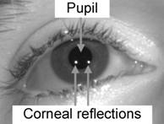

Figure 2.1 Pupil and corneal reflections

Eye tracking and gaze pattern studies have been used to evaluate human behavior for decades. The geometric and motion characteristics of the eyes are unique which makes gaze estimation and tracking important for many applications such as human attention analysis, human emotional state analysis, interactive user interfaces and human factors.

A gaze point is a location towards which the eyes are pointed at a moment in time. Eye trackers typically record a person’s gaze point every 1 to 17 milliseconds. The direction of gaze shows the focus of person’s attention. People look at things by fixating on them, i.e., holding the gaze relatively still for a short while. Between fixations, the gaze jumps rapidly from one point to another. The jumps are called saccades. Saccades are ballistic movements lasting about 30-120 milliseconds. Once a saccadic jump has been initiated it cannot be interrupted nor can its direction be changed. A gaze path consists of fixations and saccades. Information is only acquired during fixations, rapid ballistic eye movement, or saccade, which moves the eyes to a new fixation. (Rosenbaum, 1991)

The process of fixation identification by separating and labeling fixations and saccades in eye-tracking is an essential part of eye-movement data analysis and can have a dramatic impact on higher-level analyses.

The primary requirement of eye movement analysis, in the context of gaze-contingent system design, is the identiﬁcation of ﬁxations, saccades, and smooth pursuits. It is assumed that these movements provide evidence of voluntary, overt visual attention. This assumption does not preclude the plausible involuntary utility of these movements, or conversely, the covert non-use of these eye movements. Fixations naturally correspond to the desire to maintain one’s gaze on an object of interest. Similarly, pursuits are used in the same manner for objects in smooth motion. Saccades are considered manifestations of the desire to voluntarily change the focus of attention. (Duchowski 2007)

Eye-tracking based on image processing requires certain steps of processing of an image captured with a video recording device. The Figure 2.2 below presents the general scheme of the process.

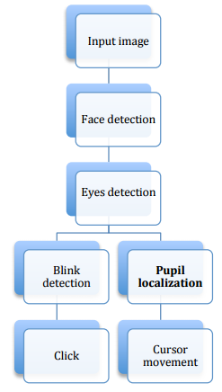

Figure 2.2 Algorithm of an image processing for eye tracking.

#### SMI REDn Scientific Eye tracker

Eye tracking device used for this project (SMI REDn Scientific) is based on the dark pupil and corneal reflection tracking: The cameras in the SMI eye tracker detect face, eyes, pupils, as well as the corneal reflections from the infrared light sources, and calculate eye movements, gaze direction and points of regard. SMI REDn is a lightweight (75g) monitor mounted device with good accuracy (0.4°). The operating range of 40 - 100 cm. It allows the test subject to sit comfortably in front of the screen while watching videos.

### Technology overview

For subjective and complex products such as movies, music, news, user emotion plays surprising critical roles in the decision process. One of the modalities that can observe the brain activities and emotional reactions is electroencephalogram (EEG). EEG signals have characteristics to change each time (non-stationary) and random because of a very dynamic activity in the brain. Although the EEG signals are dynamic, they can be classified based on certain characteristics, one of them through the power spectral analysis of several brain waves frequency range. The use of EEG data to recognize user emotion may contribute to building reliable recommender systems.

Specific emotional states, like mental stress, concentration, relaxation, fatigue, and cognitive increase activation in Delta (0.5-4 Hz), Theta (4-7 Hz), Alpha 1 and 2 (8-12 Hz), Beta 1 and 2 (12-30 Hz), Gamma (30-70 Hz) frequencies. The increase of frontal Beta-1 spectral power is associated with cognitive tasks demands and the decrease of Beta-1 power values reflects relaxation. Alpha is the dominant frequency in the human EEG and is generated in widespread areas of the cortex through corticocortical and thalamo-cortical interactions reflecting emotions. (Valenzi et al. 2014)

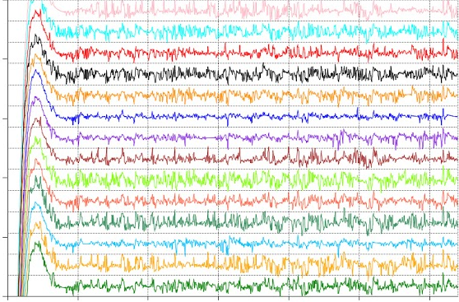

Figure 2.3 EEG visualization

#### EMOTIV Epoc BCI

As mentioned earlier, the EEG signals will be collected using a wireless EEG headset in real time, specifically the Emotiv EPOC wireless headset with a sampling frequency 128Hz. The headset has fourteen data collecting electrodes and two reference electrodes. Electrodes are placed approximately at the 10-20 locations AF3/4, F3/4, FC5/6, F7/8, T7/8, P7/8, and O1/2 as shown in Fig. X to interface with the Emotiv EPOC wireless headset. The system computes the relative power in two non-overlapping frequency bands (10-20Hz, and 20-30Hz) and generates rates from the computed values. Relative power is a simple measure that can readily be computed in real time. The EEG spectrum is known to depend on the mental state (e.g., relaxation, sleep). Alpha waves are typical for an alert, but the relaxed mental state, thus high activity is associated with the meditative state, visualization, and idleness. In contrast, beta activity is related to an active state of mind during intense focused mental activity, and high beta activity is associated with fear and anxiety. (Yazdani, Lee, and Ebrahimi 2009)



# EyeTube Development



## Challenges

### Data-Structures

Table 3.1 shows possible ways to implement the Data. At a later point of the project, a requirement was added to use the databases of the university. They do not support anything but MySQL. For that reason, many other suggestions had to be dropped.

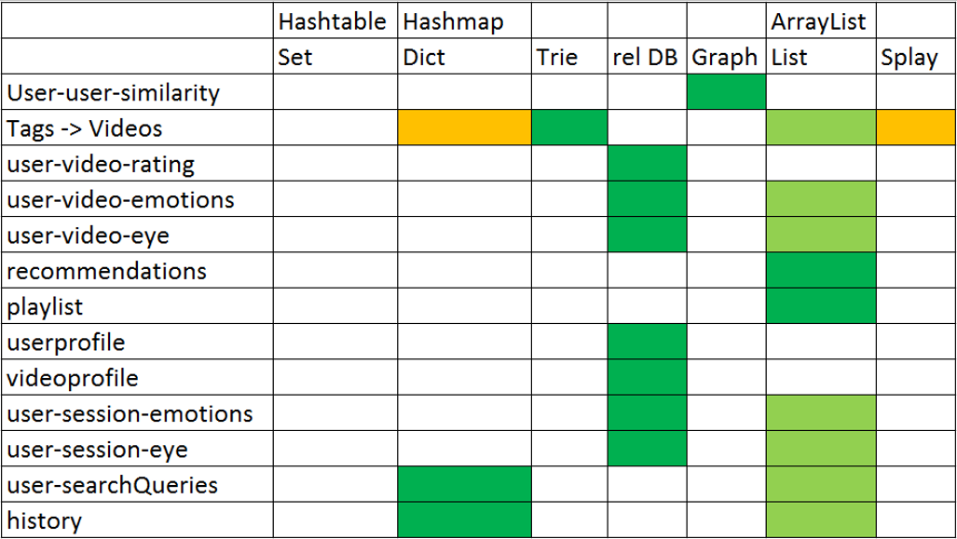

Table 3.1 Chart of suggested data structures.

Yellow: possible, light green: good, dark green: best

#### Database design and implementation

It was decided to model the database as an EER diagram, so there would be easier and clearer understanding of the database structure and its components. And later it could have been used as a base to implement the project database.

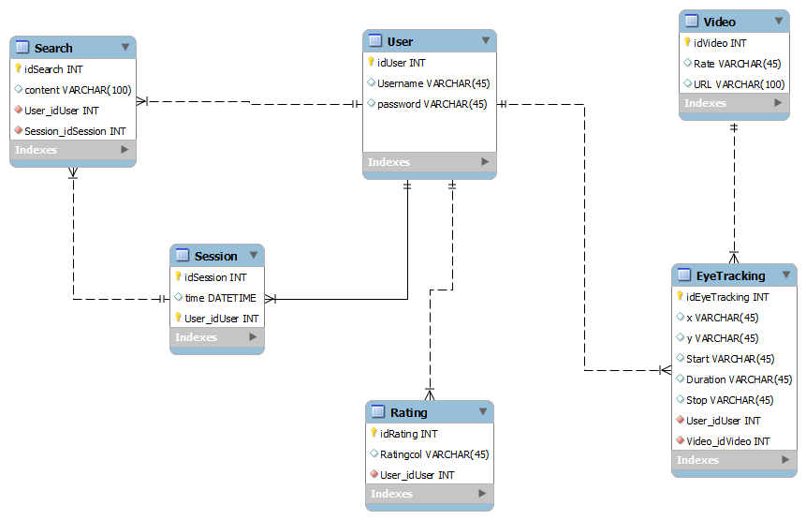

Figure 3.1 Connections between tables, including primary and foreign keys

In the diagram, all the required tables are visible as well as their primary and foreign keys and how they are connected to each other.

The next step was to add some test data into the database and see if there are any inconsistencies in the structure and try to fix any problems that occurred during this process.

The challenging part was to make a connection to the database while using different libraries to make that possible. Also, there was lots of inconsistency between the versions of Python used in different parts of the application.

#### Similarities between users

For the similarities between the individual users, was proposed a Graph data structure, as Graphs can be implemented very easily in Python with libraries such as NetworkX. Graphs are a very useful data-structure when different elements (nodes) need to be connected.

In the end, usage of NetworkX was declined. The similarities are stored in a relational database, which is equivalent to an adjacency matrix. An adjacency matrix is one possible representation of a graph.

#### Tags

To store the tags for the videos, the most efficient and elegant solution would be to use a trie. Tries are one of the most space-efficient and fast data structures, to store strings or dictionaries. The idea is to make a tree out of letters of the words. The maximum height of the tree is equal to the length of the longest word. This leads to short times for search. Words with the same prefix share the same path in the tree for that prefix. This leads to little space requirements.

Another proposal was to use a splay. Splays are quite uncommon binary trees. They are special because whenever a value is added or looked at, it gets 'splayed' to the top of the tree. This means elements, which are frequently used are quick to access. Especially for huge amounts of data like for an online-video player with millions of tags, this would make sense.

The current solution is again the database. The trie-version was implemented, but not added to the project because of the project requirement.

#### Devices

To store the data from the devices, it was proposed to use a database, where the raw data would be uploaded at runtime. This is very close to the actual implementation.

For the eye-tracker, raw data is processed first. Only the fixation points and average values are uploaded. At the same time, for safety reasons and because it is much faster than a database, the data is stored as a file. To create the file, a library called pickle is used. For the BCI only the average emotion rates are uploaded to the database.

#### User-Actions

One proposal was to record each single click from the users and all data, which would be helpful to reconstruct the user-behavior. It might be useful to add this functionality in future, to be able to tell, what was happening at what time. Right now, the recording starts when a video starts playing, is paused when the video is paused and ends when a video ends. For the current experiment, recording each single user-action is not necessary. This is because the evaluation only requires the data from the devices during the playback of the videos. So far, was proposed only a possible structure, of how the databases could be implemented. For this approach, all streams from the devices would be recorded without interruptions and all user-actions would be recorded (see illustration below). This approach would work with offsets inside the databases. After each session, it would be possible to assign the recorded data from the devices to the actions of the users.

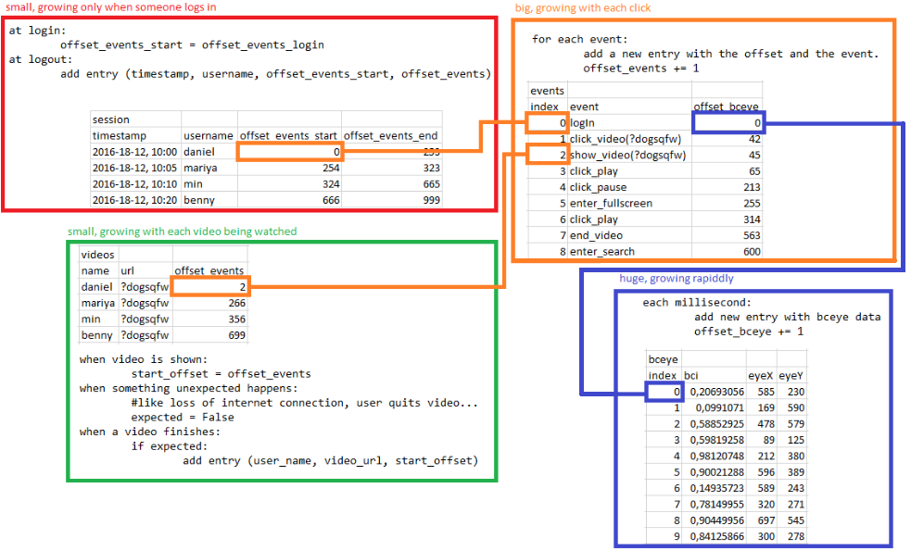

Figure 3.2 Databases to store user-actions

(orange), videos (green), bci and eye tracking data (blue), sessions (red)

### Proposals for usage of data

Below listed options of interaction with the data collected by the EBCIs that were analyzed at the initial stage of the project.

The final direction of the project was influenced by the proposal described in chapter 3.2.2. This proposal is also part of the evaluation of the project.

##### Retrieving information about videos

#### Classifying videos

There were two proposed methods to classify videos based on the data from the devices.

One way idea is to calculate average values for the emotions from different users. The most significant emotions would be used to classify the video.

The other idea was to calculate average emotions for the videos. But the results from those calculations would then be used to calculate similarities between the videos. Those similarities would be very useful to suggest new videos to users after watching a video.

#### Video Recommendation

To identify the best way for the project, one needs first to understand what the possible methods are and currently used recommendation algorithm. Therefore it was decided to find and investigate as many papers as possible about this issue. And summarize them into a table for the better understanding of the subjects.

|  |  |  |  |  |
| --- | --- | --- | --- | --- |
| Title/Author | Abstract - short summary, 1-2 sentences | Citations from google scholar | Relevancy 1-5 | relevancy - why is it (not) relevant? 1-2 sentences |
| (Davies 2016) “Video recommendation algorithm” | Uses co-viewership-Model (User Similarity Concept) for video recommendation. Two factors 1.User Type 2.Video Type | 0 | 4 | It is about video recommendation with complete examples and scenarios. |
| (Granka, Joachims, and Gay 2004) “Eye-tracking analysis of user behavior in WWW search” | Experiment with the use of eye tracking to find solutions to given questions. Evaluating the influence of ranking in the experiment. | 611 | 1 | It is not helpful in regards to video recommendation process. |
| (Davidson et al. 2010) “The YouTube video recommendation system” | It explains how the YouTube recommendation works and how the related videos are calculated. | 393 | 3 | It could be helpful to understand YouTube process so that it can give better ideas for the algorithm |
| (Jing et al. 2008) “Video Suggestion and Discovery for YouTube: Taking Random Walks Through the View Graph” | This goes more into detail about YouTube process. | 375 | 3 | It could be helpful to understand YouTube process so that it can give better ideas for the algorithm |

Table 3.2 Literature review summary

In this research, focus was made on how much the paper is relevant to the project and number of citations of the paper based on the Google scholar.

#### Find important parts of a video

There are peaks in the graphs of the BCI-data. Some of those peaks are random, caused by muscle contractions or other kinds of noise. But if many users have peaked at the same time during a video, it might be interesting to find out why. Is it possible to say which parts of a video are important, just by the Graphs of the Brain Data?

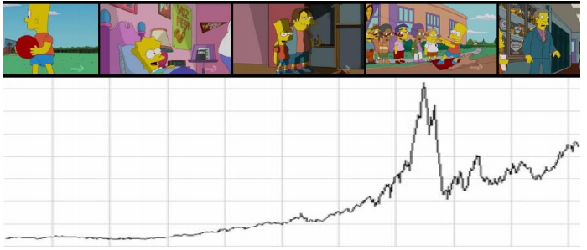

Figure 3.3 Finding important parts of a video based on BCI data

##### Similarities between users

Interesting questions, when you compare the BCI- and gaze-data of two users, could be: “If two users have similar brain-activity and similar gaze-points during a video, are they similar? Do they like the same videos?” The decision was made to focus on those questions. Based on that assumption, was created a search algorithm, which takes into account the similarities between users.

#### Calculating similarities

The idea is to compare the BCI- and Gaze-Data for each pair of users, for each video. This means, that there will be one calculation for each pair of users that watched the same video. All fixation-points and also all entries for the BCI-Data are being compared. The result is a single similarity value for each user-pair for each video. An average of all videos is calculated for each pair of users. This value indicates how similar users are.

#### Search algorithm

As a second step, the similarity will be used inside a search algorithm. Whenever a user searches for a video, there is a list of all results with tags that match the search-request.

For each video in that list, a score is calculated. The score is based on the ratings of other users. But the score is not an average of the other ratings. Instead, the ratings are weighted. The weight is the similarity between user X and the user, who rated the video. The score is divided by the sum of all similarities between user X and everyone who rated the video.

The List of videos is then sorted by the scored, descending. The first video in the sorted list is the video at the top of the user's search results.

#### Implementation for eyeTube

It was decided to implement this approach in the project. Because the project is very small, the search results from custom made algorithm were mixed with search results from YouTube. This not only gives more and better results to the users of the web player. It now is also possible for the database to grow, because new videos from YouTube can be viewed and entered into the database.

The idea of calculating similarities between individual users is also key part the final evaluation.

##### Analyzing the design of the web-page

Another very early suggestion was to use the data from the eye-tracker to give the designers of the web-page a visual feedback. Fixation-points would be displayed on a screenshot of a web-page. The colors of the fixation-points would be influenced by the emotions of the users. The size of the circles would represent the duration of the fixation. This way, the designers would be able to tell, which regions of the web-page are the most important. Also, it would help them to improve the design. This suggestion was not implemented, as the focus of the project went towards analyzing videos.

A similar visualization for videos was implemented. Also, the idea of the gaze-points was implemented to calculate similarities.

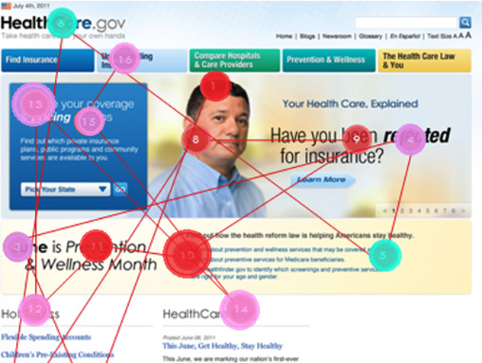

Figure 3.4 Visualization of fixation-points

## Architecture

Figure 3.5 outlines the architecture of the project software. The diagram shows the high-level relationship between the principal structural blocks:

* User interacts with the web application on the browser. Django REST framework was used as the toolkit for building application;
* Django server renders the views that are displayed to the user. Backend code processes requests, handles user actions and returns the responds. Django represents a high-level Python Web framework that follows MVC architectural style: backend code contains classes that play the role of the views, models and controllers;
* The application data is stored on the university MySql database server. Interaction with the database occurs through the Django controllers’ methods. The direct flow of data between UI views and database is omitted as MVC pattern supposes.
* Once Django server is launched, the gaze data from the eye tracking sensor is being recorded. Server start event triggers BCI tool to transmit emotions data. Backend code contains python files, which represent the listeners for the interfaces data.

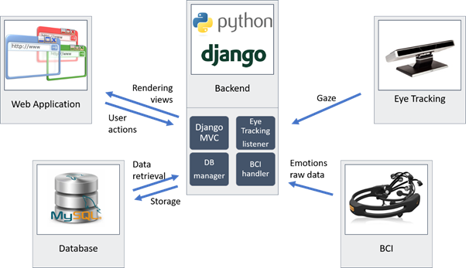

Figure 3.5 Project architecture

The following subsections give the more detailed view on the project code organization.

### Django framework infrastructure

Django framework provides the default hierarchy of the project code structure. After the new Django project is initialized, the standard code files are created and they are organized in such a way, in order to follow framework conventions. The project code is based on the predefined architecture. The required additional Python files were added and integrated to the project to follow the standard Django model.

In general, there are several conventions provided by the framework that should be followed. Compared to the other technology stacks, which also provide the project structure for the MVC pattern (in particular ASP.NET MVC), Django requires the strict adherence to the conventions and thus provides less flexibility to developers for customization of the code architecture.

Once the new Django project is initialized from the command line utility, the following folders and files are created (Figure 3.6):

1. **The folder EyeTracking** contains the files with the general project setup:
   * **settings.py** represent the overall configurations the following information:
     + registered applications within the project;
     + the connection to the database, account credentials used to establish a connection;
     + redirect urls;
     + relative paths within the file structure to the static files with html, css, js code;
     + time zone, language preferences, etc.
   * **url.py** file contains the registered global project urls, such as relative links to the login, logout pages and for each application of the project.
2. **File manage.py** is the main executable file of the Django framework.

Many actions to set up the Django project environment should be performed from the command line, by executing the commands like “django manage.py ...parameters…”, where the parameters define the particular action. Thus, Django server could be started/stopped by referencing manage.py; admin account is also could be created only from the command line; the migration of the database changes are also executed with the reference to manage.py and could not be done from the IDE, like PyCharm.

1. **Folder** **templates** provide html files for the login and logout pages.
2. **Folder** **player** contains the files of the MVC application “player”, which was registered in the project.

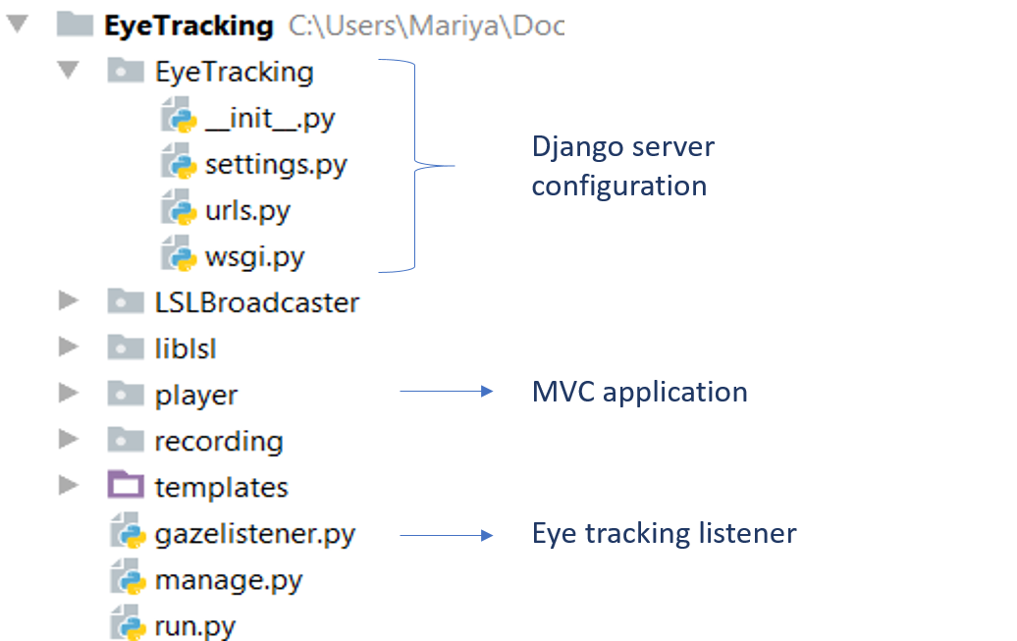

Figure 3.6 Project infrastructure

### MVC application “player”

Django project comes with the idea of the separate applications within the project. So the project itself is just the infrastructure of the common environmental settings, authentication/authorization mechanism, optionally landing page. But then on top of the general setup, each functional unit of Django web application should be registered as a separate application, representing almost standalone MVC app. In the project was used one application, registered within Django server – “player” app.

Below is the overview of the code structure of the “player” application, registered within the Django project (refer to fig. 3.7):

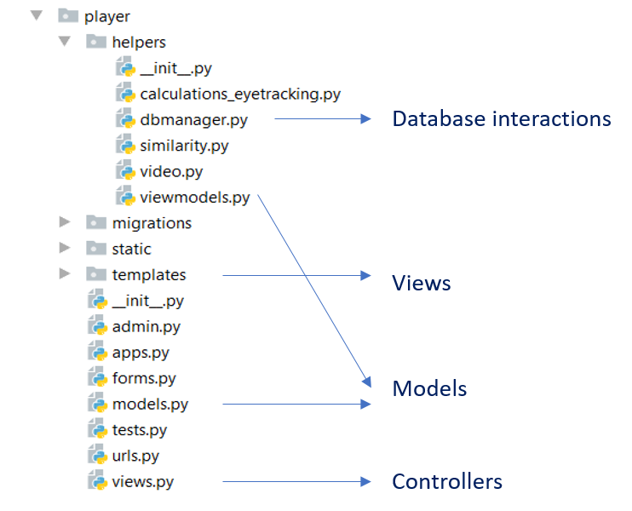

Figure 3.7 Application “player” structure

1. Python files located directly in the folder player are the standard files, required to run Django web site. Below is the explanation of the roles of some files that were customized:
   * **apps.py** contain the code to initialize application configuration. It is also the right location to place the code, that should be executed only once on the application start. Application starts listening to the eye interface here, once the application is launched.
   * **models.py** is the file, that contains the classes for the custom tables, that must be created in the database.
   * **views.py** is the main file with the execution logic. It is responsible for rendering webpages and the connection between user interaction with the web pages and processing on the backend. The file contains classes and methods for each view, that are used to pass data to the views and process user inputs and actions.
   * **urls.py** contain the registered urls, specific for the application “player” (while the inner file urls.py (described above), provided the initialization of the global web site urls, applicable for all applications of the project). For each view class and method from the views.py file, it is necessary to register url here in order to execute method or render the view.
2. **Folder templates and static** contains the html and css,js files correspondingly. Figure 3.8. below shows the inner content of the mentioned folders:

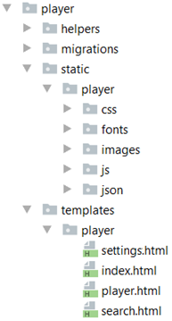

Figure 3.8 Front-end structure

Html files represent the mixture of the common html schema with the python code, integrated inside. Python code helped to process the data passed from the backend. The navigation to the pages and passing the parameters to backend methods (like the search keywords or rating values) are also done due to the Python code integrated to the views. Another example is the repeating sections with the different video categories on the Main page. This is actually one template section of the common html schema and python loop, that repeats the section 4 times, passing 4 different lists of videos to each section.

1. **Folder helpers** contain the main python files with the logic. This folder was not initialized by the Django framework, it was created manually in order to place their custom python files and separate them from the standard Django python files. It contains the following files:
   * **dbmanager.py** file provided the methods to work with the database, store and retrieve data
   * **video.py** contain the key algorithms, such as updating user similarity, searching keywords in project database and YouTube and operations of the eye-tracking device. The search-algorithm described in Chapter 3.1.2.2, is implemented in video.py as well
   * **similarity.py** returns videos from project database, which match a search string. Similarity.py uses machine learning algorithms from Sklearn and also language processing functions from NLTK for videos retrieval from the database.
   * In **viewmodels.py** file more objects are created for implementing the ratings of the videos.

### Database access

Project database is located on the university server **mysqlhost.uni-koblenz.de**.

Figure 3.9 displays the tables of the database ‘django’, that store application data. All tables could be divided on 2 types:

* The standard Django tables that store user accounts, permissions, settings. This tables are created automatically within the first connection of the Django server to the database.
* Application models, created as the classes on the backend python files. The corresponding tables in the database are added after applying migration with changes.

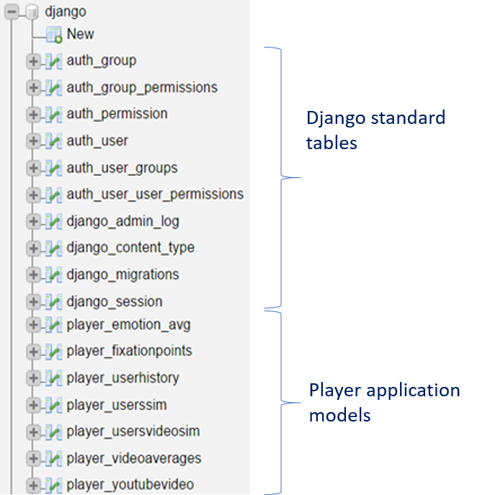

Figure 3.9 Database structure

The project uses the Code First approach on working with the database. It means that any modifications are not made directly on the database level, but with the python models classes, that represents the tables. The changes to the fields or the creation/deletion of the new models (tables) are reflected to the database within the process, known as the migrations. If the changes of the model classes are made, it is necessary to execute first the migration commands on the manage.py file before launching Django server. The tables, created in the file **models.py** are treated as the application specific tables, so after applying the migration to the databases with the new table classes, they will be created using the following name convention: projectName\_classname (case insensitive).

As it was mentioned above, methods to interact with database are located in the file dbmanager.py. The queries for databases include not only getters and setters, but also other basic statistical and accumulation calculations, such as averages and total amounts. Below the 4 notable functions are described, that contains the examples of such calculations:

#### missing\_similarity\_calculations

"missing\_similarity\_calculations" returns a list of all userpairs for all videos, where the similarity can be calculated from the existing data, but the similarity is missing in the current database. To generate this list, first, the database UsersVideoSim is used to get a set (S) of all existing similarities. After, the database FixationPoints and all files are used to generate a set (T) with all existing video-user-pairs, for which fixations exist, is generated. Finally, the difference between (S) and (T) is the set of calculations, which are missing.

#### update\_similarity

Another function "update\_similarity" calculates the arithmetic mean of similarities over all videos for one user-pair. These similarities are stored in the database UsersSim.

#### store\_fixations

"store\_fixations" is used to store a whole list of fixation points for one user for one video. The list is stored both in the database FixationPoints and as a file. The filename consists of the user-id and the video-id. The files are created, so if there are any problems with the database during or after the experiments, the data is not lost. Also, saving and loading data from files is much faster than using a database. Also, the total amount of fixation-duration is calculated from the single values and stored in a database.

#### load\_fixations

"load\_fixations" returns a list of all fixation-points for one user for one video. First, tries to load the requested fixation points from the file. If there are any problems with that, the fixations are loaded from the database.

## UI Design and Functionality

### General design ideas

When designing a page for usage with an eye tracker there are several things have to be considered: First - eye gaze as input is a challenging phenomenon due to the limitation of eye trackers like the visual angle, calibration errors, drift, and inherent eye jitter. Hence the devices do not exactly correspond to where the user is looking, and therefore user is not able to select small targets very precisely[[11]](#footnote-11) . To address this problem it was needed to make all buttons very big, but by doing that they take a lot of space and there is no much room left for other things. To fit everything in the web page and still look good, number of buttons was reduced to a minimum and only the most important functions were included.

Furthermore, there is no universal method for issuing mouse clicks with an eye tracker. Staring at a clickable target long enough will trigger the click event. To give the user immediate feedback on how long he needs to look at the target, a progress bar is displayed as described in the section hover effect.

The additional goal was to give the website a clear, easy structure and make all the pages uniform. The structure was based onYouTube because most users will know this website and then can use the page very easily. Beside, it was decided to give the web page a darker look because it is more pleasant for the eyes.

### final_1024.pngLogo

The design of the logo is based on the outline of an eye. It shows the striking features of the human eye. The focus of the logo is placed on the iris. The play icon is in the color red (RGB (228, 45, 39)) and above this icon, a heart rate is displayed. The curve and the outline of the iris are shown in gray (RGB(133,133,133)), which gives a clear contrast to the background and the rest of the logo. Both, the shape of the eye and the play icon, appear in the same colors as the YouTube scheme. It is used to evoke associations of YouTube.

Figure 3.10 Logo

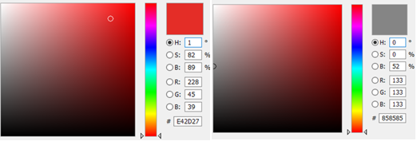

Figure 3.11 Color schemes

### Web Pages

The web pages are built with darker colors, going from pitch black to light grey. The aim was to create a comfortable-to-look, even if you use it for a longer period of time. The background and header/footer are in a dark grey. Buttons and intractable items are in light grey, so they pop out and are easier to see. The font color is white to create a clear contrast to the dark background.

### Navigation Bars

#### Top Navigation Bar (displayed on every webpage)



Figure 3.12 Top Navigation Bar

The top navigation bar is displayed on every web page and serves as an anchor point for the user. It has the same functionality on all the pages with an exception for the player page which contains additional buttons. These functions are described in the following table.

From left to right the top navigation bar consists of the following elements:

|  |  |
| --- | --- |
| Element | Functionality |
| Logo | Go back to the main page |
| Button “Left Arrow” | Go one step back in browser history |
| Search bar | Search for some videos |
| Button “Smiley” | Rate a video with the five star rating (only visible in player page) |
| Button “User” | Open the drop-down menu and manage the account:   * Settings: Change either to mouse or eye tracking control; hide or show mouse cursor; Change the video quality * Information of the web application * Help: only placeholder * Logout |

Table 3.3 Top navigation bar content

#### Bottom Navigation Bar (displayed on the player page)



Figure 3.13 Bottom Navigation Bar

The bottom navigation bar is displayed on the player page and lets the user control the video.

Options like play/pause and switch to the full screen mode where easy to design for eye tracking, as they are basically the same as in conventional video players. But changing volume and fast forwarding/rewinding were difficult to implement.

For changing the volume it was decided to make two buttons, one for increasing and one for decreasing the volume. In order to not include too many buttons in the bottom navigation bar, it was decided to only display one loudspeaker button at first and then let appear the other buttons. A mute button was also added later. Fast forwarding/rewinding a video with the progress bar, like in conventional video players, is very convenient and has the biggest scope, but is too difficult for eye tracking only, because of the accuracy issue. Precisely selecting a small segment of the progress bar is very hard with an eye tracker.

According to the final decision if one of the buttons is clicked (respectively gazed at) the video will fast forward or rewind, depending on what button is clicked, for 10 seconds fix. In this way, it is simple and accurate to use, however, there would be some problems in very long videos. If a video is maybe one hour long and the user wants to watch it from the 30 minute mark, then the implementation is not very efficient. The idea here was to change the 10 seconds fix to a certain percentage of the whole video duration. This would enable a user to fast forward a video but it is not that accurate than the other method. These options were considered but were not implemented.

From left to right the bottom navigation bar consists of the following element

|  |  |
| --- | --- |
| Element | Functionality |
| Button “Play” | Start the video |
| Button “Volume” | Change the volume; Mute/Unmute |
| Button “Rewind” | Rewind the video 10 seconds |
| Button “Fast forward” | Fast forward the video 10 seconds |
| Button “Full screen” | Activate full screen mode |

Table 3.4 Bottom navigation bar content

When a user selects the play button the video starts and a progress bar appears. This progress bar shows the current time and the whole duration of the video. It visualizes how much time is still missing. Furthermore, the play buttons change to a pause button. After selecting this button once the video stops and the pause button changes to a play button again.



Figure 3.14 Play bar

When a user wants to change the volume he can select the button for the volume. After that three different buttons appear: a first button to increase the volume, a second button to mute the volume and a third button to decrease the volume. In addition to that, a small rectangle is visible, which shows the current volume in the range from 0% to 100%.



Figure 3.15 Sound bar

### Login Page

##### Design

Figure 3.16 Login page

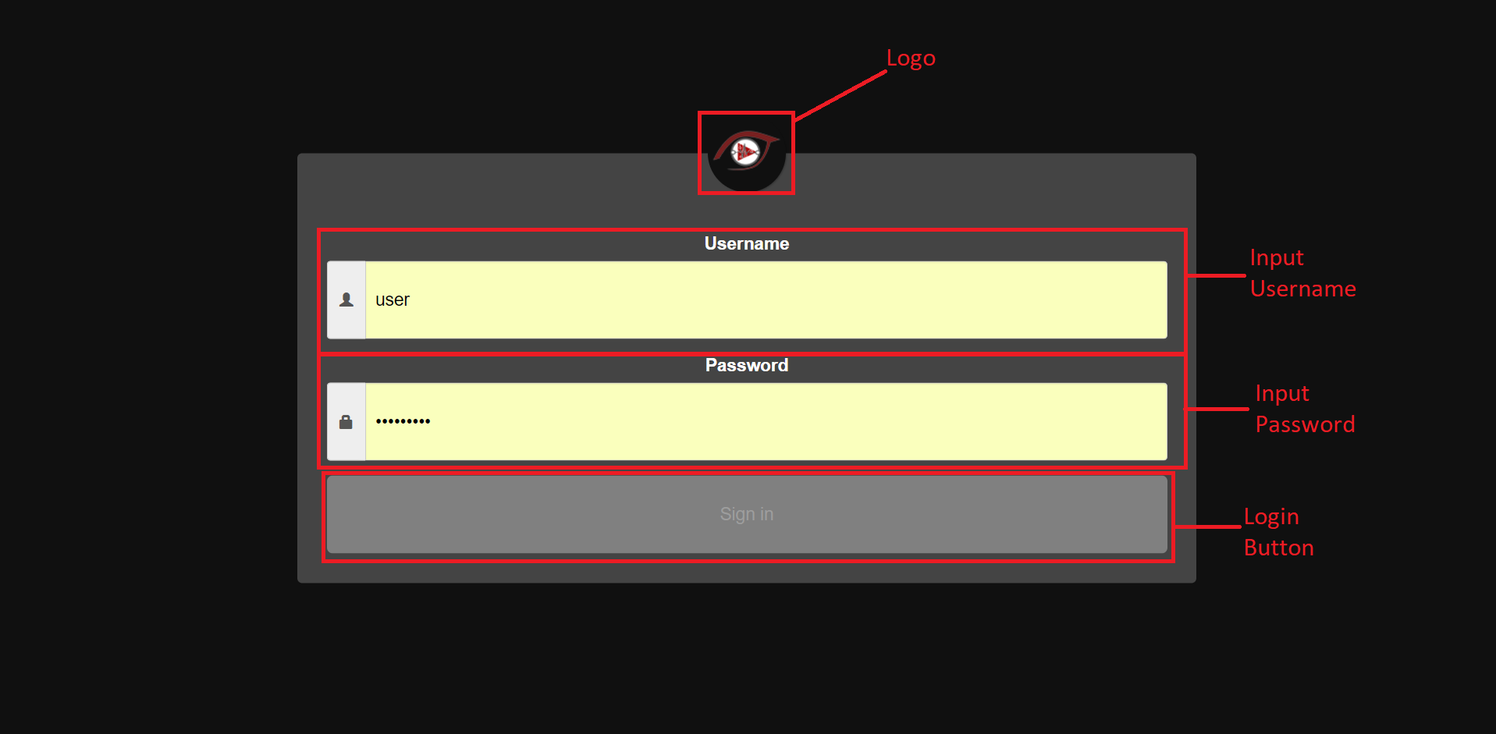The login page enables the user to log into his personal account. The account stores data about favorite videos of the user and enables the website to calculate what videos the user might want to see.

##### Functionality

User accounts to login into the application are created from the admin interface of the Django service. Admin section is available via the relative path ~/admin/

In order to access admin interface, it is necessary to login with Admin credentials.

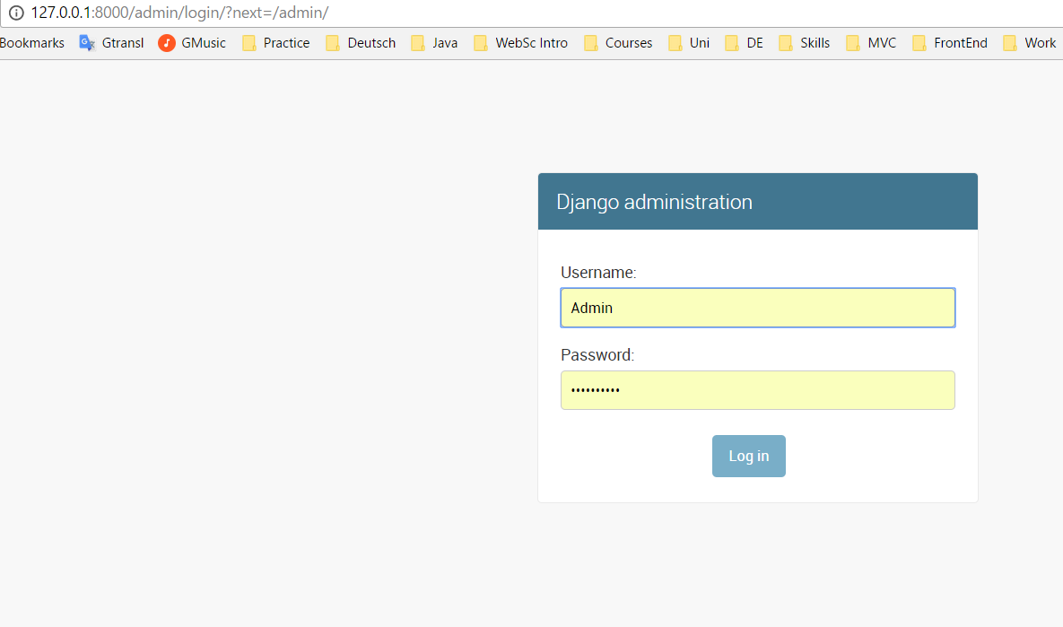

Figure 3.17 Admin login

Admin user account could be created with Power Shell scripting executing the required commands on manage.py file of the Django solution.

Admin site provides the possibility for the admin user to create users and groups (roles or permissions – Groups were not used in the project, all users have equal permissions).

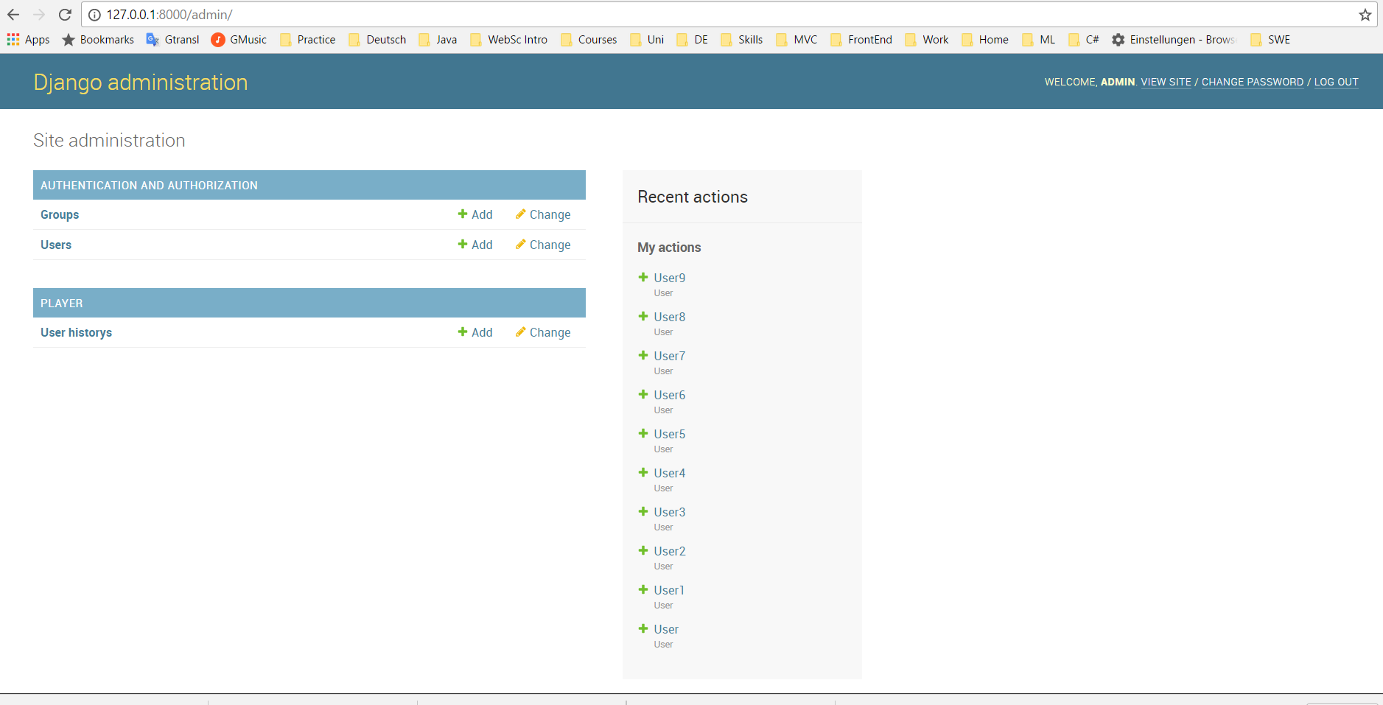

Figure 3.18 Admin page

User information is stored in the database on the table auth\_user, that is one of the system tables, populated automatically by the Django framework. The table keeps the encrypted user passwords, information concerning the last login date and user profiles.

UserId are integers, generated automatically on the moment of the new user creation. In the project UserIds fields are used as foreign keys to reference the corresponding users in such tables as player\_userhistory, player\_usersim, player\_usersvideosim.

Django server is configured to redirect site visitors to the login page if the request is not authenticated. It means that whatever link the visitor wants to navigate, the login page will be displayed first if the current user is not log in yet. This setup is written on the class PlayerIndexView of the file ~/player/views.py.

In the case of the successful login, when the entered username and password passed the validation towards database values, the user will be automatically redirected to the index page of the web application ~/player/.

### Main Page

##### Design

The main page is the first page the user sees after he logged in. The interface of the main page is divided into two parts: The header (top navigation bar) and body. The main page shows some video suggestions related to the user's interests and based on recommended videos on YouTube. It is categorized into five different groups (top rated, last watched, recommended and test videos ...) and the videos are displayed as thumbnails. Each thumbnail corresponds to the initial image of a video. A hover effect enables the start of a video by looking on the thumbnail of a video in GTW browser. In a standard browser, it is possible to select a video by clicking on the respective image. To let the user scroll trough the videos with eye tracking there are arrows at the right and left of the video carousel.

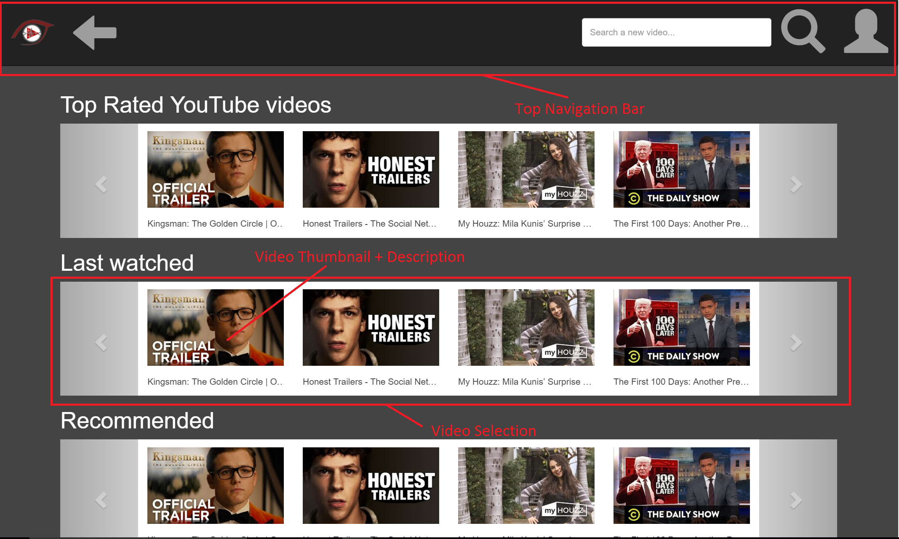

Figure 3.19 Main page

##### Functionality

Class PlayerIndexView of the file player/views.py provides a method that passes the list of the videos to the main page.

2 lists of videos are populated and returned to the view:

top-rated YouTube videos

last-watched videos of the current authenticated user.

Top-rated videos are retrieved directly from the YouTube API. 10 top-rated videos were retrieved; however, the number could be adjusted, as it is one of the parameters of the web request to YouTube web API:

https://www.googleapis.com/youtube/v3/videos?chart=mostPopular&part=snippet&type=video&maxResults=10&key=... 10 last watched videos are populated in 2 steps:

from the database, table player\_userhistory define the records of the last 10 videoIds, that the current user watched

for each videoId from the previous step define video information for the view from the YouTube API:

https://www.googleapis.com/youtube/v3/videos?part=snippet,contentDetails&id=" + str(videoid) + "&key=...

### Search Page

##### Design

The interface of the search page is divided into two parts: The header (top navigation bar) and body. It enables the user to search for videos via the search text field. When entering a set of keywords into the search field, they are sent to the YouTube database, which returns a list of corresponding search results. This list consists of eight videos, which are sorted descending by views and popularity. This means the videos with the most views is played on top. Each list entry consists of a thumbnail, the title, description, views, average rating, duration and channel of a video. By looking on the play button or the thumbnail the player page opens.

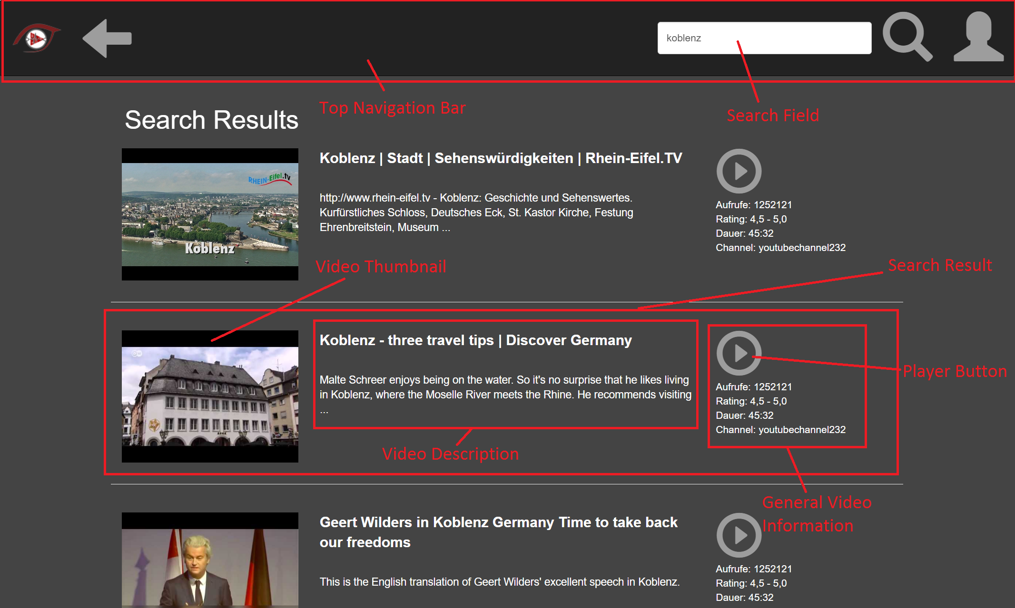

Figure 3.20 Search page

##### Functionality

The class SearchView (player/views.py) provides methods that retrieve a result set of videos that correspond to the search keywords entered by the user.

The search result set of videos constitutes of the mixture of 2 videos sets:

1. 25 videos retrieved from the YouTube API by calling API function, that returns similar videos to the input keyword, that is one of the parameters of the function: **https://www.googleapis.com/youtube/v3/search?part=snippet&&maxResults=25&type=video&q="** + input + **"&key=...**
2. YouTube results are mixed with the videos that are found from the database based on the user similarities. The idea of the approach is to define similarity of the current users with the stored in the database users and add to the search results videos that similar users already watched and rated them high. Besides these videos should also corresponds to the search keyword.

The steps of mixing videos from YouTube and project database are:

1. Relevant users who have similarity scores with the current user in the user-similarity table UsersSim are retrieved ascendingly.
2. Video histories of relevant users are retrieved from history-user table UserHistory, as well as the maximum ratings each user gave to the videos.
3. Rated-similarity scores are ratings of watched videos multiplied with users’ similarity scores.
4. From the watched video history table History\_videos, had been used similarity methods to get the relevant videos by the search keywords. It returns top 10 relevant watched videos. The similarity methods will be described later in this part.
5. Calculate the total rated-similarity scores of each top 10 videos by summing up rated-similarity scores of the video all users watched.
6. Return these videos by descending order as the search-history result.
7. The YouTube search result is valued from 5 to 1. If there are search-history result in the YouTube search videos, those videos are weighted more.
8. The descending ordered result of last step is presented as the final result of the method.

Similarity algorithm in search session is cosine TF-IDF similarity. nltk (Natural Language Toolkit) was used to process the text, sklearn to transform language to statistical form for further analysis. The steps are described following:

1. Handle the text of both video tags and search input: lowercase and delete all punctuation and stopwords such as “the”,”a” and “are”.
2. Tokenize and stem the text to separate sentences into words and remove morphological affixes from words.
3. Vectorize and transform the words into the matrix using TF-IDF algorithmus TfidfVectorizer and fit\_transform.
4. Calculate the cosine similarity between tags of videos and search input.
5. Return the 10 videos from highest to lowest scores.

### Player Page

##### Design

The player page is the core of the web application. Every time when a user selects a video this page appears and the video can be played. The interface of the player page is divided into three parts: The header (top navigation bar), body and footer (bottom navigation bar). Below the header, a video and a playlist beside it can be seen. If a user chooses another video with mouse or gaze, the web page refreshes and the video is displayed on the right side. Under the main video, you can find some additional information to it (e. g. rating and the current emotional state of the viewer). The footer serves a user to control the video. Therefore it consists of various buttons, which have been described in Bottom Navigation Bar. If a user will activate the fullscreen mode the video size will maximize and the footer is still visible. So the user still has the control over the video. In addition to the bottom navigation bar, a small gray rectangle with an arrow inside appears on the right side over the footer. By looking at this rectangle the bottom navigation bar will be closed so the user can fully enjoy the video.

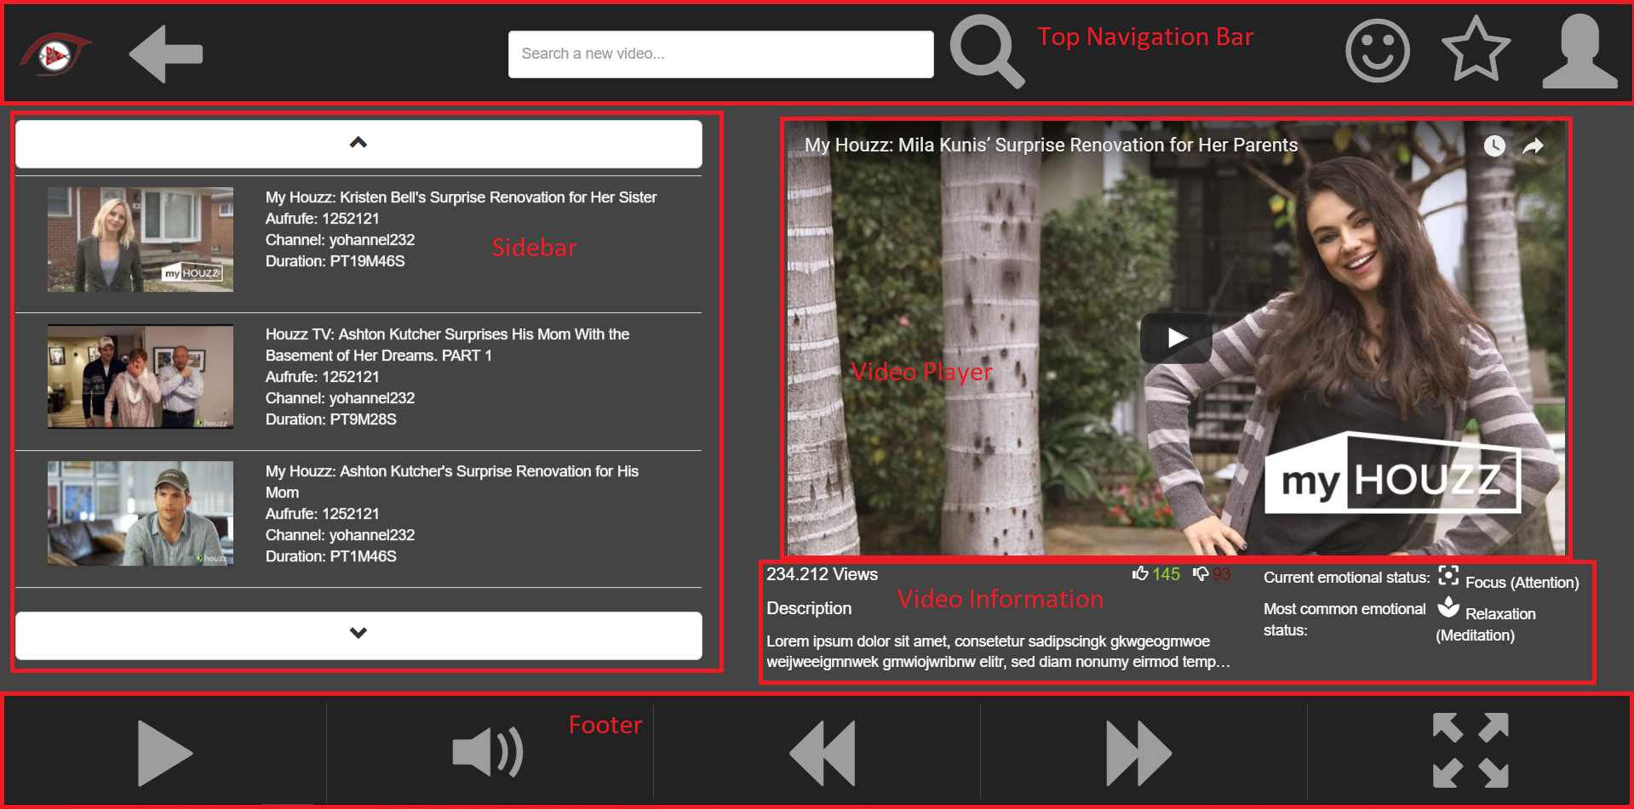

Figure 3.21 Player Page

##### Functionality

Whenever a Video starts playing, the recording of the gaze-data automatically starts. The gaze-data is pre-processed. The result of the pre-processing is a list of fixation-points. After each video, the fixation-points are uploaded to a database and also stored as a pickle-dump in a file. The primary keys for the database are the user-ID and the video-ID. If there are entries for this user-ID and video-ID in the database already, the fixations are not uploaded to the database. User-ID and video-ID are also used as the filename for the pickle-dumps. The pickle-dumps are being created as a backup, in case there are problems with the database.

### Special Functions

##### Browser

The web application can be used in a standard browser (e. g. Chrome Web Browser) or in GTW browser. In the standard browser, the user can use the mouse for clicking on elements and the mouse wheel for scrolling up and down. In GTW browser the scrolling function is already given. That means that a user can scroll up and down only with his eyes and the scrolling with the mouse wheel is not necessary for GTW browser. Furthermore, the mouse click is replaced by another technique - the hover effect. This effect is described in Hover-Effect section.

##### Hover-Effect

As far as there is no actual click possibility with the eye tracking devices, there was a task to simulate the click function with hover effect. Therefore, was used the approach of Greek partner who has developed an interactive Web page, which is directly controllable with gaze[[12]](#footnote-12). Standard mouse over events approach was utilized for triggering dwell time-based elements on the Web page. Therefore, was implemented a class function which allows to simulate the click process on any element when a user looks at an element for a specific amount of time. This time is defined as a constant variable with the value of 1.5 seconds in JavaScript which can be easily changed to any other desired value. When the mouse is hovering over a triggerable button, the dwell time is started and a visualization queues the remaining time to the user.

In order to indicate this functionality to the user so that users know what elements are clickable through only staring at them, visualized effect was added to the mentioned elements. These effects could be in different forms. For instance, a transparent overlay effect will appear whenever a user stare at the buttons on the toolbars in the player page or a progress bar will appear under the image thumbnails in case of selecting items in the index or the search page.

Using mouse over let one control the page in standard Web browsers with mouse and in GTW browser with gaze, as long as "mouse follows gaze" is activated.

##### Star Rating

The used star rating enables each user the opportunity to rate each video once. The collected information will be stored in a database. With this information, it is possible to calculate an average of popularity. A user can either give minimum one star to symbolize a poor video or maximum five stars to symbolize an excellent video. The following image shows a bootstrap modal which opens when a user selects the star in the top navigation bar. This popup shows the five-star-rating, the calculated average of the previous rates and an overview of how many people give one, two, three, four or five stars.

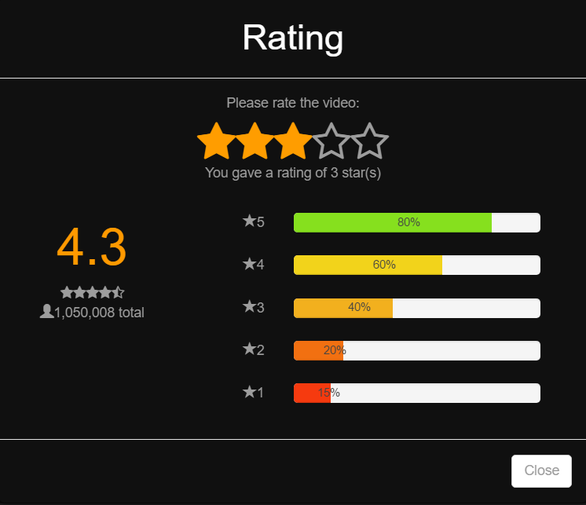

Figure 3.22 Rating menu

##### Functionality

In order to make the rating functionality work “on the fly”, Ajax technology was used.

So once the user clicks on any star, the Ajax call triggers the backend method from the views.py file and passes to it the rating value, and videoId that was rated. For this purpose, the corresponding backend method was first registered as the URL in the URLS.py file, and as a result, it could be launched from the external Ajax calls. After parameters rating value and videoId were received from the user interaction with the popup frame, they are stored in the database.

The rating popup contains also the statistical overview of the rating values for this particular video. So after storing the new rating value in the database, all statistical values are recalculated and returned to the frontend as JSON data. So the frontend js function could parse the returned and update the popup window with the new statistics just after the user clicked on the star.

Backend methods that implement processing of the rating data and calculating statistics are located on the file player/helpers/viewmodels.py. The method rating() from the views.py is registered as the separate url to trigger.

##### Full Screen Mode

The full screen mode was especially challenging to implement. What should happen to the bottom navigation bar when enabling full screen mode? In conventional video players like YouTube, the control bar will disappear after a few seconds of not moving the mouse and will reappear if you move the mouse. However, with an eye tracker every eye movement is treated like a mouse movement and the control bar would probably be displayed all the time. Hiding the bottom navigation bar is also not an option, because how can the user now control the video? The solution is to add a small arrow at the bottom end of the screen. When enabling full screen mode, the bottom navigation bar is displayed. When clicking the arrow it will hide and reappear when clicked again. In this way, the user can control the video and enjoy watching it without being distracted with the large bar (except the small arrow button).



# User Interaction and similarity measures



## Eye Tracking and fixations of gaze points

### Calculation of User Similarity based on Eye Tracking data

In this research project, an approach is presented on how similarities of users can be determined by gaze data. A method has been developed to convert captured gaze data into fixations. Afterwards, these fixations of the individual users are compared with each other, in order to make statements about their similarity.

So far, heat maps are mostly used for research in the literature, to sum up the viewpoints of individuals and to figure out which objects were particularly watched in pictures or web pages. A common use case is the Usability of web pages and to track user’s attentions.[[13]](#footnote-13) [[14]](#footnote-14) [[15]](#footnote-15) [[16]](#footnote-16) [[17]](#footnote-17) [[18]](#footnote-18)

The approach deals with the similarity of users based eye tracking data while watching video trailer. A method consisting of 6 steps is applied and will be described individually hereinafter. The complete graphic can be found in Figure 4.14.

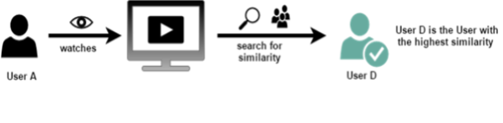

Figure 4.1 Overview of the general approach: Calculate user similarity based on eye tracking data

Figure 4.1 shows the general idea of this method. The idea is to figure out whether persons who have similarities in gaze data also show similarities in film preferences. If there is a connection, this information can be useful, for example, to get a better individual recommendation list for videos.

#### Step 1: Collect Gaze data of User

For the analysis, the gaze points from the participant were recorded during the video playback to detect the raw data of gaze points. While a Video is played, the Gaze-Stream of the user will be recorded. As soon as the user has finished the full Video the Gaze stream will be locally stored for post processing. The Gaze stream contains every gaze position with each timestamp.

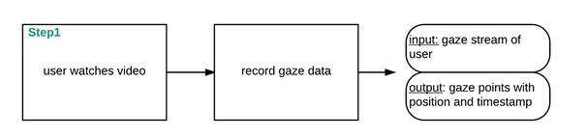

Figure 4.2 Step 1 collecting the gaze data for different Videos

#### Step 2: Calculate Fixations

To get more significant information about the gaze data fixations were calculated. ‘**Fixations** are eye movements that stabilize the retina over a stationary object of interest.’

The goal of eye movement signal analysis is to **characterize the signal** in terms of salient eye movements, i.e., **saccades and fixations** (and possibly smooth pursuits). Figure 4.3 shows an occurring fixation and displays the meaning of a saccade.

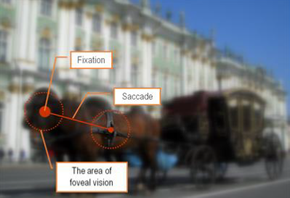

Figure 4.3 Pictures shows difference between fixation and saccade[[19]](#footnote-19)

Typically, the analysis task is to **locate regions** where the signal average changes abruptly indicating the end of a fixation and the onset of a saccade and then again assumes a stationary characteristic indicating the beginning of a new fixation. [[20]](#footnote-20)

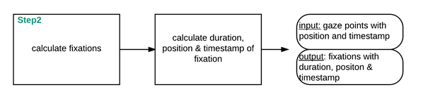

Figure 4.4 Step 2 Transformation of raw data to fixation

To identify fixation is a common method to reduce the complexity of the eye tracking data. While retaining only the most significant characteristics for the purpose of understanding. [[21]](#footnote-21)

A simplified approach was implemented, which is shown in pseudocode in Figure 4.5. The *max\_dist* is the maximum allowed Euclidean distance between two gaze points. In a fixation it was set to 50px. *min\_dur* is the minimum duration a set of gaze points needs to count as fixation, it was set to 200ms. 200ms duration for fixations was suggested by several papers whereas the maximum distance of 50 pixels was determined by internal project experiments. [[22]](#footnote-22) [[23]](#footnote-23) [[24]](#footnote-24)

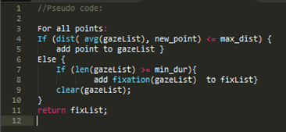

Figure 4.5 Pseudo Code for transformation of raw data to fixation

With this information, were defined several Areas of Interests (AoI) .[[25]](#footnote-25)

In used approach, the Input data will be deleted and only the output data is stored. This reduces the needed storage for the data base.

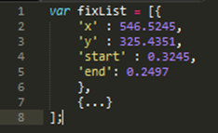

Figure 4.6 Representation of the fixations in a list of json objects

Fixations are stored in a List with several JSON objects, comparable to Figure 4.6), including the following information:

* x- and y-position of fixation
* start and end time in milliseconds
* Thus the duration of the fixation can be calculated with (end time - start time).

#### Step 3: Calculate common fixations

Based on the stored fixation data of the users common fixations can be calculated. Location and time will be considered.

The fixation lists of two users act as input to calculate common fixations. A **common fixation** occurs when two users simultaneously look at a similar position in the video. A similar position is given if the centers of the fixation are not more than *50px* apart. Comparable Figure 4.7, which depicts the definition.

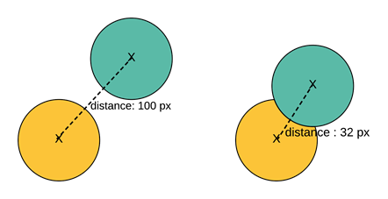

Figure 4.7 Common fixation

Common fixation is detected, if the distance between the two fixation center points (X) is less than *50px*. On the left side two fixations appear at the same timestamp, but the distance is more than the threshold of *50px.* Instead on the right side a real common fixation is shown.

It is possible and common that only a part of a fixation of user A overlaps with the corresponding fixation of user B. The grey bars indicate the time period of the fixation, the first letter indicates the user (***U1*** and ***U2***), and the second letter indicates whether it is a start- *(****s****)* or end end-point *(****e****)*. The blue color visualizes the overlapping fixation time.

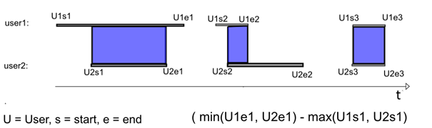

Figure 4.8 Common Fixation of two users (U1, U2) over time (t).

Only time is considered.

The formula:



calculates whether there is a temporal overlap of the fixation, afterwards the locality of the fixation is considered. If the distance between the two fixation center points is less than *50px,* this indicated a common fixation.

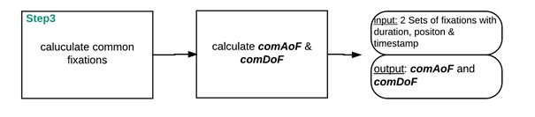

Figure 4.9 Step 3 Calculation of common Fixations for one Video

If all fixations are calculated, the amount is stored in the ***comAoF***(**com**mon **A**mount **o**f **F**ixations) variable. The duration of all overlaps is saved in the variable ***comDoF***(**com**mon **D**uration **o**f **F**ixations). Both variables are needed for the further calculation of the similarity of two users by the fixation and will be stored for every user pair that watched the same video. An overview of this step is given by Figure 4.9.

#### Step 4: Calculate arithmetic mean of accruing fixations for each Video

To differentiate well-made trailers from others, the similarities are compared by the average number and duration of the fixations for each video individually. Each video is viewed individually in this step. All existing data from *N*-different users are needed to calculate the average fixation number ***avAoF (av***erage**A**mount**o**f**F**ixation) and fixation time ***avDoF* *(av***erage**D**uration**o**f**F**ixation). Figure 4.10 visualizes this method.

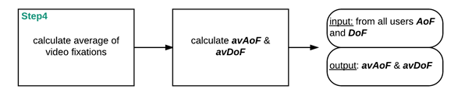

Figure 4.10 Step 4 Calculation of arithmetic mean of Amount and Duration of Fixations

The arithmetic mean of the amount and duration of the fixations is calculated by iterating over all data and adding the resulting fixations to ***totalAoF*** and the associated duration to ***totalDoF***. Afterwards, each value is divided by a number of users, who have watched this video. The results are further processed in step 5. They determine how the similarity of the users in the individual videos is weighted. To understand step 4 more precisely, Figure 4.10 should be considered.

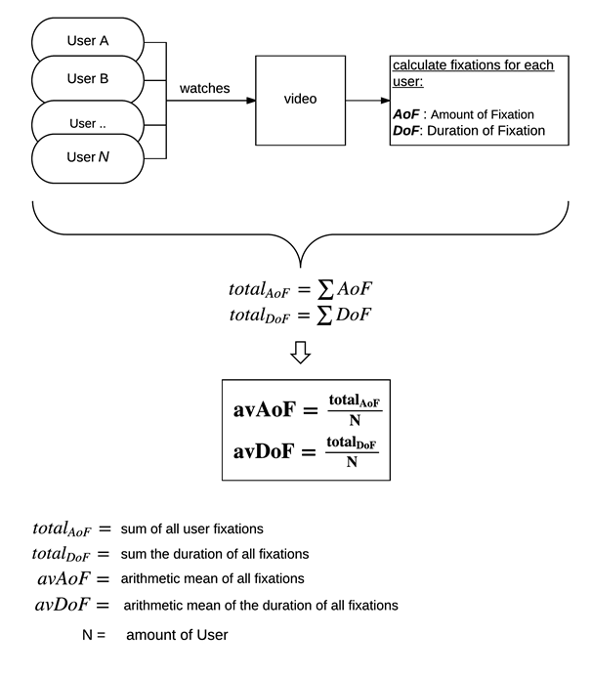

Figure 4.11 Step 4 Calculate the average of fixation per person and the duration time of fixations

#### Step 5: Calculation of a Video similarity

To calculate the similarity of two users was applied a scale to the common fixations for each video the both of them watched.

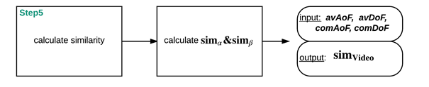

Figure 4.12 Step 5 Calculation of Video similarity for two users

The scale maps the common fixations to the values 0, 0.25, 0.5, 0.75 and 1, whereas 0 is the least and 1 the highest possible similarity.

This is applied to the common fixation count and the common fixation duration separately, by calculating the average of the two resulting value. It is based on the average fixation duration (**avFoD**) and amount (**avAoF**) respectively for the video in question and goes as follows:

|  |  |  |  |  |  |
| --- | --- | --- | --- | --- | --- |
| | | 0% | 1 - 24 % | 25 - 49 % | 50 - 74 % | 75 - 100 % |
| $$sim_{Video}$$ | **0** | **0.25** | **0.5** | **0.75** | **1** |

Table 4.1 Division of the weight of similarity

$sim_{α }$ = Describes the similarity value for the number of fixations that occur. This value

is calculated with the average amount of fixations (*avAoF*) of the Video.

100% correspond to the average fixation of individual users (*avAoF*)

50% are accordingly = ( $\frac{avAoF}{2}$) , 25% = ( $\frac{avAoF}{4}$) ..

$sim_{β }$ = Describes the similarity value for the duration of fixations that occur

This value is calculated with the average duration of fixation (*avDoF*) of the video. 100% corresponds to the average duration of fixations of individual users (*avDoF* ) 50% are accordingly

= ( $\frac{avDoF}{2}$) , 25% = ( $\frac{avDoF}{4}$) ..

The values were chosen because each video can have a different number of fixations and duration. Therefore, each video is viewed individually, in order to make a vague statement about the similarity of two users. If there are common fixations with two users as often as the average value for a person, then an enormous similarity is to be inferred.

By adding $sim_{α }$ and $sim_{β }$ and dividing these value through 2 the user similarity regarding the individual video ($sim_{Video}$) can be calculated.

$$sim_{Video}= \frac{sim_{α }+ sim_{β}}{2}$$

This method is applied to all shared videos and stores a value for each video that contains the similarity to that video.

#### Step 6: Calculate the overall similarity

Subsequently, the total similarity of the users can be determined by means of gaze data. To this end, all existing video similarity values are added and divided by the number of viewed videos. Figure 4.13 visualize this process. The value is between 0 and 1 and indicates the similarity, whereas 0 is the least and 1 the highest possible similarity.

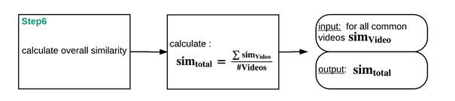

Figure 4.13 Step 6 Calculation of the overall similarity for two users

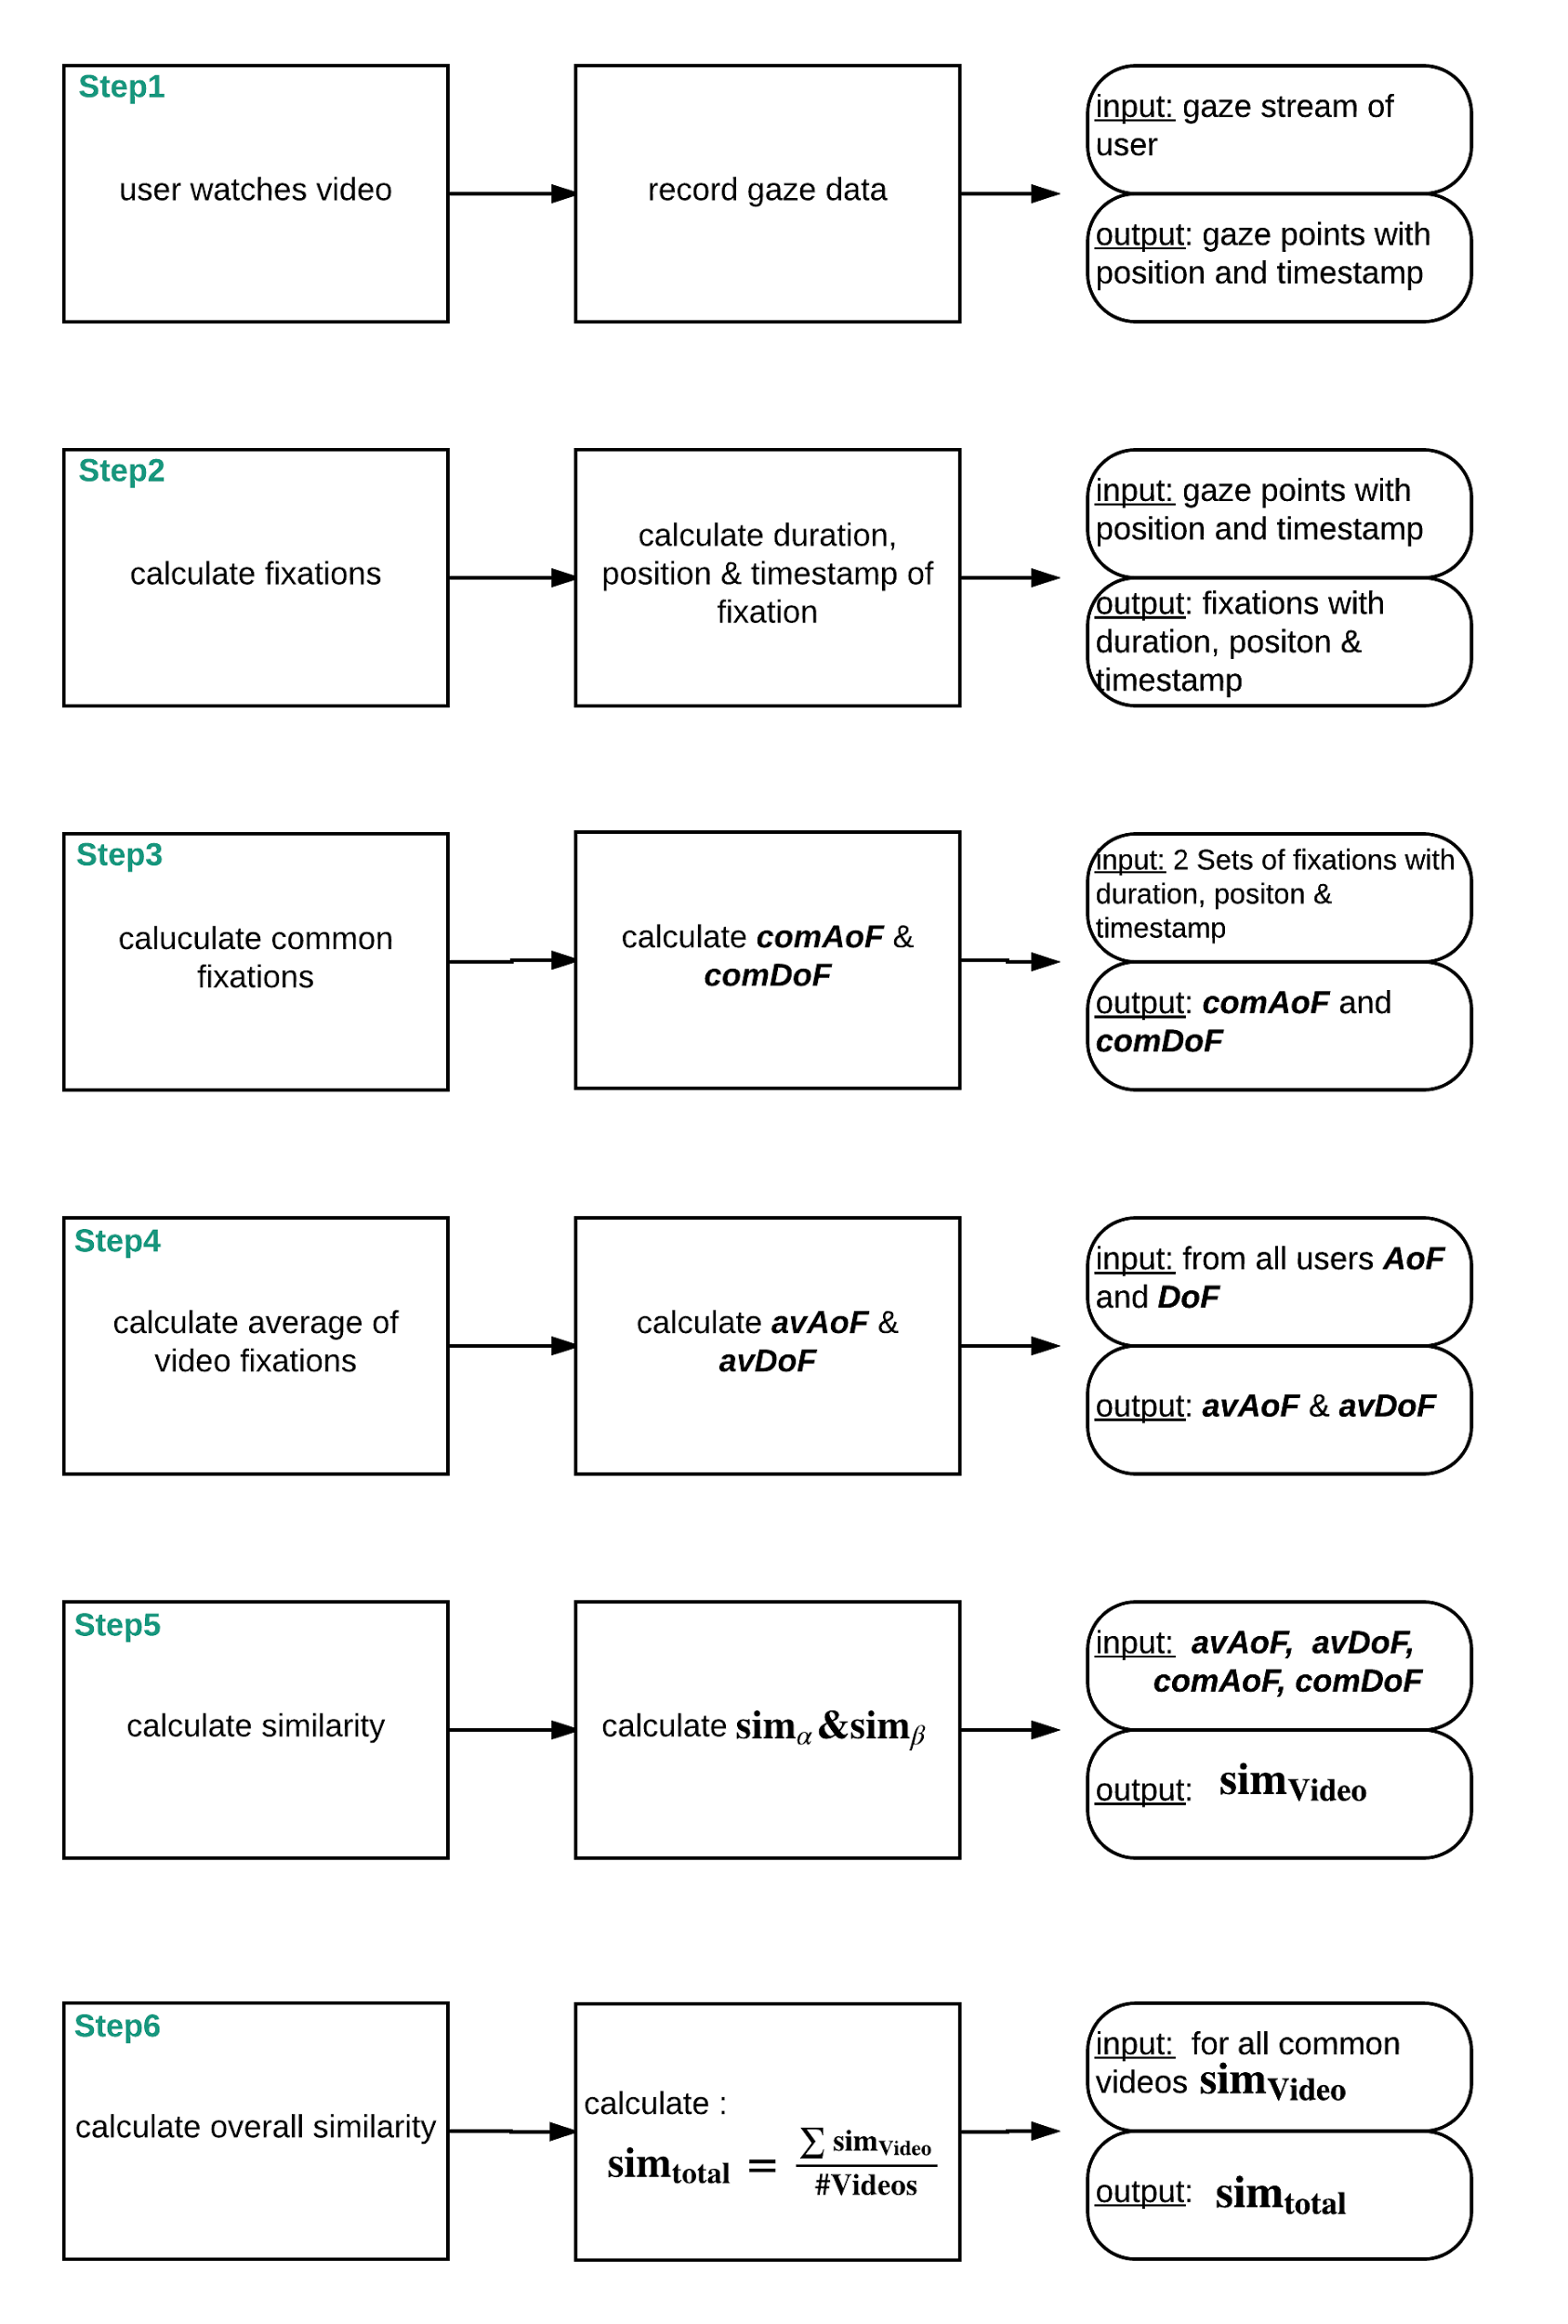

Figure 4.14 Summary of all 6 individual steps for calculation of user similarity based on gaze data

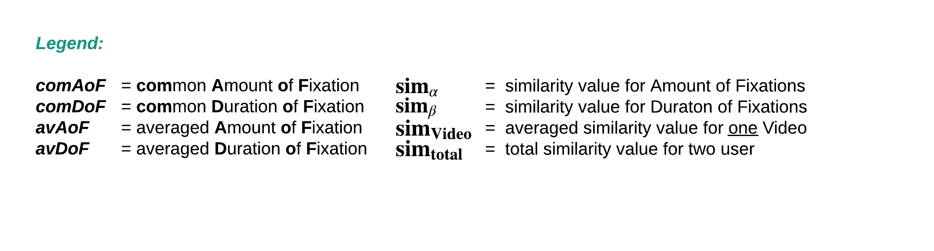

### Visualization of Fixation Points

The visualization of the individual fixation points of the user is another feature in ‘**EyeTube**’. It allows the visual comparison of the fixation points. The user can display the data of the last 5 persons with their different fixation points for each video, which has already stored data. An individual color is assigned to each person. For example User A is represented by the color blue, user B by the color red. Every time user A has a Fixation a blue circle will appear in the appropriate region of the video, the same applies to user B with a red circle.

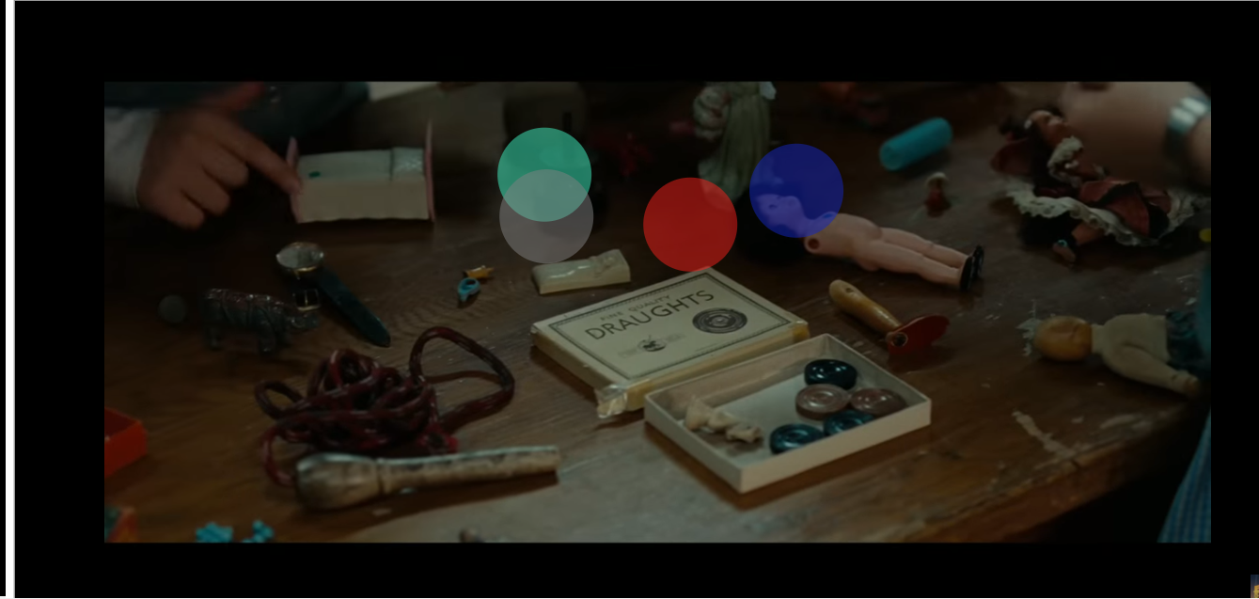

Figure 4.15 Visualization tool 1

Background = 'Trailer: Never let me go' [[26]](#footnote-26)

If the ‘Development Mode’ activated, it is possible to start the visualization tool. By activating this option you can see the visualized fixations of the last 5 Users. Used for analysis purpose and to clarify what is meant by an ***overlapping fixation*** of two users, the feature is realized with HTML and JavaScript.

The Visualization is realized by different layers for the JavaScript canvas.

In the background-layer, the original video is displayed. For each user, a new layer with a canvas is added. The fixations are visualized as points around the central point of the fixation with a 50px radius. Users are represented by a unique color.

For each user, a fixation-list exists, comparable to Figure 4.15. Every fixation is represented in a Json-Object inside this list. A fixation has a position (x- and y-coordinate) and a start- and end-time in milliseconds. With these timestamps, the duration of the fixation can be calculated (end time - start time). The JavaScript intern Interval-Method is used to automatically call the drawing method for each fixation. This method draws the colored circle as soon as a fixation appears in the correct canvas and calls the *clear()-*method to erase the circle as soon, as the duration of the fixation is over.

The visualization tool underlines the meaning of the overlapping fixation of users. Comparable to Figure 4.15. It displays a screenshot of a full screen visualization of the video ‘Never let me go’ with the fixations of 5 users. The screenshot displays four different colors because only these persons had a fixation at this time. The grey and the light blue circles have a common fixation at this timestamp. Recognizable by the overlapping colored circles.

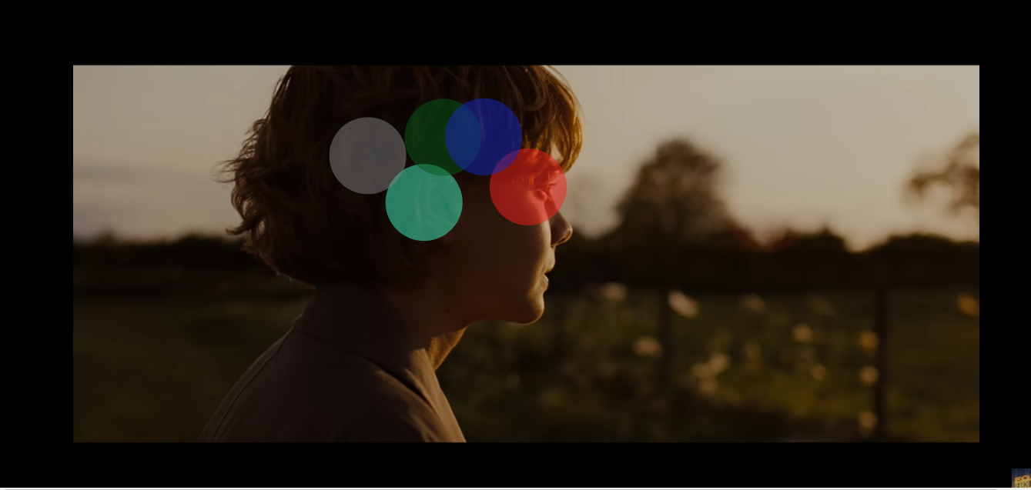

Figure 4.16 Visualization tool 2

In Figure 4.16 all five User have a fixation at this time of the video. Each User has a common fixation to another. But the red user only has a common fixation with the blue one. The blue user has a common fixation with the red and the green user.

## BCI and emotion detection

### Emotion recognition

There are different emotion classifications proposed by researchers. In this research was used the model developed by Emotiv. Manufacturer provides five basic measures of mental performance, derived directly from the mental activity. Each measure is automatically scaled to suit the normal range and base level of each condition – the system learns the usual state and capabilities and provides an adjusted value showing the relative performance on each occasion, compared to the overall behavior.

The measures include:

Engagement: the level of immersion in the moment. A mixture of attention and concentration.

Focus: a measure of the fixed attention to one specific task. Focus measures the depth of attention as well as the frequency that the attention switches between tasks. A high level of task switching is an indication of poor focus and distraction. The focus is closely related to the Flow state.

Interest: the degree of attraction or aversion to the current activity. Low interest scores indicate a strong aversion to the task, high interest indicates a strong affinity with the task while mid-range scores indicate user neither likes nor dislikes the activity. Interest is related to the enjoyment of the current task.

Relaxation: a measure of the ability to switch off and allow to rest and recover from intense concentration.

Stress: a measure of the level of comfort with the current challenge. High stress can result from an inability to complete a difficult task, feeling overwhelmed and fearing negative consequences for failing to satisfy the task requirements. Generally a low to moderate level of Stress can improve productivity, whereas a higher level tends to be destructive and can have long term consequences for the health and wellbeing.

### EmoEngine and Emotiv SDK

The Emotiv API is exposed as an ANSI C interface that is declared in 3 header files (edk.h, EmoStateDLL.h, edkErrorCode.h) and implemented in 2 Windows DLLs (edk.dll and edk\_utils.dll). C or C++ applications that use the Emotiv API simply include edk.h and link with edk.dll.

There are three main categories of EmoEngine events that the application may handle:

Hardware-related events: Events that communicate when users connect or disconnect Emotiv input devices to the computer (e.g. EE\_UserAdded).

New EmoState events: Events that communicate changes in the user’s facial, cognitive and emotional state. User can retrieve the updated EmoState by calling EE\_EmoEngineEventGetEmoState(). (e.g. EE\_EmoStateUpdated).

Suite-specific events: Events related to training and configuring the Mental Commands and Performance Metrics detection suites (e.g. EE\_CognitivEvent).

Solution used in the research is based on provided by the EMOTIV emostate\_logger.py code and data resolved from the Performance metrics interfaces.

### Accuracy issues

According to the Emotiv statements, internal measures have accuracy between 65% and 100% depending on the emotion and the subject.

The output for each emotion is a floating point number between zero and one. Ideally they should be scaled based on historical patterns of each individual user, but in this case, during each experiment would take a few hours for the system to settle down for a given subject. Self-scaling provides a useful within-subject scale but makes it very difficult to compare subjects.

Performance Metrics detections are the most heavily filtered and the most likely to be shut down temporarily by excess noise. There is no connection between facial expression information into the emotional detections implemented in this case. Lots of frowns would be associated with higher frustration levels.

### Calculation of User Similarity based on emotions

#### Step 1: Detecting and logging emotions

For further user similarity measurement, 6 emotional states are recorded during each session of video watching. While a video is played, the stream of the EEG data will be recorded. After the video is finished the stream will be locally stored for post processing. The final record contains the average of each emotion state. Storing and analyzing raw EEG data proved to be inefficient in measuring user-similarity as well as hardware-consuming,

#### Step 2: Calculation of a Video similarity

Based on the stored emotion averages the similarity will be calculated. For calculations would be used Pearson correlation optimized for 6 dimensional items-sets (6 emotions.)

*a; b* - users

*r a,p* - emotion of user *a* for item *p*

*p* : a set of items, rated both by *a* and *b*

Possible similarity values between 0 and 1

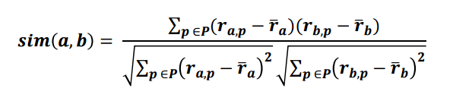

This approach is usually used in collaborative filtering. Apart from that it was chosen for the following reasons:

* distribution of correlation between random vectors becomes narrowly focused around zero as the dimensionality is increased;
* the significance of small correlations increases with growing dimensionality;
* the approach is effective for capturing the similarity of patterns of feature changes.



# Experimental Analyses



## Introduction

A recommendation system based on similarity measurements has become one of the most used approaches to providing personalized services for users. The key to this approach is to find similar users or items using a user-item rating matrix so that the system can show recommendations for users. However, most approaches related to this approach are based on similarity algorithms, such as cosine, Pearson correlation coefficient, and mean squared difference. These methods still need improvement, especially in the conditions when new users or new items are added. The video player for YouTube, developed in this research, has the functionality to collect additional data which can be used for new user similarity models. These models may improve the recommendation performance compared to the case where only the ratings are available to calculate the similarities for each user. The proposed model considers the captured fixation points and emotions based on EEG. The results of this evaluation aim to explore how the new similarity model would intersect with the rating-based model.

### Goal of the experiment

The experiment has three major goals:

* to understand and assess the effectiveness of the developed system;
* test the accuracy of the used emotion recognition algorithm;
* compare three similarity measurements based on rating feedback, fixations, and emotions.

Similarity measures based on user ratings will be used as control data since for now, this is the major method of similarity measurement used by online video-sharing/streaming services. The Evaluation methods that will be used are questionnaires, observations and individual experiments.

### Relevant points

Currently, the most advanced methods of similarity measurements compare users by the videos they had or had not watched. This technology helps to make more efficient predictions but requires more users and bigger sets of watched videos. Considering the resource and time limitations, in this project, the research group decided to not implement this feature for new models. For this reason, to make the comparison fair, rating collected directly from YouTube cannot be used during the evaluation. Instead, users will rate all watched videos using an alternative rating scale created as a part of the project and based on ratings given only by test subjects.

## Formulation of the Hypothesis

#### Main Hypothesis

Similarity measurements based on the fixation points and emotions provide relevant similarity ratings with accuracy close to similarity measurements based on personal rating. User rating based similarity is used as control data.

Then the main statement is to investigate whether there is a link between the similarities of eye tracking, BCI and personal perception. Pictures are usually analyzed by means of eye tracking. The number of fixation points indicates the degree of interest. In this experiment, it was examined whether this statement applies to video trailers as well. Another question is whether test subjects with a lot of fixations actually more interested in a particular video or not.

## Experimental Set-Up

The experiment took place from 19.05.2017 to 26.05.2017 in the research laboratory of the working group WEST at the University of Koblenz-Landau, Campus Koblenz. General parameters of the experiment can be found in Table 5.1. A total number of 20 test subjects took part in the experiment. Test subjects were invited one after the other. Consequently, it was not a group task. The duration of the experiment was approximately 30 minutes. At the beginning of the experiment, the participant was asked to sign an “Informed Consent Form”, which was prepared before the experiment. A study coordinator (participant of the research lab/project lab) was in the same room all the time. During the whole test, a study coordinator was about one meter away from the subject and explained the experiment and the tasks to be performed. In addition, they were always available to answer questions. The test subject was asked to sit in front of a second monitor. The eye tracker was attached to the screen and the BCI was placed on the head of the test subject. The curtains on the windows were closed to insure the light balance. The test subject was sitting on a static chair to guarantee the constant distance between the person’s eyes and the screen to be 50-75 cm. The test subject was asked to avoid talking as well as to limit their movements and gesticulation while watching the videos. All manipulations with the video player including switching between videos were done by the study coordinator.

#### Overview

The goal of the test studies is to record gaze- and EEG- data of users while they are watching videos. Further (not during the test) the recorded data will be used for the evaluation of the user similarity and accuracy of recorded emotions caused by videos. During this evaluation, all test subjects will also have to answer a set of questions using prepared Google Forms. The questionnaire data will be used to analyze and compare the recorded data.

|  |  |
| --- | --- |
| Estimated time | ca. 20-30 minutes |
| Participants | supervisor and test subject |
| Supervisor | research lab participant, responsible for preparation of the test environment, assisting and leading the test subject and recording of the results. |
| Test subject | volunteer, participating in the experiment. |

Table 5.1 Experiment Parameters

#### Computer

The computer used for the experiment is a laptop with a second monitor connected to it. The second monitor displays the player interface whereas the laptop monitor displays additional information allowing the supervisor to control all software, devices’ connection states and the record processes, not disturbing the test subject.

#### Software

Software includes:

* Python 3 environment
* the server of the player
* programs connected to the devices iViewRED and Emotiv ControlPanel
* LSL connections

#### Server

Console output of recording. It must be monitored during the whole experiment to ensure the correct recording.

#### iViewRED

iViewRED – software used to connect the eye-tracker to the computer and do the calibration.

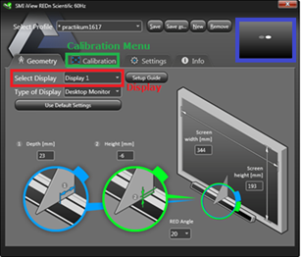

Figure 5.1 iViewRED

The distance and visibility of the user’s eyes can be controlled. The iViewRED-m application provides an Eye Tracking monitor to give a visual cue to the user to locate the optimal position relative to the monitor. According to the RED-m Eye Tracking System Manual, the optimal position is a distance of 50 to 75 cm from the screen and approximately centered facing the screen. Movement of the test subject should be limited during the watch.

#### Calibration

Calibration must be done before starting the experiment and before showing each new video. During the calibration the test subject must look at the red dot, moving to five different parts of the screen. Calibration should be re-done if:

1. one eye was not detected in any of the five cases or
2. the distance between two eye-traces or the eyes-traces and the red dot is to big in all five cases.

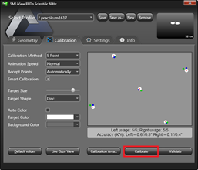

Figure 5.2 Example of good calibration

#### EmotivXavierControlpanel

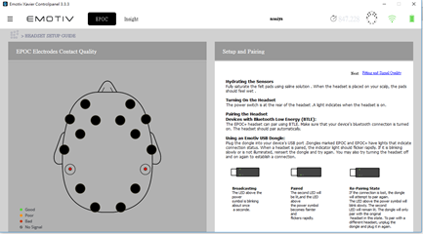

Figure 5.3 EmotivXavierControlpanel

EmotivXavierControlpanel – software used to connect the BCI to the computer and to check the input signal quality. Considering that experiment was conducted using damaged connectors, up to 5 of them might not work or have worse signal quality.

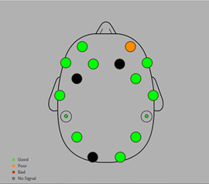

Figure 5.4 Acceptable input

#### Videos and Questionnaires

In the Bookmarks Bar of the Chrome browser, two folders were created containing links to six videos opened in the player and the questionnaires. Links to videos are enumerated according to the Table 5.4. This enumeration should be used when defining the order of showing videos according to the Latin Square. Movies of three different genres, horror (5 & 6) , emotion (3 & 4) and comedy (1 & 2) were selected.

#### Recording control and check

In order to start the recording of gaze- and EEG- data only one page (one window, one tab) should be open at the same time.

The video must be started only by pressing the custom made buttons of the player. Usage of built-in YouTube buttons will neither start nor stop the recording.

The video must be played from beginning to the end to ensure the record starting and stopping correctly.

In order to insure that the recording has been successful the supervisor has to check the database before starting the next video.

### Setup steps

1. Turn on the computer.
2. Switch to extended screens.
3. Close the curtains on the windows.
4. Attach and connect the eye-tracker.
5. Launch the software (setup.bat or list).
6. Turn on the BCI and charge it if the battery is low.
7. Assemble BCI by fastening the connectors.
8. Clean the connectors.
9. Hydrate the connectors.
10. Define Test Subject’s number and the order of videos.
11. Open the first video.
12. Open the questionnaires and enter the Test Subject’s number.
13. Open the database.

## Procedure

#### Pretest

Before running the experiment with the test subjects the setup was pretested by project participants. During the first iteration of the pretest, detailed experiment steps and limitations caused by the specific recording procedure were defined. Also, several data storing errors were discovered.

During the second iteration of pretest participants insured that the data storing error was fixed and the overall environment functioned correctly.

#### Experiment steps

|  |  |
| --- | --- |
| 1 | Put the BCI on a test subject. Explain the rules (movement/talking while watching) |
| 2 | Do calibration for the test subject. |
| 3 | Test Subject answers questionnaire 1. |
| 4 | Start 1st video. |
| 5 | Stop 1st video. |
| 6 | Test subject answers questionnaire 2 for 1st video. |
| 7 | Check the state of the record. |
| 8 | Do calibration for the test subject. |
| 9 | Start 2nd video. |
| 10 | Stop 2nd video. |
| 11 | Test subject answers questionnaire 2 for 2nd video. |
| 12 | Check the state of the record. |
| 13 | Do calibration for the test subject. |
| 14 | Start 3rd video. |
| 15 | Stop 3rd video. |
| 16 | Test subject answers questionnaire 2 for 3rd video. |
| 17 | Check the state of the record. |
| 18 | Do calibration for the test subject. |
| 19 | Start 4th video. |
| 20 | Stop 4th video. |
| 21 | Test subject answers questionnaire 2 for 4th video. |
| 22 | Check the state of the record. |
| 23 | Do calibration for the test subject. |
| 24 | Start 5th video. |
| 25 | Stop 5th video. |
| 26 | Test subject answers questionnaire 2 for 5th video. |
| 27 | Check the state of the record. |
| 28 | Do calibration for the test subject. |
| 29 | Start 6th video. |
| 30 | Stop 6th video. |
| 31 | Test subject answers questionnaire 2 for 6th video. |
| 32 | Check the state of the record. |
| Post-experiment steps | |
| 1 | Clean and hydrate the connectors. |
| 2 | Close all software; turn off devices and the computer. |
| 3 | Hide devices in the cupboard, shut the cupboard and the lab. |

Table 5.2 Experiment steps

### Latin Square Design

The Latin Square is an experimental design which is used to control the variation in an experiment. The order in which treatments are given can actually affect the behavior of the subjects or elicit a false response, due to fatigue or outside factors changing the behavior of the subjects. To counteract this, it was decided to use a counterbalanced design, which reduces the chances of the order of treatment or other factors adversely influencing the results. This design was also used to control the variation in the experiment.

In experimental design, a Latin Square is an n x n array filled with n different symbols. For the Latin Square design, there are two factors, which are divided into a tabular grid with the property that each row and each column receive each treatment exactly once. This design allows experiments with a relatively small number of runs. So it was possible to use it in project scenario because the sample consisted of 20 subjects. One disadvantage was that the 6 x 6 Latin Square was only practicable for six people. That's why the Latin Square was used three times completely and started again with a new Latin Square at the last run.

Since each participant had seen six trailers, for the experiment was used a 6 x 6 Latin Square as shown in Table 5.4:

|  |  |  |
| --- | --- | --- |
| Number in the Latin Square | Movie title | Link |
| 1 | Going in Style | https://www.youtube.com/watch?v=hcdTN5soeQw |
| 2 | Suicide Squad | https://www.youtube.com/watch?v=CmRih\_VtVAs |
| 3 | Love is all you need? | https://www.youtube.com/watch?v=qMOONBCqzG8 |
| 4 | Wolves | https://www.youtube.com/watch?v=CQ1wztlDACc |
| 5 | Lights out | https://www.youtube.com/watch?v=6LiKKFZyhRU |
| 6 | Ouija | https://www.youtube.com/watch?v=\_T1Jj1inE8M |

Table 5.3 Latin Square movie numbers

|  |  |  |  |  |  |  |
| --- | --- | --- | --- | --- | --- | --- |
|  | Video 1 | Video 2 | Video 3 | Video 4 | Video 5 | Video 6 |
| Subject 1 | 1 | 2 | 6 | 3 | 5 | 4 |
| Subject 2 | 2 | 3 | 1 | 4 | 6 | 5 |
| Subject 3 | 3 | 4 | 2 | 5 | 1 | 6 |
| Subject 4 | 4 | 5 | 3 | 6 | 2 | 1 |
| Subject 5 | 5 | 6 | 4 | 1 | 3 | 2 |
| Subject 6 | 6 | 1 | 5 | 2 | 4 | 3 |

Table 5.4 Latin Square

In this example, subject 1 received the treatment levels in order 1 (Going in Style), 2 (Suicide squad), 3 (Love is all you need?), 4 (Wolves), 5 (Lights out) and 6 (Ouija) and subject 2 received the treatment levels in order 2 (Suicide squad), 3 (Love is all you need?), 1 (Going in Style), 4 (Wolves), 6 (Ouija) and 5 (Lights out).

### Questionnaires

During the experiment two different questionnaires were used - a demographic[[27]](#footnote-27) and a post-task questionnaire[[28]](#footnote-28). Both will be described more precisely in the next subsections. For the creation of these forms, was used “Google Forms”[[29]](#footnote-29) tool, enabling the group to access the files and results simultaneously at one collaboration point. Both questionnaires contain, among other things, a text field for the user id. This was necessary in order to be able to assign the individual questionnaires to the recorded data and for the data evaluation.

##### Demographic Questionnaire

In general, a demographic questionnaire contains questions about the sample. In this way, a meaningful data aggregate on the demographic characteristics of all participants could be created. In detail, the gender, age, the level of education and profession of the 20 respondents were asked. In addition to that, test subjects were asked whether they have eye problems or if they wear glasses or contact lenses.

Normally the first questions should respond to the topic and have a clear thematic reference. Consequently, you put the demographic data to the end of the survey to raise interest and not to bother the participant. Though, it was decided to start with this questionnaire for the simple reason that the acquired data was necessary to properly calibrate the eye tracker.

##### Post-Task Questionnaire

It was decided to show each subject six different videos. The main task for the subjects was the rating of each video with subsequent assessment of their emotions. For both tasks, was used a Likert-scale, which will be described in the next subsection. Furthermore, test subjects were asked if they have already watched the trailers or corresponding movies prior to the experiment. This information was used take potential biases into consideration. Eventually, test subject were asked if they would like to watch the whole movie after watching the trailer. This was done to get another indication of popularity which was later used to define the correlation between rating and emotions.

### Likert-Scale

For this experiment was used a 5-stage Likert-scale in order to ask subjects about their emotions (interest, stress, engagement, focus, relaxation) and rating after watching each video. 7-stage-Likert-scale wasn’t used as it was planned originally because during the pretest phase the test subjects had difficulties in differentiating their answers that precisely, especially their emotions. This scale is the most frequently used scaling method in social science and has the advantage of an easy evaluation of all answers. Like any method, the Likert-scale also has disadvantages one of those being the possibility to avoid answering the question altogether by choosing the neutral option. This problem is specific to the odd numbered Likert-scale which was chosen anyway since the most accurate answer may be neutrality. In this project the scale for the emotions and rating were classified as follows:

|  |  |  |  |  |  |
| --- | --- | --- | --- | --- | --- |
| Classification of the likert-scale for the emotions | Strongly disagree | Disagree | Neutral | Agree | Strongly agree |
| Classification of the likert-scale for the rating | Bad | Poor | Neutral | Good | Excellent |

Table 5.5 Likert-scale

## Data Evaluation / Results

The evaluation study was conducted with 20 subjects. There were 10 male and 10 female participants. Three data sets could not be considered in the analysis. Test subjects 10, 11 and 13 have false values, probably caused by susceptibility errors during the evaluation. The similarity results of the users can be found in Table 5.6, Table 5.7 and Table 5.17.

The evaluation is mainly concerned with the question whether similarities can be calculated solely by means of the subjects' visual data during a video.

The study is divided into three sections:

First, the observed similarities of the eye tracking data are viewed individually. Subsequently, statements about user similarity are considered more closely. Very similar subjects are compared by their subjective opinions and preferences. Is there a connection between the visual data and the personal preferences?

In the second section user pairs are considered which should be different according to their gaze data.

Subsequently, the obtained data is weighed with the statements about the perceived emotions and the measured data of the EPOC-device.

At the third stage, the overall gaze based similarities are compared to the ones based on the rating. The similarity was calculated according to the rating given by each test subject to each movie. The resulting output is visualized in Table 5.6. For each user, the three most similar users were defined. The similarities based on fixations and emotions are represented in a similar manner to assess the overlapping of similar users. Similarity values are color-coded, ranging from red (below average) over white (average) to blue (above average).

|  |  |  |  |  |  |  |  |  |  |  |
| --- | --- | --- | --- | --- | --- | --- | --- | --- | --- | --- |
| **User** | **1** | **2** | **3** | **4** | **5** | **6** | **7** | **8** | **9** | **10** |
| **1** |  | 0,817 | 0,927 | 0,877 | 0,916 | 0,845 | 0,904 | 0,869 | 0,925 | 0,943 |
| **2** | 0,817 |  | 0,961 | 0,801 | 0,951 | 0,916 | 0,85 | 0,974 | 0,901 | 0,778 |
| **3** | 0,927 | 0,961 |  | 0,866 | 0,967 | 0,926 | 0,927 | 0,977 | 0,943 | 0,882 |
| **4** | 0,877 | 0,801 | 0,866 |  | 0,928 | 0,907 | 0,811 | 0,867 | 0,837 | 0,98 |
| **5** | 0,916 | 0,951 | 0,967 | 0,928 |  | 0,965 | 0,916 | 0,967 | 0,925 | 0,922 |
| **6** | 0,845 | 0,916 | 0,926 | 0,907 | 0,965 |  | 0,895 | 0,967 | 0,914 | 0,884 |
| **7** | 0,904 | 0,85 | 0,927 | 0,811 | 0,916 | 0,895 |  | 0,881 | 0,843 | 0,86 |
| **8** | 0,869 | 0,974 | 0,977 | 0,867 | 0,967 | 0,967 | 0,881 |  | 0,956 | 0,853 |
| **9** | 0,925 | 0,901 | 0,943 | 0,837 | 0,925 | 0,914 | 0,843 | 0,956 |  | 0,863 |
| **10** | 0,943 | 0,778 | 0,882 | 0,98 | 0,922 | 0,884 | 0,86 | 0,853 | 0,863 |  |
| **11** | 0,93 | 0,939 | 0,981 | 0,912 | 0,989 | 0,965 | 0,959 | 0,967 | 0,925 | 0,922 |
| **12** | 0,869 | 0,9 | 0,929 | 0,901 | 0,944 | 0,981 | 0,853 | 0,972 | 0,961 | 0,889 |
| **13** | 0,967 | 0,879 | 0,932 | 0,872 | 0,935 | 0,853 | 0,832 | 0,904 | 0,954 | 0,908 |
| **14** | 0,912 | 0,93 | 0,942 | 0,907 | 0,99 | 0,971 | 0,912 | 0,957 | 0,938 | 0,908 |
| **15** | 0,901 | 0,927 | 0,944 | 0,955 | 0,98 | 0,953 | 0,838 | 0,962 | 0,939 | 0,934 |
| **16** | 0,784 | 0,867 | 0,907 | 0,76 | 0,86 | 0,93 | 0,883 | 0,935 | 0,888 | 0,764 |
| **17** | 0,971 | 0,743 | 0,861 | 0,886 | 0,895 | 0,837 | 0,913 | 0,804 | 0,851 | 0,952 |
| **18** | 0,983 | 0,864 | 0,947 | 0,908 | 0,961 | 0,92 | 0,949 | 0,914 | 0,934 | 0,953 |
| **19** | 0,874 | 0,955 | 0,947 | 0,925 | 0,991 | 0,941 | 0,874 | 0,95 | 0,883 | 0,9 |
| **20** | 0,981 | 0,802 | 0,909 | 0,818 | 0,899 | 0,846 | 0,944 | 0,853 | 0,907 | 0,898 |
| **average** | 0,905 | 0,881 | 0,930 | 0,879 | 0,942 | 0,916 | 0,886 | 0,922 | 0,910 | 0,894 |
| **Max sim.** | 0,983 | 0,974 | 0,981 | 0,98 | 0,991 | 0,981 | 0,959 | 0,977 | 0,961 | 0,98 |
| **Most sim users** | 18; 20;  13 | 12; 3; 8 | 11; 8; 5 | 10; 15; 5 | 14; 19; 15 | 12; 14; 8; | 11; 18; 20 | 2; 3; 12 | 12; 13; 8 | 4; 17; 18 |
| **User** | **11** | **12** | **13** | **14** | **15** | **16** | **17** | **18** | **19** | **20** |
| **1** | 0,93 | 0,869 | 0,967 | 0,912 | 0,901 | 0,784 | 0,971 | 0,983 | 0,874 | 0,981 |
| **2** | 0,939 | 0,9 | 0,879 | 0,93 | 0,927 | 0,867 | 0,743 | 0,864 | 0,955 | 0,802 |
| **3** | 0,981 | 0,929 | 0,932 | 0,942 | 0,944 | 0,907 | 0,861 | 0,947 | 0,947 | 0,909 |
| **4** | 0,912 | 0,901 | 0,872 | 0,907 | 0,955 | 0,76 | 0,886 | 0,908 | 0,925 | 0,818 |
| **5** | 0,989 | 0,944 | 0,935 | 0,99 | 0,98 | 0,86 | 0,895 | 0,961 | 0,991 | 0,899 |
| **6** | 0,965 | 0,981 | 0,853 | 0,971 | 0,953 | 0,93 | 0,837 | 0,92 | 0,941 | 0,846 |
| **7** | 0,959 | 0,853 | 0,832 | 0,912 | 0,838 | 0,883 | 0,913 | 0,949 | 0,874 | 0,944 |
| **8** | 0,967 | 0,972 | 0,904 | 0,957 | 0,962 | 0,935 | 0,804 | 0,914 | 0,95 | 0,853 |
| **9** | 0,925 | 0,961 | 0,954 | 0,938 | 0,939 | 0,888 | 0,851 | 0,934 | 0,883 | 0,907 |
| **10** | 0,922 | 0,889 | 0,908 | 0,908 | 0,934 | 0,764 | 0,952 | 0,953 | 0,9 | 0,898 |
| **11** |  | 0,944 | 0,918 | 0,977 | 0,956 | 0,904 | 0,91 | 0,973 | 0,967 | 0,927 |
| **12** | 0,944 |  | 0,887 | 0,953 | 0,961 | 0,935 | 0,83 | 0,919 | 0,91 | 0,853 |
| **13** | 0,918 | 0,887 |  | 0,931 | 0,943 | 0,757 | 0,909 | 0,951 | 0,913 | 0,927 |
| **14** | 0,977 | 0,953 | 0,931 |  | 0,967 | 0,862 | 0,904 | 0,964 | 0,968 | 0,911 |
| **15** | 0,956 | 0,961 | 0,943 | 0,967 |  | 0,838 | 0,862 | 0,933 | 0,974 | 0,853 |
| **16** | 0,904 | 0,935 | 0,757 | 0,862 | 0,838 |  | 0,733 | 0,847 | 0,811 | 0,808 |
| **17** | 0,91 | 0,83 | 0,909 | 0,904 | 0,862 | 0,733 |  | 0,975 | 0,851 | 0,972 |
| **18** | 0,973 | 0,919 | 0,951 | 0,964 | 0,933 | 0,847 | 0,975 |  | 0,921 | 0,981 |
| **19** | 0,967 | 0,91 | 0,913 | 0,968 | 0,974 | 0,811 | 0,851 | 0,921 |  | 0,842 |
| **20** | 0,927 | 0,853 | 0,927 | 0,911 | 0,853 | 0,808 | 0,972 | 0,981 | 0,842 |  |
| **average** | 0 | 0,915 | 0,904 | 0,937 | 0,927 | 0,846 | 0,877 | 0,937 | 0,916 | 0,891 |
| **Max sim.** | 0,989 | 0,981 | 0,967 | 0,99 | 0,98 | 0,935 | 0,975 | 0,983 | 0,991 | 0,981 |
| **Most sim users** | 5; 3; 14 | 6; 8; 9; 15 | 1; 9; 18 | 5; 11; 6 | 5; 19; 14 | 8; 12; 6 | 18; 20; 1 | 1; 20; 17 | 5; 15; 14 | 1; 18; 17 |

Table 5.6 Rating-based similarity

### Evaluation of the Eye Tracking Data

The test subjects have seen six actual movie trailers from three different emotional categories (horror, emotion and comedy/action). Their gaze data were recorded and only the ascertained fixations saved. The user's common fixations were identified and the resulting similarity was determined.

**Gaze-based similarities pairwise of all participants**

The proposed algorithms calculate the similarities of two users according to each video. Then the arithmetic mean of all video similarities is calculated providing information about the overall similarity of two users. The detailed description of the procedure for determining the similarity concerning gaze data can be found in Chapter 4.1.1. Table 5.7 demonstrates the overall gaze-based similarities of all participants.

|  |  |  |  |  |  |  |  |  |  |  |
| --- | --- | --- | --- | --- | --- | --- | --- | --- | --- | --- |
| **User** | **1** | **2** | **3** | **4** | **5** | **6** | **7** | **8** | **9** | **10** |
| **1** | 0 | 0,27 | 0,25 | 0,21 | 0,27 | 0,25 | 0,25 | 0,25 | 0,25 | 0,25 |
| **2** | 0,27 | 0 | 0,27 | 0,27 | 0,4 | 0,33 | 0,27 | 0,31 | 0,35 | 0,25 |
| **3** | 0,25 | 0,27 | 0 | 0,25 | 0,29 | 0,35 | 0,29 | 0,33 | 0,33 | 0,25 |
| **4** | 0,21 | 0,27 | 0,25 | 0 | 0,27 | 0,27 | 0,27 | 0,21 | 0,25 | 0,25 |
| **5** | 0,27 | 0,4 | 0,29 | 0,27 | 0 | 0,38 | 0,31 | 0,29 | 0,33 | 0,25 |
| **6** | 0,25 | 0,33 | 0,35 | 0,27 | 0,38 | 0 | 0,38 | 0,44 | 0,46 | 0,25 |
| **7** | 0,25 | 0,27 | 0,29 | 0,27 | 0,31 | 0,38 | 0 | 0,31 | 0,27 | 0,25 |
| **8** | 0,25 | 0,31 | 0,33 | 0,21 | 0,29 | 0,44 | 0,31 | 0 | 0,38 | 0,25 |
| **9** | 0,25 | 0,35 | 0,33 | 0,25 | 0,33 | 0,46 | 0,27 | 0,38 | 0 | 0,25 |
| **10** | 0,25 | 0,25 | 0,25 | 0,25 | 0,25 | 0,25 | 0,25 | 0,25 | 0,25 | 0 |
| **11** | 0 | 0 | 0 | 0 | 0 | 0 | 0 | 0 | 0 | 0 |
| **12** | 0,29 | 0,48 | 0,38 | 0,21 | 0,42 | 0,42 | 0,33 | 0,35 | 0,42 | 0,25 |
| **13** | 0,21 | 0,25 | 0,25 | 0,25 | 0,25 | 0,25 | 0,25 | 0,25 | 0,25 | 0,25 |
| **14** | 0,31 | 0,44 | 0,33 | 0,25 | 0,38 | 0,35 | 0,38 | 0,33 | 0,33 | 0,25 |
| **15** | 0,27 | 0,29 | 0,31 | 0,17 | 0,29 | 0,33 | 0,29 | 0,31 | 0,27 | 0,25 |
| **16** | 0,29 | 0,42 | 0,4 | 0,21 | 0,46 | 0,5 | 0,35 | 0,38 | 0,44 | 0,25 |
| **17** | 0,29 | 0,46 | 0,35 | 0,27 | 0,44 | 0,46 | 0,31 | 0,31 | 0,42 | 0,25 |
| **18** | 0,29 | 0,42 | 0,33 | 0,25 | 0,42 | 0,4 | 0,29 | 0,35 | 0,44 | 0,25 |
| **19** | 0,33 | 0,35 | 0,25 | 0,25 | 0,33 | 0,27 | 0,31 | 0,27 | 0,25 | 0,25 |
| **20** | 0,25 | 0,21 | 0,21 | 0,21 | 0,25 | 0,21 | 0,21 | 0,21 | 0,21 | 0,21 |
| **Average** | 0,239 | 0,302 | 0,271 | 0,216 | 0,302 | 0,315 | 0,266 | 0,277 | 0,295 | 0,223 |
| **Max sim.** | 0,33 | 0,48 | 0,4 | 0,27 | 0,46 | 0,5 | 0,38 | 0,44 | 0,46 | / |
| **Most sim users** | 19; 12; 6; 17; 18; 14 | 12; 14; 17 | 16; 12; 6; 17 | 17; 2; 5; 6; 7 | 16; 17; 18; 12 | 16; 9; 17 | 6; 14; 16 | 6; 9; 16 | 6; 16; 18 | / |

|  |  |  |  |  |  |  |  |  |  |  |
| --- | --- | --- | --- | --- | --- | --- | --- | --- | --- | --- |
| **User** | **11** | **12** | **13** | **14** | **15** | **16** | **17** | **18** | **19** | **20** |
| **1** | 0 | 0,29 | 0,21 | 0,31 | 0,27 | 0,29 | 0,29 | 0,29 | 0,33 | 0,25 |
| **2** | 0 | 0,48 | 0,25 | 0,44 | 0,29 | 0,42 | 0,46 | 0,42 | 0,35 | 0,21 |
| **3** | 0 | 0,38 | 0,25 | 0,33 | 0,31 | 0,4 | 0,35 | 0,33 | 0,25 | 0,21 |
| **4** | 0 | 0,21 | 0,25 | 0,25 | 0,17 | 0,21 | 0,27 | 0,25 | 0,25 | 0,21 |
| **5** | 0 | 0,42 | 0,25 | 0,38 | 0,29 | 0,46 | 0,44 | 0,42 | 0,33 | 0,25 |
| **6** | 0 | 0,42 | 0,25 | 0,35 | 0,33 | 0,5 | 0,46 | 0,4 | 0,27 | 0,21 |
| **7** | 0 | 0,33 | 0,25 | 0,38 | 0,29 | 0,35 | 0,31 | 0,29 | 0,31 | 0,21 |
| **8** | 0 | 0,35 | 0,25 | 0,33 | 0,31 | 0,38 | 0,31 | 0,35 | 0,27 | 0,21 |
| **9** | 0 | 0,42 | 0,25 | 0,33 | 0,27 | 0,44 | 0,42 | 0,44 | 0,25 | 0,21 |
| **10** | 0 | 0,25 | 0,25 | 0,25 | 0,25 | 0,25 | 0,25 | 0,25 | 0,25 | 0,21 |
| **11** | 0 | 0 | 0 | 0 | 0 | 0 | 0 | 0 | 0 | 0 |
| **12** | 0 | 0 | 0,25 | 0,5 | 0,33 | 0,5 | 0,48 | 0,44 | 0,44 | 0,21 |
| **13** | 0 | 0,25 | 0 | 0,25 | 0,25 | 0,25 | 0,25 | 0,25 | 0,25 | 0,17 |
| **14** | 0 | 0,5 | 0,25 | 0 | 0,31 | 0,46 | 0,48 | 0,44 | 0,48 | 0,25 |
| **15** | 0 | 0,33 | 0,25 | 0,31 | 0 | 0,35 | 0,33 | 0,27 | 0,27 | 0,21 |
| **16** | 0 | 0,5 | 0,25 | 0,46 | 0,35 | 0 | 0,5 | 0,5 | 0,31 | 0,21 |
| **17** | 0 | 0,48 | 0,25 | 0,48 | 0,33 | 0,5 | 0 | 0,48 | 0,33 | 0,25 |
| **18** | 0 | 0,44 | 0,25 | 0,44 | 0,27 | 0,5 | 0,48 | 0 | 0,33 | 0,21 |
| **19** | 0 | 0,44 | 0,25 | 0,48 | 0,27 | 0,31 | 0,33 | 0,33 | 0 | 0,25 |
| **20** | 0 | 0,21 | 0,17 | 0,25 | 0,21 | 0,21 | 0,25 | 0,21 | 0,25 | 0 |
| **Average** | 0 | 0,335 | 0,219 | 0,326 | 0,255 | 0,339 | 0,333 | 0,318 | 0,276 | 0,197 |
| **Max sim.** | / | 0,5 | / | 0,5 | 0,35 | 0,5 | 0,5 | 0,5 | 0,48 | 0,25 |
| **Most sim users** | / | 14; 16; 17; 2 | / | 12; 17; 19 | 16; 17; 12 | 12, 17, 18 | 16;12; 14; 18 | 16; 17; 14; 12; 9 | 14; 12; 2 | 1; 5; 14; 17;18 |

Table 5.7 Gaze-based similarity

The values are color-coded. See also the key under the table. The red color symbolizes very low and blue very high numbers. For example, User 8 has a similarity value of 0.44 with User 6. User 20 and User 2 only 0.21. The lowest reachable value is 0 and the highest 1. The highest reached similarity between two users is 0.5. This high value appears for 5 user pairs: user 6 & 16, user 12 & 14, user 12 & 16, user 16 & 17, user 16 & 18. If you consider user 3 and user 4 with user 20, then you realize, that they have the same similarity value. While user 4 and user 20 have low similarity values continuously compared to other participants, the data of User 3 are streaky, this participant has low and high values for similarity.

**Invalid Values**

* **Comparison with oneself:** Mainly in red are values 0. Normally a user should have a really high value (1) compared with himself. Obviously, this calculation would not generate any further knowledge, which is why the value 0 is to be found there. It will not be calculated and handled like a recording mistake. (For example, user 10 compared with user 10.)
* **Interrupted collecting procedure:** Since no values for the calculation of these similarities exist, these cases are evaluated as if there are no or only incorrect data. All other 0 values are caused by missing or incorrect data. The main reason for this is an interruption of the gaze data stream during the watching caused by unstable hardware connection. For the reasons mentioned above, test 11 was not considered. Tests 10 and 13 were not considered, since all users were assigned the same similarity value (0,25), strongly suggesting the data to be faulty.

**Individual Analysis of User 16**

Since user 16 has the highest similarity values in common, their values are analyzed more closely in Table 5.8 which demonstrates the individual data for each of the 6 videos. The similarities of the gaze data in the individual videos are shown in the table and the resulting overall similarity in the overall column at the right side.

These values could also be found in the overall similarity table above. But even the smallest overall similarities of user 16 to others are comparatively high (~0,3). 0,21 is the minimum value.

Regarding this table, it should be mentioned that the lowest (red) and most frequent values (blue) of the coloring where used. So they are not exactly the same colors as in the upper table. For Video 2 the highest Values appears 5 times.

To independently judge the actual video, the similarity values for each video were viewed individually. The weighting of the similarity is based on the average fixations of that particular video. Thus, if a trailer has a very high number of fixations in total, more shared fixations are necessary for a high similarity value. In the case of a high average number, more common fixations must also appear in order to obtain a high similarity value than in the case of videos with an average of fewer fixations. Thereby an independent weighting of the similarity can take place. Movie trailers are intrinsically intended to guide the viewer's eye mostly to a point of the video. The method of individual weighting was developed so as to be able to use well-made trailers as well as those which do not provide guidance of the view.

|  |  |  |  |  |  |  |  |
| --- | --- | --- | --- | --- | --- | --- | --- |
| **test16:** |  |  |  |  |  |  |  |
| **Users** | **video 1** | **video 2** | **video 3** | **video 4** | **video 5** | **video 6** | **overall** |
| **test1** | 0,25 | 0,25 | 0,38 | 0,25 | 0,25 | 0,38 | 0,29 |
| **test2** | 0,38 | 0,5 | 0,38 | 0,38 | 0,5 | 0,38 | 0,42 |
| **test3** | 0,38 | 0,38 | 0,38 | 0,62 | 0,25 | 0,38 | 0,4 |
| **test4** | 0,25 | 0,25 | 0 | 0,25 | 0,25 | 0,25 | 0,21 |
| **test5** | 0,25 | 0,62 | 0,25 | 0,38 | 0,62 | 0,62 | 0,46 |
| **test6** | 0,62 | 0,62 | 0,38 | 0,5 | 0,38 | 0,5 | 0,5 |
| **test7** | 0,62 | 0,5 | 0,25 | 0,25 | 0,25 | 0,25 | 0,35 |
| **test8** | 0,62 | 0,5 | 0,25 | 0,25 | 0,25 | 0,38 | 0,38 |
| **test9** | 0,5 | 0,25 | 0,38 | 0,5 | 0,38 | 0,62 | 0,44 |
| **test10** | 0,25 | 0,25 | 0,25 | 0,25 | 0,25 | 0,25 | 0,25 |
| **test11** | 0 | 0 | 0 | 0 | 0 | 0 | 0 |
| **test12** | 0,5 | 0,5 | 0,5 | 0,5 | 0,5 | 0,5 | 0,5 |
| **test13** | 0,25 | 0,25 | 0,25 | 0,25 | 0,25 | 0,25 | 0,25 |
| **test14** | 0,62 | 0,62 | 0,25 | 0,38 | 0,38 | 0,5 | 0,46 |
| **test15** | 0,38 | 0,38 | 0,38 | 0,38 | 0,38 | 0,25 | 0,35 |
| **test16** | 0 | 0 | 0 | 0 | 0 | 0 | 0 |
| **test17** | 0,25 | 0,62 | 0,38 | 0,62 | 0,62 | 0,5 | 0,5 |
| **test18** | 0,5 | 0,62 | 0,25 | 0,62 | 0,38 | 0,62 | 0,5 |
| **test19** | 0,38 | 0,38 | 0,25 | 0,25 | 0,25 | 0,38 | 0,31 |
| **test20** | 0,25 | 0,25 | 0,25 | 0 | 0,25 | 0,25 | 0,21 |
| Ø | 0,3625 | 0,387 | 0,2705 | 0,3315 | 0,3195 | 0,363 | 0,339 |

Table 5.8 Similarity for user 16

### Analysis of Genres

If only an image or a web page is analyzed, the number and duration of the fixation are mostly decisive in order to assess whether the test person is interested in this particular image. For the evaluation, short movie trailers were considered. It turned out that the statement **‘many fixations lead to high interest’ for videos does not apply**. Many test persons had a high number or a long duration of fixations and liked the content of the video not or only partially.

#### Horror

|  |  |  |  |  |  |  |
| --- | --- | --- | --- | --- | --- | --- |
| [Bearbeiten](https://mysqlhost.uni-koblenz.de/phpMyAdmin/tbl_change.php?db=django&table=auth_user&where_clause=%60auth_user%60.%60id%60+%3D+151&clause_is_unique=1&sql_query=SELECT+*+FROM+%60auth_user%60&goto=sql.php&default_action=update&token=2b0021e32585e0f227505cd845871c97)[Kopieren](https://mysqlhost.uni-koblenz.de/phpMyAdmin/tbl_change.php?db=django&table=auth_user&where_clause=%60auth_user%60.%60id%60+%3D+151&clause_is_unique=1&sql_query=SELECT+*+FROM+%60auth_user%60&goto=sql.php&default_action=insert&token=2b0021e32585e0f227505cd845871c97)[Löschen](https://mysqlhost.uni-koblenz.de/phpMyAdmin/sql.php?db=django&table=auth_user&sql_query=DELETE+FROM+%60auth_user%60+WHERE+%60auth_user%60.%60id%60+%3D+151&message_to_show=Der+Datensatz+wurde+gel%C3%B6scht.&goto=sql.php?db%3Ddjango%26table%3Dauth_user%26sql_query%3DSELECT%2B*%2BFROM%2B%60auth_user%60%26message_to_show%3DDer%2BDatensatz%2Bwurde%2Bgel%C3%B6scht.%26goto%3Dsql.php?db%3Ddjango%26amp;table%3Dauth_user%26amp;sql_query%3DSELECT%2B*%2BFROM%2B%60auth_user%60%26amp;token%3D2b0021e32585e0f227505cd845871c97%26token%3D2b0021e32585e0f227505cd845871c97&token=2b0021e32585e0f227505cd845871c97)[Bearbeiten](https://mysqlhost.uni-koblenz.de/phpMyAdmin/tbl_change.php?db=django&table=auth_user&where_clause=%60auth_user%60.%60id%60+%3D+152&clause_is_unique=1&sql_query=SELECT+*+FROM+%60auth_user%60&goto=sql.php&default_action=update&token=2b0021e32585e0f227505cd845871c97)[Kopieren](https://mysqlhost.uni-koblenz.de/phpMyAdmin/tbl_change.php?db=django&table=auth_user&where_clause=%60auth_user%60.%60id%60+%3D+152&clause_is_unique=1&sql_query=SELECT+*+FROM+%60auth_user%60&goto=sql.php&default_action=insert&token=2b0021e32585e0f227505cd845871c97)[Löschen](https://mysqlhost.uni-koblenz.de/phpMyAdmin/sql.php?db=django&table=auth_user&sql_query=DELETE+FROM+%60auth_user%60+WHERE+%60auth_user%60.%60id%60+%3D+152&message_to_show=Der+Datensatz+wurde+gel%C3%B6scht.&goto=sql.php?db%3Ddjango%26table%3Dauth_user%26sql_query%3DSELECT%2B*%2BFROM%2B%60auth_user%60%26message_to_show%3DDer%2BDatensatz%2Bwurde%2Bgel%C3%B6scht.%26goto%3Dsql.php?db%3Ddjango%26amp;table%3Dauth_user%26amp;sql_query%3DSELECT%2B*%2BFROM%2B%60auth_user%60%26amp;token%3D2b0021e32585e0f227505cd845871c97%26token%3D2b0021e32585e0f227505cd845871c97&token=2b0021e32585e0f227505cd845871c97)[Bearbeiten](https://mysqlhost.uni-koblenz.de/phpMyAdmin/tbl_change.php?db=django&table=auth_user&where_clause=%60auth_user%60.%60id%60+%3D+153&clause_is_unique=1&sql_query=SELECT+*+FROM+%60auth_user%60&goto=sql.php&default_action=update&token=2b0021e32585e0f227505cd845871c97)[Kopieren](https://mysqlhost.uni-koblenz.de/phpMyAdmin/tbl_change.php?db=django&table=auth_user&where_clause=%60auth_user%60.%60id%60+%3D+153&clause_is_unique=1&sql_query=SELECT+*+FROM+%60auth_user%60&goto=sql.php&default_action=insert&token=2b0021e32585e0f227505cd845871c97)[Löschen](https://mysqlhost.uni-koblenz.de/phpMyAdmin/sql.php?db=django&table=auth_user&sql_query=DELETE+FROM+%60auth_user%60+WHERE+%60auth_user%60.%60id%60+%3D+153&message_to_show=Der+Datensatz+wurde+gel%C3%B6scht.&goto=sql.php?db%3Ddjango%26table%3Dauth_user%26sql_query%3DSELECT%2B*%2BFROM%2B%60auth_user%60%26message_to_show%3DDer%2BDatensatz%2Bwurde%2Bgel%C3%B6scht.%26goto%3Dsql.php?db%3Ddjango%26amp;table%3Dauth_user%26amp;sql_query%3DSELECT%2B*%2BFROM%2B%60auth_user%60%26amp;token%3D2b0021e32585e0f227505cd845871c97%26token%3D2b0021e32585e0f227505cd845871c97&token=2b0021e32585e0f227505cd845871c97)[Bearbeiten](https://mysqlhost.uni-koblenz.de/phpMyAdmin/tbl_change.php?db=django&table=auth_user&where_clause=%60auth_user%60.%60id%60+%3D+154&clause_is_unique=1&sql_query=SELECT+*+FROM+%60auth_user%60&goto=sql.php&default_action=update&token=2b0021e32585e0f227505cd845871c97)[Kopieren](https://mysqlhost.uni-koblenz.de/phpMyAdmin/tbl_change.php?db=django&table=auth_user&where_clause=%60auth_user%60.%60id%60+%3D+154&clause_is_unique=1&sql_query=SELECT+*+FROM+%60auth_user%60&goto=sql.php&default_action=insert&token=2b0021e32585e0f227505cd845871c97)[Löschen](https://mysqlhost.uni-koblenz.de/phpMyAdmin/sql.php?db=django&table=auth_user&sql_query=DELETE+FROM+%60auth_user%60+WHERE+%60auth_user%60.%60id%60+%3D+154&message_to_show=Der+Datensatz+wurde+gel%C3%B6scht.&goto=sql.php?db%3Ddjango%26table%3Dauth_user%26sql_query%3DSELECT%2B*%2BFROM%2B%60auth_user%60%26message_to_show%3DDer%2BDatensatz%2Bwurde%2Bgel%C3%B6scht.%26goto%3Dsql.php?db%3Ddjango%26amp;table%3Dauth_user%26amp;sql_query%3DSELECT%2B*%2BFROM%2B%60auth_user%60%26amp;token%3D2b0021e32585e0f227505cd845871c97%26token%3D2b0021e32585e0f227505cd845871c97&token=2b0021e32585e0f227505cd845871c97)[Bearbeiten](https://mysqlhost.uni-koblenz.de/phpMyAdmin/tbl_change.php?db=django&table=auth_user&where_clause=%60auth_user%60.%60id%60+%3D+155&clause_is_unique=1&sql_query=SELECT+*+FROM+%60auth_user%60&goto=sql.php&default_action=update&token=2b0021e32585e0f227505cd845871c97)[Kopieren](https://mysqlhost.uni-koblenz.de/phpMyAdmin/tbl_change.php?db=django&table=auth_user&where_clause=%60auth_user%60.%60id%60+%3D+155&clause_is_unique=1&sql_query=SELECT+*+FROM+%60auth_user%60&goto=sql.php&default_action=insert&token=2b0021e32585e0f227505cd845871c97)[Löschen](https://mysqlhost.uni-koblenz.de/phpMyAdmin/sql.php?db=django&table=auth_user&sql_query=DELETE+FROM+%60auth_user%60+WHERE+%60auth_user%60.%60id%60+%3D+155&message_to_show=Der+Datensatz+wurde+gel%C3%B6scht.&goto=sql.php?db%3Ddjango%26table%3Dauth_user%26sql_query%3DSELECT%2B*%2BFROM%2B%60auth_user%60%26message_to_show%3DDer%2BDatensatz%2Bwurde%2Bgel%C3%B6scht.%26goto%3Dsql.php?db%3Ddjango%26amp;table%3Dauth_user%26amp;sql_query%3DSELECT%2B*%2BFROM%2B%60auth_user%60%26amp;token%3D2b0021e32585e0f227505cd845871c97%26token%3D2b0021e32585e0f227505cd845871c97&token=2b0021e32585e0f227505cd845871c97)[Bearbeiten](https://mysqlhost.uni-koblenz.de/phpMyAdmin/tbl_change.php?db=django&table=auth_user&where_clause=%60auth_user%60.%60id%60+%3D+156&clause_is_unique=1&sql_query=SELECT+*+FROM+%60auth_user%60&goto=sql.php&default_action=update&token=2b0021e32585e0f227505cd845871c97)[Kopieren](https://mysqlhost.uni-koblenz.de/phpMyAdmin/tbl_change.php?db=django&table=auth_user&where_clause=%60auth_user%60.%60id%60+%3D+156&clause_is_unique=1&sql_query=SELECT+*+FROM+%60auth_user%60&goto=sql.php&default_action=insert&token=2b0021e32585e0f227505cd845871c97)[Löschen](https://mysqlhost.uni-koblenz.de/phpMyAdmin/sql.php?db=django&table=auth_user&sql_query=DELETE+FROM+%60auth_user%60+WHERE+%60auth_user%60.%60id%60+%3D+156&message_to_show=Der+Datensatz+wurde+gel%C3%B6scht.&goto=sql.php?db%3Ddjango%26table%3Dauth_user%26sql_query%3DSELECT%2B*%2BFROM%2B%60auth_user%60%26message_to_show%3DDer%2BDatensatz%2Bwurde%2Bgel%C3%B6scht.%26goto%3Dsql.php?db%3Ddjango%26amp;table%3Dauth_user%26amp;sql_query%3DSELECT%2B*%2BFROM%2B%60auth_user%60%26amp;token%3D2b0021e32585e0f227505cd845871c97%26token%3D2b0021e32585e0f227505cd845871c97&token=2b0021e32585e0f227505cd845871c97)[Bearbeiten](https://mysqlhost.uni-koblenz.de/phpMyAdmin/tbl_change.php?db=django&table=auth_user&where_clause=%60auth_user%60.%60id%60+%3D+157&clause_is_unique=1&sql_query=SELECT+*+FROM+%60auth_user%60&goto=sql.php&default_action=update&token=2b0021e32585e0f227505cd845871c97)[Kopieren](https://mysqlhost.uni-koblenz.de/phpMyAdmin/tbl_change.php?db=django&table=auth_user&where_clause=%60auth_user%60.%60id%60+%3D+157&clause_is_unique=1&sql_query=SELECT+*+FROM+%60auth_user%60&goto=sql.php&default_action=insert&token=2b0021e32585e0f227505cd845871c97)[Löschen](https://mysqlhost.uni-koblenz.de/phpMyAdmin/sql.php?db=django&table=auth_user&sql_query=DELETE+FROM+%60auth_user%60+WHERE+%60auth_user%60.%60id%60+%3D+157&message_to_show=Der+Datensatz+wurde+gel%C3%B6scht.&goto=sql.php?db%3Ddjango%26table%3Dauth_user%26sql_query%3DSELECT%2B*%2BFROM%2B%60auth_user%60%26message_to_show%3DDer%2BDatensatz%2Bwurde%2Bgel%C3%B6scht.%26goto%3Dsql.php?db%3Ddjango%26amp;table%3Dauth_user%26amp;sql_query%3DSELECT%2B*%2BFROM%2B%60auth_user%60%26amp;token%3D2b0021e32585e0f227505cd845871c97%26token%3D2b0021e32585e0f227505cd845871c97&token=2b0021e32585e0f227505cd845871c97)[Bearbeiten](https://mysqlhost.uni-koblenz.de/phpMyAdmin/tbl_change.php?db=django&table=auth_user&where_clause=%60auth_user%60.%60id%60+%3D+158&clause_is_unique=1&sql_query=SELECT+*+FROM+%60auth_user%60&goto=sql.php&default_action=update&token=2b0021e32585e0f227505cd845871c97)[Kopieren](https://mysqlhost.uni-koblenz.de/phpMyAdmin/tbl_change.php?db=django&table=auth_user&where_clause=%60auth_user%60.%60id%60+%3D+158&clause_is_unique=1&sql_query=SELECT+*+FROM+%60auth_user%60&goto=sql.php&default_action=insert&token=2b0021e32585e0f227505cd845871c97)[Löschen](https://mysqlhost.uni-koblenz.de/phpMyAdmin/sql.php?db=django&table=auth_user&sql_query=DELETE+FROM+%60auth_user%60+WHERE+%60auth_user%60.%60id%60+%3D+158&message_to_show=Der+Datensatz+wurde+gel%C3%B6scht.&goto=sql.php?db%3Ddjango%26table%3Dauth_user%26sql_query%3DSELECT%2B*%2BFROM%2B%60auth_user%60%26message_to_show%3DDer%2BDatensatz%2Bwurde%2Bgel%C3%B6scht.%26goto%3Dsql.php?db%3Ddjango%26amp;table%3Dauth_user%26amp;sql_query%3DSELECT%2B*%2BFROM%2B%60auth_user%60%26amp;token%3D2b0021e32585e0f227505cd845871c97%26token%3D2b0021e32585e0f227505cd845871c97&token=2b0021e32585e0f227505cd845871c97)[Bearbeiten](https://mysqlhost.uni-koblenz.de/phpMyAdmin/tbl_change.php?db=django&table=auth_user&where_clause=%60auth_user%60.%60id%60+%3D+159&clause_is_unique=1&sql_query=SELECT+*+FROM+%60auth_user%60&goto=sql.php&default_action=update&token=2b0021e32585e0f227505cd845871c97)[Kopieren](https://mysqlhost.uni-koblenz.de/phpMyAdmin/tbl_change.php?db=django&table=auth_user&where_clause=%60auth_user%60.%60id%60+%3D+159&clause_is_unique=1&sql_query=SELECT+*+FROM+%60auth_user%60&goto=sql.php&default_action=insert&token=2b0021e32585e0f227505cd845871c97)[Löschen](https://mysqlhost.uni-koblenz.de/phpMyAdmin/sql.php?db=django&table=auth_user&sql_query=DELETE+FROM+%60auth_user%60+WHERE+%60auth_user%60.%60id%60+%3D+159&message_to_show=Der+Datensatz+wurde+gel%C3%B6scht.&goto=sql.php?db%3Ddjango%26table%3Dauth_user%26sql_query%3DSELECT%2B*%2BFROM%2B%60auth_user%60%26message_to_show%3DDer%2BDatensatz%2Bwurde%2Bgel%C3%B6scht.%26goto%3Dsql.php?db%3Ddjango%26amp;table%3Dauth_user%26amp;sql_query%3DSELECT%2B*%2BFROM%2B%60auth_user%60%26amp;token%3D2b0021e32585e0f227505cd845871c97%26token%3D2b0021e32585e0f227505cd845871c97&token=2b0021e32585e0f227505cd845871c97)[Bearbeiten](https://mysqlhost.uni-koblenz.de/phpMyAdmin/tbl_change.php?db=django&table=auth_user&where_clause=%60auth_user%60.%60id%60+%3D+160&clause_is_unique=1&sql_query=SELECT+*+FROM+%60auth_user%60&goto=sql.php&default_action=update&token=2b0021e32585e0f227505cd845871c97)[Kopieren](https://mysqlhost.uni-koblenz.de/phpMyAdmin/tbl_change.php?db=django&table=auth_user&where_clause=%60auth_user%60.%60id%60+%3D+160&clause_is_unique=1&sql_query=SELECT+*+FROM+%60auth_user%60&goto=sql.php&default_action=insert&token=2b0021e32585e0f227505cd845871c97)[Löschen](https://mysqlhost.uni-koblenz.de/phpMyAdmin/sql.php?db=django&table=auth_user&sql_query=DELETE+FROM+%60auth_user%60+WHERE+%60auth_user%60.%60id%60+%3D+160&message_to_show=Der+Datensatz+wurde+gel%C3%B6scht.&goto=sql.php?db%3Ddjango%26table%3Dauth_user%26sql_query%3DSELECT%2B*%2BFROM%2B%60auth_user%60%26message_to_show%3DDer%2BDatensatz%2Bwurde%2Bgel%C3%B6scht.%26goto%3Dsql.php?db%3Ddjango%26amp;table%3Dauth_user%26amp;sql_query%3DSELECT%2B*%2BFROM%2B%60auth_user%60%26amp;token%3D2b0021e32585e0f227505cd845871c97%26token%3D2b0021e32585e0f227505cd845871c97&token=2b0021e32585e0f227505cd845871c97)[Bearbeiten](https://mysqlhost.uni-koblenz.de/phpMyAdmin/tbl_change.php?db=django&table=auth_user&where_clause=%60auth_user%60.%60id%60+%3D+161&clause_is_unique=1&sql_query=SELECT+*+FROM+%60auth_user%60&goto=sql.php&default_action=update&token=2b0021e32585e0f227505cd845871c97)[Kopieren](https://mysqlhost.uni-koblenz.de/phpMyAdmin/tbl_change.php?db=django&table=auth_user&where_clause=%60auth_user%60.%60id%60+%3D+161&clause_is_unique=1&sql_query=SELECT+*+FROM+%60auth_user%60&goto=sql.php&default_action=insert&token=2b0021e32585e0f227505cd845871c97)[Löschen](https://mysqlhost.uni-koblenz.de/phpMyAdmin/sql.php?db=django&table=auth_user&sql_query=DELETE+FROM+%60auth_user%60+WHERE+%60auth_user%60.%60id%60+%3D+161&message_to_show=Der+Datensatz+wurde+gel%C3%B6scht.&goto=sql.php?db%3Ddjango%26table%3Dauth_user%26sql_query%3DSELECT%2B*%2BFROM%2B%60auth_user%60%26message_to_show%3DDer%2BDatensatz%2Bwurde%2Bgel%C3%B6scht.%26goto%3Dsql.php?db%3Ddjango%26amp;table%3Dauth_user%26amp;sql_query%3DSELECT%2B*%2BFROM%2B%60auth_user%60%26amp;token%3D2b0021e32585e0f227505cd845871c97%26token%3D2b0021e32585e0f227505cd845871c97&token=2b0021e32585e0f227505cd845871c97)[Bearbeiten](https://mysqlhost.uni-koblenz.de/phpMyAdmin/tbl_change.php?db=django&table=auth_user&where_clause=%60auth_user%60.%60id%60+%3D+162&clause_is_unique=1&sql_query=SELECT+*+FROM+%60auth_user%60&goto=sql.php&default_action=update&token=2b0021e32585e0f227505cd845871c97)[Kopieren](https://mysqlhost.uni-koblenz.de/phpMyAdmin/tbl_change.php?db=django&table=auth_user&where_clause=%60auth_user%60.%60id%60+%3D+162&clause_is_unique=1&sql_query=SELECT+*+FROM+%60auth_user%60&goto=sql.php&default_action=insert&token=2b0021e32585e0f227505cd845871c97)[Löschen](https://mysqlhost.uni-koblenz.de/phpMyAdmin/sql.php?db=django&table=auth_user&sql_query=DELETE+FROM+%60auth_user%60+WHERE+%60auth_user%60.%60id%60+%3D+162&message_to_show=Der+Datensatz+wurde+gel%C3%B6scht.&goto=sql.php?db%3Ddjango%26table%3Dauth_user%26sql_query%3DSELECT%2B*%2BFROM%2B%60auth_user%60%26message_to_show%3DDer%2BDatensatz%2Bwurde%2Bgel%C3%B6scht.%26goto%3Dsql.php?db%3Ddjango%26amp;table%3Dauth_user%26amp;sql_query%3DSELECT%2B*%2BFROM%2B%60auth_user%60%26amp;token%3D2b0021e32585e0f227505cd845871c97%26token%3D2b0021e32585e0f227505cd845871c97&token=2b0021e32585e0f227505cd845871c97)[Bearbeiten](https://mysqlhost.uni-koblenz.de/phpMyAdmin/tbl_change.php?db=django&table=auth_user&where_clause=%60auth_user%60.%60id%60+%3D+163&clause_is_unique=1&sql_query=SELECT+*+FROM+%60auth_user%60&goto=sql.php&default_action=update&token=2b0021e32585e0f227505cd845871c97)[Kopieren](https://mysqlhost.uni-koblenz.de/phpMyAdmin/tbl_change.php?db=django&table=auth_user&where_clause=%60auth_user%60.%60id%60+%3D+163&clause_is_unique=1&sql_query=SELECT+*+FROM+%60auth_user%60&goto=sql.php&default_action=insert&token=2b0021e32585e0f227505cd845871c97)[Löschen](https://mysqlhost.uni-koblenz.de/phpMyAdmin/sql.php?db=django&table=auth_user&sql_query=DELETE+FROM+%60auth_user%60+WHERE+%60auth_user%60.%60id%60+%3D+163&message_to_show=Der+Datensatz+wurde+gel%C3%B6scht.&goto=sql.php?db%3Ddjango%26table%3Dauth_user%26sql_query%3DSELECT%2B*%2BFROM%2B%60auth_user%60%26message_to_show%3DDer%2BDatensatz%2Bwurde%2Bgel%C3%B6scht.%26goto%3Dsql.php?db%3Ddjango%26amp;table%3Dauth_user%26amp;sql_query%3DSELECT%2B*%2BFROM%2B%60auth_user%60%26amp;token%3D2b0021e32585e0f227505cd845871c97%26token%3D2b0021e32585e0f227505cd845871c97&token=2b0021e32585e0f227505cd845871c97)[Bearbeiten](https://mysqlhost.uni-koblenz.de/phpMyAdmin/tbl_change.php?db=django&table=auth_user&where_clause=%60auth_user%60.%60id%60+%3D+164&clause_is_unique=1&sql_query=SELECT+*+FROM+%60auth_user%60&goto=sql.php&default_action=update&token=2b0021e32585e0f227505cd845871c97)[Kopieren](https://mysqlhost.uni-koblenz.de/phpMyAdmin/tbl_change.php?db=django&table=auth_user&where_clause=%60auth_user%60.%60id%60+%3D+164&clause_is_unique=1&sql_query=SELECT+*+FROM+%60auth_user%60&goto=sql.php&default_action=insert&token=2b0021e32585e0f227505cd845871c97)[Löschen](https://mysqlhost.uni-koblenz.de/phpMyAdmin/sql.php?db=django&table=auth_user&sql_query=DELETE+FROM+%60auth_user%60+WHERE+%60auth_user%60.%60id%60+%3D+164&message_to_show=Der+Datensatz+wurde+gel%C3%B6scht.&goto=sql.php?db%3Ddjango%26table%3Dauth_user%26sql_query%3DSELECT%2B*%2BFROM%2B%60auth_user%60%26message_to_show%3DDer%2BDatensatz%2Bwurde%2Bgel%C3%B6scht.%26goto%3Dsql.php?db%3Ddjango%26amp;table%3Dauth_user%26amp;sql_query%3DSELECT%2B*%2BFROM%2B%60auth_user%60%26amp;token%3D2b0021e32585e0f227505cd845871c97%26token%3D2b0021e32585e0f227505cd845871c97&token=2b0021e32585e0f227505cd845871c97)[Bearbeiten](https://mysqlhost.uni-koblenz.de/phpMyAdmin/tbl_change.php?db=django&table=auth_user&where_clause=%60auth_user%60.%60id%60+%3D+165&clause_is_unique=1&sql_query=SELECT+*+FROM+%60auth_user%60&goto=sql.php&default_action=update&token=2b0021e32585e0f227505cd845871c97)[Kopieren](https://mysqlhost.uni-koblenz.de/phpMyAdmin/tbl_change.php?db=django&table=auth_user&where_clause=%60auth_user%60.%60id%60+%3D+165&clause_is_unique=1&sql_query=SELECT+*+FROM+%60auth_user%60&goto=sql.php&default_action=insert&token=2b0021e32585e0f227505cd845871c97)[Löschen](https://mysqlhost.uni-koblenz.de/phpMyAdmin/sql.php?db=django&table=auth_user&sql_query=DELETE+FROM+%60auth_user%60+WHERE+%60auth_user%60.%60id%60+%3D+165&message_to_show=Der+Datensatz+wurde+gel%C3%B6scht.&goto=sql.php?db%3Ddjango%26table%3Dauth_user%26sql_query%3DSELECT%2B*%2BFROM%2B%60auth_user%60%26message_to_show%3DDer%2BDatensatz%2Bwurde%2Bgel%C3%B6scht.%26goto%3Dsql.php?db%3Ddjango%26amp;table%3Dauth_user%26amp;sql_query%3DSELECT%2B*%2BFROM%2B%60auth_user%60%26amp;token%3D2b0021e32585e0f227505cd845871c97%26token%3D2b0021e32585e0f227505cd845871c97&token=2b0021e32585e0f227505cd845871c97)[Bearbeiten](https://mysqlhost.uni-koblenz.de/phpMyAdmin/tbl_change.php?db=django&table=auth_user&where_clause=%60auth_user%60.%60id%60+%3D+166&clause_is_unique=1&sql_query=SELECT+*+FROM+%60auth_user%60&goto=sql.php&default_action=update&token=2b0021e32585e0f227505cd845871c97)[Kopieren](https://mysqlhost.uni-koblenz.de/phpMyAdmin/tbl_change.php?db=django&table=auth_user&where_clause=%60auth_user%60.%60id%60+%3D+166&clause_is_unique=1&sql_query=SELECT+*+FROM+%60auth_user%60&goto=sql.php&default_action=insert&token=2b0021e32585e0f227505cd845871c97)[Löschen](https://mysqlhost.uni-koblenz.de/phpMyAdmin/sql.php?db=django&table=auth_user&sql_query=DELETE+FROM+%60auth_user%60+WHERE+%60auth_user%60.%60id%60+%3D+166&message_to_show=Der+Datensatz+wurde+gel%C3%B6scht.&goto=sql.php?db%3Ddjango%26table%3Dauth_user%26sql_query%3DSELECT%2B*%2BFROM%2B%60auth_user%60%26message_to_show%3DDer%2BDatensatz%2Bwurde%2Bgel%C3%B6scht.%26goto%3Dsql.php?db%3Ddjango%26amp;table%3Dauth_user%26amp;sql_query%3DSELECT%2B*%2BFROM%2B%60auth_user%60%26amp;token%3D2b0021e32585e0f227505cd845871c97%26token%3D2b0021e32585e0f227505cd845871c97&token=2b0021e32585e0f227505cd845871c97)[Bearbeiten](https://mysqlhost.uni-koblenz.de/phpMyAdmin/tbl_change.php?db=django&table=auth_user&where_clause=%60auth_user%60.%60id%60+%3D+167&clause_is_unique=1&sql_query=SELECT+*+FROM+%60auth_user%60&goto=sql.php&default_action=update&token=2b0021e32585e0f227505cd845871c97)[Kopieren](https://mysqlhost.uni-koblenz.de/phpMyAdmin/tbl_change.php?db=django&table=auth_user&where_clause=%60auth_user%60.%60id%60+%3D+167&clause_is_unique=1&sql_query=SELECT+*+FROM+%60auth_user%60&goto=sql.php&default_action=insert&token=2b0021e32585e0f227505cd845871c97)[Löschen](https://mysqlhost.uni-koblenz.de/phpMyAdmin/sql.php?db=django&table=auth_user&sql_query=DELETE+FROM+%60auth_user%60+WHERE+%60auth_user%60.%60id%60+%3D+167&message_to_show=Der+Datensatz+wurde+gel%C3%B6scht.&goto=sql.php?db%3Ddjango%26table%3Dauth_user%26sql_query%3DSELECT%2B*%2BFROM%2B%60auth_user%60%26message_to_show%3DDer%2BDatensatz%2Bwurde%2Bgel%C3%B6scht.%26goto%3Dsql.php?db%3Ddjango%26amp;table%3Dauth_user%26amp;sql_query%3DSELECT%2B*%2BFROM%2B%60auth_user%60%26amp;token%3D2b0021e32585e0f227505cd845871c97%26token%3D2b0021e32585e0f227505cd845871c97&token=2b0021e32585e0f227505cd845871c97)[Bearbeiten](https://mysqlhost.uni-koblenz.de/phpMyAdmin/tbl_change.php?db=django&table=auth_user&where_clause=%60auth_user%60.%60id%60+%3D+168&clause_is_unique=1&sql_query=SELECT+*+FROM+%60auth_user%60&goto=sql.php&default_action=update&token=2b0021e32585e0f227505cd845871c97)[Kopieren](https://mysqlhost.uni-koblenz.de/phpMyAdmin/tbl_change.php?db=django&table=auth_user&where_clause=%60auth_user%60.%60id%60+%3D+168&clause_is_unique=1&sql_query=SELECT+*+FROM+%60auth_user%60&goto=sql.php&default_action=insert&token=2b0021e32585e0f227505cd845871c97)[Löschen](https://mysqlhost.uni-koblenz.de/phpMyAdmin/sql.php?db=django&table=auth_user&sql_query=DELETE+FROM+%60auth_user%60+WHERE+%60auth_user%60.%60id%60+%3D+168&message_to_show=Der+Datensatz+wurde+gel%C3%B6scht.&goto=sql.php?db%3Ddjango%26table%3Dauth_user%26sql_query%3DSELECT%2B*%2BFROM%2B%60auth_user%60%26message_to_show%3DDer%2BDatensatz%2Bwurde%2Bgel%C3%B6scht.%26goto%3Dsql.php?db%3Ddjango%26amp;table%3Dauth_user%26amp;sql_query%3DSELECT%2B*%2BFROM%2B%60auth_user%60%26amp;token%3D2b0021e32585e0f227505cd845871c97%26token%3D2b0021e32585e0f227505cd845871c97&token=2b0021e32585e0f227505cd845871c97)[Bearbeiten](https://mysqlhost.uni-koblenz.de/phpMyAdmin/tbl_change.php?db=django&table=auth_user&where_clause=%60auth_user%60.%60id%60+%3D+169&clause_is_unique=1&sql_query=SELECT+*+FROM+%60auth_user%60&goto=sql.php&default_action=update&token=2b0021e32585e0f227505cd845871c97)[Kopieren](https://mysqlhost.uni-koblenz.de/phpMyAdmin/tbl_change.php?db=django&table=auth_user&where_clause=%60auth_user%60.%60id%60+%3D+169&clause_is_unique=1&sql_query=SELECT+*+FROM+%60auth_user%60&goto=sql.php&default_action=insert&token=2b0021e32585e0f227505cd845871c97)[Löschen](https://mysqlhost.uni-koblenz.de/phpMyAdmin/sql.php?db=django&table=auth_user&sql_query=DELETE+FROM+%60auth_user%60+WHERE+%60auth_user%60.%60id%60+%3D+169&message_to_show=Der+Datensatz+wurde+gel%C3%B6scht.&goto=sql.php?db%3Ddjango%26table%3Dauth_user%26sql_query%3DSELECT%2B*%2BFROM%2B%60auth_user%60%26message_to_show%3DDer%2BDatensatz%2Bwurde%2Bgel%C3%B6scht.%26goto%3Dsql.php?db%3Ddjango%26amp;table%3Dauth_user%26amp;sql_query%3DSELECT%2B*%2BFROM%2B%60auth_user%60%26amp;token%3D2b0021e32585e0f227505cd845871c97%26token%3D2b0021e32585e0f227505cd845871c97&token=2b0021e32585e0f227505cd845871c97)[Bearbeiten](https://mysqlhost.uni-koblenz.de/phpMyAdmin/tbl_change.php?db=django&table=auth_user&where_clause=%60auth_user%60.%60id%60+%3D+170&clause_is_unique=1&sql_query=SELECT+*+FROM+%60auth_user%60&goto=sql.php&default_action=update&token=2b0021e32585e0f227505cd845871c97)[Kopieren](https://mysqlhost.uni-koblenz.de/phpMyAdmin/tbl_change.php?db=django&table=auth_user&where_clause=%60auth_user%60.%60id%60+%3D+170&clause_is_unique=1&sql_query=SELECT+*+FROM+%60auth_user%60&goto=sql.php&default_action=insert&token=2b0021e32585e0f227505cd845871c97)[Löschen](https://mysqlhost.uni-koblenz.de/phpMyAdmin/sql.php?db=django&table=auth_user&sql_query=DELETE+FROM+%60auth_user%60+WHERE+%60auth_user%60.%60id%60+%3D+170&message_to_show=Der+Datensatz+wurde+gel%C3%B6scht.&goto=sql.php?db%3Ddjango%26table%3Dauth_user%26sql_query%3DSELECT%2B*%2BFROM%2B%60auth_user%60%26message_to_show%3DDer%2BDatensatz%2Bwurde%2Bgel%C3%B6scht.%26goto%3Dsql.php?db%3Ddjango%26amp;table%3Dauth_user%26amp;sql_query%3DSELECT%2B*%2BFROM%2B%60auth_user%60%26amp;token%3D2b0021e32585e0f227505cd845871c97%26token%3D2b0021e32585e0f227505cd845871c97&token=2b0021e32585e0f227505cd845871c97)  **User** | [Bearbeiten](https://mysqlhost.uni-koblenz.de/phpMyAdmin/tbl_change.php?db=django&table=auth_user&where_clause=%60auth_user%60.%60id%60+%3D+151&clause_is_unique=1&sql_query=SELECT+*+FROM+%60auth_user%60&goto=sql.php&default_action=update&token=2b0021e32585e0f227505cd845871c97)[Kopieren](https://mysqlhost.uni-koblenz.de/phpMyAdmin/tbl_change.php?db=django&table=auth_user&where_clause=%60auth_user%60.%60id%60+%3D+151&clause_is_unique=1&sql_query=SELECT+*+FROM+%60auth_user%60&goto=sql.php&default_action=insert&token=2b0021e32585e0f227505cd845871c97)[Löschen](https://mysqlhost.uni-koblenz.de/phpMyAdmin/sql.php?db=django&table=auth_user&sql_query=DELETE+FROM+%60auth_user%60+WHERE+%60auth_user%60.%60id%60+%3D+151&message_to_show=Der+Datensatz+wurde+gel%C3%B6scht.&goto=sql.php?db%3Ddjango%26table%3Dauth_user%26sql_query%3DSELECT%2B*%2BFROM%2B%60auth_user%60%26message_to_show%3DDer%2BDatensatz%2Bwurde%2Bgel%C3%B6scht.%26goto%3Dsql.php?db%3Ddjango%26amp;table%3Dauth_user%26amp;sql_query%3DSELECT%2B*%2BFROM%2B%60auth_user%60%26amp;token%3D2b0021e32585e0f227505cd845871c97%26token%3D2b0021e32585e0f227505cd845871c97&token=2b0021e32585e0f227505cd845871c97)[Bearbeiten](https://mysqlhost.uni-koblenz.de/phpMyAdmin/tbl_change.php?db=django&table=auth_user&where_clause=%60auth_user%60.%60id%60+%3D+152&clause_is_unique=1&sql_query=SELECT+*+FROM+%60auth_user%60&goto=sql.php&default_action=update&token=2b0021e32585e0f227505cd845871c97)[Kopieren](https://mysqlhost.uni-koblenz.de/phpMyAdmin/tbl_change.php?db=django&table=auth_user&where_clause=%60auth_user%60.%60id%60+%3D+152&clause_is_unique=1&sql_query=SELECT+*+FROM+%60auth_user%60&goto=sql.php&default_action=insert&token=2b0021e32585e0f227505cd845871c97)[Löschen](https://mysqlhost.uni-koblenz.de/phpMyAdmin/sql.php?db=django&table=auth_user&sql_query=DELETE+FROM+%60auth_user%60+WHERE+%60auth_user%60.%60id%60+%3D+152&message_to_show=Der+Datensatz+wurde+gel%C3%B6scht.&goto=sql.php?db%3Ddjango%26table%3Dauth_user%26sql_query%3DSELECT%2B*%2BFROM%2B%60auth_user%60%26message_to_show%3DDer%2BDatensatz%2Bwurde%2Bgel%C3%B6scht.%26goto%3Dsql.php?db%3Ddjango%26amp;table%3Dauth_user%26amp;sql_query%3DSELECT%2B*%2BFROM%2B%60auth_user%60%26amp;token%3D2b0021e32585e0f227505cd845871c97%26token%3D2b0021e32585e0f227505cd845871c97&token=2b0021e32585e0f227505cd845871c97)[Bearbeiten](https://mysqlhost.uni-koblenz.de/phpMyAdmin/tbl_change.php?db=django&table=auth_user&where_clause=%60auth_user%60.%60id%60+%3D+153&clause_is_unique=1&sql_query=SELECT+*+FROM+%60auth_user%60&goto=sql.php&default_action=update&token=2b0021e32585e0f227505cd845871c97)[Kopieren](https://mysqlhost.uni-koblenz.de/phpMyAdmin/tbl_change.php?db=django&table=auth_user&where_clause=%60auth_user%60.%60id%60+%3D+153&clause_is_unique=1&sql_query=SELECT+*+FROM+%60auth_user%60&goto=sql.php&default_action=insert&token=2b0021e32585e0f227505cd845871c97)[Löschen](https://mysqlhost.uni-koblenz.de/phpMyAdmin/sql.php?db=django&table=auth_user&sql_query=DELETE+FROM+%60auth_user%60+WHERE+%60auth_user%60.%60id%60+%3D+153&message_to_show=Der+Datensatz+wurde+gel%C3%B6scht.&goto=sql.php?db%3Ddjango%26table%3Dauth_user%26sql_query%3DSELECT%2B*%2BFROM%2B%60auth_user%60%26message_to_show%3DDer%2BDatensatz%2Bwurde%2Bgel%C3%B6scht.%26goto%3Dsql.php?db%3Ddjango%26amp;table%3Dauth_user%26amp;sql_query%3DSELECT%2B*%2BFROM%2B%60auth_user%60%26amp;token%3D2b0021e32585e0f227505cd845871c97%26token%3D2b0021e32585e0f227505cd845871c97&token=2b0021e32585e0f227505cd845871c97)[Bearbeiten](https://mysqlhost.uni-koblenz.de/phpMyAdmin/tbl_change.php?db=django&table=auth_user&where_clause=%60auth_user%60.%60id%60+%3D+154&clause_is_unique=1&sql_query=SELECT+*+FROM+%60auth_user%60&goto=sql.php&default_action=update&token=2b0021e32585e0f227505cd845871c97)[Kopieren](https://mysqlhost.uni-koblenz.de/phpMyAdmin/tbl_change.php?db=django&table=auth_user&where_clause=%60auth_user%60.%60id%60+%3D+154&clause_is_unique=1&sql_query=SELECT+*+FROM+%60auth_user%60&goto=sql.php&default_action=insert&token=2b0021e32585e0f227505cd845871c97)[Löschen](https://mysqlhost.uni-koblenz.de/phpMyAdmin/sql.php?db=django&table=auth_user&sql_query=DELETE+FROM+%60auth_user%60+WHERE+%60auth_user%60.%60id%60+%3D+154&message_to_show=Der+Datensatz+wurde+gel%C3%B6scht.&goto=sql.php?db%3Ddjango%26table%3Dauth_user%26sql_query%3DSELECT%2B*%2BFROM%2B%60auth_user%60%26message_to_show%3DDer%2BDatensatz%2Bwurde%2Bgel%C3%B6scht.%26goto%3Dsql.php?db%3Ddjango%26amp;table%3Dauth_user%26amp;sql_query%3DSELECT%2B*%2BFROM%2B%60auth_user%60%26amp;token%3D2b0021e32585e0f227505cd845871c97%26token%3D2b0021e32585e0f227505cd845871c97&token=2b0021e32585e0f227505cd845871c97)[Bearbeiten](https://mysqlhost.uni-koblenz.de/phpMyAdmin/tbl_change.php?db=django&table=auth_user&where_clause=%60auth_user%60.%60id%60+%3D+155&clause_is_unique=1&sql_query=SELECT+*+FROM+%60auth_user%60&goto=sql.php&default_action=update&token=2b0021e32585e0f227505cd845871c97)[Kopieren](https://mysqlhost.uni-koblenz.de/phpMyAdmin/tbl_change.php?db=django&table=auth_user&where_clause=%60auth_user%60.%60id%60+%3D+155&clause_is_unique=1&sql_query=SELECT+*+FROM+%60auth_user%60&goto=sql.php&default_action=insert&token=2b0021e32585e0f227505cd845871c97)[Löschen](https://mysqlhost.uni-koblenz.de/phpMyAdmin/sql.php?db=django&table=auth_user&sql_query=DELETE+FROM+%60auth_user%60+WHERE+%60auth_user%60.%60id%60+%3D+155&message_to_show=Der+Datensatz+wurde+gel%C3%B6scht.&goto=sql.php?db%3Ddjango%26table%3Dauth_user%26sql_query%3DSELECT%2B*%2BFROM%2B%60auth_user%60%26message_to_show%3DDer%2BDatensatz%2Bwurde%2Bgel%C3%B6scht.%26goto%3Dsql.php?db%3Ddjango%26amp;table%3Dauth_user%26amp;sql_query%3DSELECT%2B*%2BFROM%2B%60auth_user%60%26amp;token%3D2b0021e32585e0f227505cd845871c97%26token%3D2b0021e32585e0f227505cd845871c97&token=2b0021e32585e0f227505cd845871c97)[Bearbeiten](https://mysqlhost.uni-koblenz.de/phpMyAdmin/tbl_change.php?db=django&table=auth_user&where_clause=%60auth_user%60.%60id%60+%3D+156&clause_is_unique=1&sql_query=SELECT+*+FROM+%60auth_user%60&goto=sql.php&default_action=update&token=2b0021e32585e0f227505cd845871c97)[Kopieren](https://mysqlhost.uni-koblenz.de/phpMyAdmin/tbl_change.php?db=django&table=auth_user&where_clause=%60auth_user%60.%60id%60+%3D+156&clause_is_unique=1&sql_query=SELECT+*+FROM+%60auth_user%60&goto=sql.php&default_action=insert&token=2b0021e32585e0f227505cd845871c97)[Löschen](https://mysqlhost.uni-koblenz.de/phpMyAdmin/sql.php?db=django&table=auth_user&sql_query=DELETE+FROM+%60auth_user%60+WHERE+%60auth_user%60.%60id%60+%3D+156&message_to_show=Der+Datensatz+wurde+gel%C3%B6scht.&goto=sql.php?db%3Ddjango%26table%3Dauth_user%26sql_query%3DSELECT%2B*%2BFROM%2B%60auth_user%60%26message_to_show%3DDer%2BDatensatz%2Bwurde%2Bgel%C3%B6scht.%26goto%3Dsql.php?db%3Ddjango%26amp;table%3Dauth_user%26amp;sql_query%3DSELECT%2B*%2BFROM%2B%60auth_user%60%26amp;token%3D2b0021e32585e0f227505cd845871c97%26token%3D2b0021e32585e0f227505cd845871c97&token=2b0021e32585e0f227505cd845871c97)[Bearbeiten](https://mysqlhost.uni-koblenz.de/phpMyAdmin/tbl_change.php?db=django&table=auth_user&where_clause=%60auth_user%60.%60id%60+%3D+157&clause_is_unique=1&sql_query=SELECT+*+FROM+%60auth_user%60&goto=sql.php&default_action=update&token=2b0021e32585e0f227505cd845871c97)[Kopieren](https://mysqlhost.uni-koblenz.de/phpMyAdmin/tbl_change.php?db=django&table=auth_user&where_clause=%60auth_user%60.%60id%60+%3D+157&clause_is_unique=1&sql_query=SELECT+*+FROM+%60auth_user%60&goto=sql.php&default_action=insert&token=2b0021e32585e0f227505cd845871c97)[Löschen](https://mysqlhost.uni-koblenz.de/phpMyAdmin/sql.php?db=django&table=auth_user&sql_query=DELETE+FROM+%60auth_user%60+WHERE+%60auth_user%60.%60id%60+%3D+157&message_to_show=Der+Datensatz+wurde+gel%C3%B6scht.&goto=sql.php?db%3Ddjango%26table%3Dauth_user%26sql_query%3DSELECT%2B*%2BFROM%2B%60auth_user%60%26message_to_show%3DDer%2BDatensatz%2Bwurde%2Bgel%C3%B6scht.%26goto%3Dsql.php?db%3Ddjango%26amp;table%3Dauth_user%26amp;sql_query%3DSELECT%2B*%2BFROM%2B%60auth_user%60%26amp;token%3D2b0021e32585e0f227505cd845871c97%26token%3D2b0021e32585e0f227505cd845871c97&token=2b0021e32585e0f227505cd845871c97)[Bearbeiten](https://mysqlhost.uni-koblenz.de/phpMyAdmin/tbl_change.php?db=django&table=auth_user&where_clause=%60auth_user%60.%60id%60+%3D+158&clause_is_unique=1&sql_query=SELECT+*+FROM+%60auth_user%60&goto=sql.php&default_action=update&token=2b0021e32585e0f227505cd845871c97)[Kopieren](https://mysqlhost.uni-koblenz.de/phpMyAdmin/tbl_change.php?db=django&table=auth_user&where_clause=%60auth_user%60.%60id%60+%3D+158&clause_is_unique=1&sql_query=SELECT+*+FROM+%60auth_user%60&goto=sql.php&default_action=insert&token=2b0021e32585e0f227505cd845871c97)[Löschen](https://mysqlhost.uni-koblenz.de/phpMyAdmin/sql.php?db=django&table=auth_user&sql_query=DELETE+FROM+%60auth_user%60+WHERE+%60auth_user%60.%60id%60+%3D+158&message_to_show=Der+Datensatz+wurde+gel%C3%B6scht.&goto=sql.php?db%3Ddjango%26table%3Dauth_user%26sql_query%3DSELECT%2B*%2BFROM%2B%60auth_user%60%26message_to_show%3DDer%2BDatensatz%2Bwurde%2Bgel%C3%B6scht.%26goto%3Dsql.php?db%3Ddjango%26amp;table%3Dauth_user%26amp;sql_query%3DSELECT%2B*%2BFROM%2B%60auth_user%60%26amp;token%3D2b0021e32585e0f227505cd845871c97%26token%3D2b0021e32585e0f227505cd845871c97&token=2b0021e32585e0f227505cd845871c97)[Bearbeiten](https://mysqlhost.uni-koblenz.de/phpMyAdmin/tbl_change.php?db=django&table=auth_user&where_clause=%60auth_user%60.%60id%60+%3D+159&clause_is_unique=1&sql_query=SELECT+*+FROM+%60auth_user%60&goto=sql.php&default_action=update&token=2b0021e32585e0f227505cd845871c97)[Kopieren](https://mysqlhost.uni-koblenz.de/phpMyAdmin/tbl_change.php?db=django&table=auth_user&where_clause=%60auth_user%60.%60id%60+%3D+159&clause_is_unique=1&sql_query=SELECT+*+FROM+%60auth_user%60&goto=sql.php&default_action=insert&token=2b0021e32585e0f227505cd845871c97)[Löschen](https://mysqlhost.uni-koblenz.de/phpMyAdmin/sql.php?db=django&table=auth_user&sql_query=DELETE+FROM+%60auth_user%60+WHERE+%60auth_user%60.%60id%60+%3D+159&message_to_show=Der+Datensatz+wurde+gel%C3%B6scht.&goto=sql.php?db%3Ddjango%26table%3Dauth_user%26sql_query%3DSELECT%2B*%2BFROM%2B%60auth_user%60%26message_to_show%3DDer%2BDatensatz%2Bwurde%2Bgel%C3%B6scht.%26goto%3Dsql.php?db%3Ddjango%26amp;table%3Dauth_user%26amp;sql_query%3DSELECT%2B*%2BFROM%2B%60auth_user%60%26amp;token%3D2b0021e32585e0f227505cd845871c97%26token%3D2b0021e32585e0f227505cd845871c97&token=2b0021e32585e0f227505cd845871c97)[Bearbeiten](https://mysqlhost.uni-koblenz.de/phpMyAdmin/tbl_change.php?db=django&table=auth_user&where_clause=%60auth_user%60.%60id%60+%3D+160&clause_is_unique=1&sql_query=SELECT+*+FROM+%60auth_user%60&goto=sql.php&default_action=update&token=2b0021e32585e0f227505cd845871c97)[Kopieren](https://mysqlhost.uni-koblenz.de/phpMyAdmin/tbl_change.php?db=django&table=auth_user&where_clause=%60auth_user%60.%60id%60+%3D+160&clause_is_unique=1&sql_query=SELECT+*+FROM+%60auth_user%60&goto=sql.php&default_action=insert&token=2b0021e32585e0f227505cd845871c97)[Löschen](https://mysqlhost.uni-koblenz.de/phpMyAdmin/sql.php?db=django&table=auth_user&sql_query=DELETE+FROM+%60auth_user%60+WHERE+%60auth_user%60.%60id%60+%3D+160&message_to_show=Der+Datensatz+wurde+gel%C3%B6scht.&goto=sql.php?db%3Ddjango%26table%3Dauth_user%26sql_query%3DSELECT%2B*%2BFROM%2B%60auth_user%60%26message_to_show%3DDer%2BDatensatz%2Bwurde%2Bgel%C3%B6scht.%26goto%3Dsql.php?db%3Ddjango%26amp;table%3Dauth_user%26amp;sql_query%3DSELECT%2B*%2BFROM%2B%60auth_user%60%26amp;token%3D2b0021e32585e0f227505cd845871c97%26token%3D2b0021e32585e0f227505cd845871c97&token=2b0021e32585e0f227505cd845871c97)[Bearbeiten](https://mysqlhost.uni-koblenz.de/phpMyAdmin/tbl_change.php?db=django&table=auth_user&where_clause=%60auth_user%60.%60id%60+%3D+161&clause_is_unique=1&sql_query=SELECT+*+FROM+%60auth_user%60&goto=sql.php&default_action=update&token=2b0021e32585e0f227505cd845871c97)[Kopieren](https://mysqlhost.uni-koblenz.de/phpMyAdmin/tbl_change.php?db=django&table=auth_user&where_clause=%60auth_user%60.%60id%60+%3D+161&clause_is_unique=1&sql_query=SELECT+*+FROM+%60auth_user%60&goto=sql.php&default_action=insert&token=2b0021e32585e0f227505cd845871c97)[Löschen](https://mysqlhost.uni-koblenz.de/phpMyAdmin/sql.php?db=django&table=auth_user&sql_query=DELETE+FROM+%60auth_user%60+WHERE+%60auth_user%60.%60id%60+%3D+161&message_to_show=Der+Datensatz+wurde+gel%C3%B6scht.&goto=sql.php?db%3Ddjango%26table%3Dauth_user%26sql_query%3DSELECT%2B*%2BFROM%2B%60auth_user%60%26message_to_show%3DDer%2BDatensatz%2Bwurde%2Bgel%C3%B6scht.%26goto%3Dsql.php?db%3Ddjango%26amp;table%3Dauth_user%26amp;sql_query%3DSELECT%2B*%2BFROM%2B%60auth_user%60%26amp;token%3D2b0021e32585e0f227505cd845871c97%26token%3D2b0021e32585e0f227505cd845871c97&token=2b0021e32585e0f227505cd845871c97)[Bearbeiten](https://mysqlhost.uni-koblenz.de/phpMyAdmin/tbl_change.php?db=django&table=auth_user&where_clause=%60auth_user%60.%60id%60+%3D+162&clause_is_unique=1&sql_query=SELECT+*+FROM+%60auth_user%60&goto=sql.php&default_action=update&token=2b0021e32585e0f227505cd845871c97)[Kopieren](https://mysqlhost.uni-koblenz.de/phpMyAdmin/tbl_change.php?db=django&table=auth_user&where_clause=%60auth_user%60.%60id%60+%3D+162&clause_is_unique=1&sql_query=SELECT+*+FROM+%60auth_user%60&goto=sql.php&default_action=insert&token=2b0021e32585e0f227505cd845871c97)[Löschen](https://mysqlhost.uni-koblenz.de/phpMyAdmin/sql.php?db=django&table=auth_user&sql_query=DELETE+FROM+%60auth_user%60+WHERE+%60auth_user%60.%60id%60+%3D+162&message_to_show=Der+Datensatz+wurde+gel%C3%B6scht.&goto=sql.php?db%3Ddjango%26table%3Dauth_user%26sql_query%3DSELECT%2B*%2BFROM%2B%60auth_user%60%26message_to_show%3DDer%2BDatensatz%2Bwurde%2Bgel%C3%B6scht.%26goto%3Dsql.php?db%3Ddjango%26amp;table%3Dauth_user%26amp;sql_query%3DSELECT%2B*%2BFROM%2B%60auth_user%60%26amp;token%3D2b0021e32585e0f227505cd845871c97%26token%3D2b0021e32585e0f227505cd845871c97&token=2b0021e32585e0f227505cd845871c97)[Bearbeiten](https://mysqlhost.uni-koblenz.de/phpMyAdmin/tbl_change.php?db=django&table=auth_user&where_clause=%60auth_user%60.%60id%60+%3D+163&clause_is_unique=1&sql_query=SELECT+*+FROM+%60auth_user%60&goto=sql.php&default_action=update&token=2b0021e32585e0f227505cd845871c97)[Kopieren](https://mysqlhost.uni-koblenz.de/phpMyAdmin/tbl_change.php?db=django&table=auth_user&where_clause=%60auth_user%60.%60id%60+%3D+163&clause_is_unique=1&sql_query=SELECT+*+FROM+%60auth_user%60&goto=sql.php&default_action=insert&token=2b0021e32585e0f227505cd845871c97)[Löschen](https://mysqlhost.uni-koblenz.de/phpMyAdmin/sql.php?db=django&table=auth_user&sql_query=DELETE+FROM+%60auth_user%60+WHERE+%60auth_user%60.%60id%60+%3D+163&message_to_show=Der+Datensatz+wurde+gel%C3%B6scht.&goto=sql.php?db%3Ddjango%26table%3Dauth_user%26sql_query%3DSELECT%2B*%2BFROM%2B%60auth_user%60%26message_to_show%3DDer%2BDatensatz%2Bwurde%2Bgel%C3%B6scht.%26goto%3Dsql.php?db%3Ddjango%26amp;table%3Dauth_user%26amp;sql_query%3DSELECT%2B*%2BFROM%2B%60auth_user%60%26amp;token%3D2b0021e32585e0f227505cd845871c97%26token%3D2b0021e32585e0f227505cd845871c97&token=2b0021e32585e0f227505cd845871c97)[Bearbeiten](https://mysqlhost.uni-koblenz.de/phpMyAdmin/tbl_change.php?db=django&table=auth_user&where_clause=%60auth_user%60.%60id%60+%3D+164&clause_is_unique=1&sql_query=SELECT+*+FROM+%60auth_user%60&goto=sql.php&default_action=update&token=2b0021e32585e0f227505cd845871c97)[Kopieren](https://mysqlhost.uni-koblenz.de/phpMyAdmin/tbl_change.php?db=django&table=auth_user&where_clause=%60auth_user%60.%60id%60+%3D+164&clause_is_unique=1&sql_query=SELECT+*+FROM+%60auth_user%60&goto=sql.php&default_action=insert&token=2b0021e32585e0f227505cd845871c97)[Löschen](https://mysqlhost.uni-koblenz.de/phpMyAdmin/sql.php?db=django&table=auth_user&sql_query=DELETE+FROM+%60auth_user%60+WHERE+%60auth_user%60.%60id%60+%3D+164&message_to_show=Der+Datensatz+wurde+gel%C3%B6scht.&goto=sql.php?db%3Ddjango%26table%3Dauth_user%26sql_query%3DSELECT%2B*%2BFROM%2B%60auth_user%60%26message_to_show%3DDer%2BDatensatz%2Bwurde%2Bgel%C3%B6scht.%26goto%3Dsql.php?db%3Ddjango%26amp;table%3Dauth_user%26amp;sql_query%3DSELECT%2B*%2BFROM%2B%60auth_user%60%26amp;token%3D2b0021e32585e0f227505cd845871c97%26token%3D2b0021e32585e0f227505cd845871c97&token=2b0021e32585e0f227505cd845871c97)[Bearbeiten](https://mysqlhost.uni-koblenz.de/phpMyAdmin/tbl_change.php?db=django&table=auth_user&where_clause=%60auth_user%60.%60id%60+%3D+165&clause_is_unique=1&sql_query=SELECT+*+FROM+%60auth_user%60&goto=sql.php&default_action=update&token=2b0021e32585e0f227505cd845871c97)[Kopieren](https://mysqlhost.uni-koblenz.de/phpMyAdmin/tbl_change.php?db=django&table=auth_user&where_clause=%60auth_user%60.%60id%60+%3D+165&clause_is_unique=1&sql_query=SELECT+*+FROM+%60auth_user%60&goto=sql.php&default_action=insert&token=2b0021e32585e0f227505cd845871c97)[Löschen](https://mysqlhost.uni-koblenz.de/phpMyAdmin/sql.php?db=django&table=auth_user&sql_query=DELETE+FROM+%60auth_user%60+WHERE+%60auth_user%60.%60id%60+%3D+165&message_to_show=Der+Datensatz+wurde+gel%C3%B6scht.&goto=sql.php?db%3Ddjango%26table%3Dauth_user%26sql_query%3DSELECT%2B*%2BFROM%2B%60auth_user%60%26message_to_show%3DDer%2BDatensatz%2Bwurde%2Bgel%C3%B6scht.%26goto%3Dsql.php?db%3Ddjango%26amp;table%3Dauth_user%26amp;sql_query%3DSELECT%2B*%2BFROM%2B%60auth_user%60%26amp;token%3D2b0021e32585e0f227505cd845871c97%26token%3D2b0021e32585e0f227505cd845871c97&token=2b0021e32585e0f227505cd845871c97)[Bearbeiten](https://mysqlhost.uni-koblenz.de/phpMyAdmin/tbl_change.php?db=django&table=auth_user&where_clause=%60auth_user%60.%60id%60+%3D+166&clause_is_unique=1&sql_query=SELECT+*+FROM+%60auth_user%60&goto=sql.php&default_action=update&token=2b0021e32585e0f227505cd845871c97)[Kopieren](https://mysqlhost.uni-koblenz.de/phpMyAdmin/tbl_change.php?db=django&table=auth_user&where_clause=%60auth_user%60.%60id%60+%3D+166&clause_is_unique=1&sql_query=SELECT+*+FROM+%60auth_user%60&goto=sql.php&default_action=insert&token=2b0021e32585e0f227505cd845871c97)[Löschen](https://mysqlhost.uni-koblenz.de/phpMyAdmin/sql.php?db=django&table=auth_user&sql_query=DELETE+FROM+%60auth_user%60+WHERE+%60auth_user%60.%60id%60+%3D+166&message_to_show=Der+Datensatz+wurde+gel%C3%B6scht.&goto=sql.php?db%3Ddjango%26table%3Dauth_user%26sql_query%3DSELECT%2B*%2BFROM%2B%60auth_user%60%26message_to_show%3DDer%2BDatensatz%2Bwurde%2Bgel%C3%B6scht.%26goto%3Dsql.php?db%3Ddjango%26amp;table%3Dauth_user%26amp;sql_query%3DSELECT%2B*%2BFROM%2B%60auth_user%60%26amp;token%3D2b0021e32585e0f227505cd845871c97%26token%3D2b0021e32585e0f227505cd845871c97&token=2b0021e32585e0f227505cd845871c97)[Bearbeiten](https://mysqlhost.uni-koblenz.de/phpMyAdmin/tbl_change.php?db=django&table=auth_user&where_clause=%60auth_user%60.%60id%60+%3D+167&clause_is_unique=1&sql_query=SELECT+*+FROM+%60auth_user%60&goto=sql.php&default_action=update&token=2b0021e32585e0f227505cd845871c97)[Kopieren](https://mysqlhost.uni-koblenz.de/phpMyAdmin/tbl_change.php?db=django&table=auth_user&where_clause=%60auth_user%60.%60id%60+%3D+167&clause_is_unique=1&sql_query=SELECT+*+FROM+%60auth_user%60&goto=sql.php&default_action=insert&token=2b0021e32585e0f227505cd845871c97)[Löschen](https://mysqlhost.uni-koblenz.de/phpMyAdmin/sql.php?db=django&table=auth_user&sql_query=DELETE+FROM+%60auth_user%60+WHERE+%60auth_user%60.%60id%60+%3D+167&message_to_show=Der+Datensatz+wurde+gel%C3%B6scht.&goto=sql.php?db%3Ddjango%26table%3Dauth_user%26sql_query%3DSELECT%2B*%2BFROM%2B%60auth_user%60%26message_to_show%3DDer%2BDatensatz%2Bwurde%2Bgel%C3%B6scht.%26goto%3Dsql.php?db%3Ddjango%26amp;table%3Dauth_user%26amp;sql_query%3DSELECT%2B*%2BFROM%2B%60auth_user%60%26amp;token%3D2b0021e32585e0f227505cd845871c97%26token%3D2b0021e32585e0f227505cd845871c97&token=2b0021e32585e0f227505cd845871c97)[Bearbeiten](https://mysqlhost.uni-koblenz.de/phpMyAdmin/tbl_change.php?db=django&table=auth_user&where_clause=%60auth_user%60.%60id%60+%3D+168&clause_is_unique=1&sql_query=SELECT+*+FROM+%60auth_user%60&goto=sql.php&default_action=update&token=2b0021e32585e0f227505cd845871c97)[Kopieren](https://mysqlhost.uni-koblenz.de/phpMyAdmin/tbl_change.php?db=django&table=auth_user&where_clause=%60auth_user%60.%60id%60+%3D+168&clause_is_unique=1&sql_query=SELECT+*+FROM+%60auth_user%60&goto=sql.php&default_action=insert&token=2b0021e32585e0f227505cd845871c97)[Löschen](https://mysqlhost.uni-koblenz.de/phpMyAdmin/sql.php?db=django&table=auth_user&sql_query=DELETE+FROM+%60auth_user%60+WHERE+%60auth_user%60.%60id%60+%3D+168&message_to_show=Der+Datensatz+wurde+gel%C3%B6scht.&goto=sql.php?db%3Ddjango%26table%3Dauth_user%26sql_query%3DSELECT%2B*%2BFROM%2B%60auth_user%60%26message_to_show%3DDer%2BDatensatz%2Bwurde%2Bgel%C3%B6scht.%26goto%3Dsql.php?db%3Ddjango%26amp;table%3Dauth_user%26amp;sql_query%3DSELECT%2B*%2BFROM%2B%60auth_user%60%26amp;token%3D2b0021e32585e0f227505cd845871c97%26token%3D2b0021e32585e0f227505cd845871c97&token=2b0021e32585e0f227505cd845871c97)[Bearbeiten](https://mysqlhost.uni-koblenz.de/phpMyAdmin/tbl_change.php?db=django&table=auth_user&where_clause=%60auth_user%60.%60id%60+%3D+169&clause_is_unique=1&sql_query=SELECT+*+FROM+%60auth_user%60&goto=sql.php&default_action=update&token=2b0021e32585e0f227505cd845871c97)[Kopieren](https://mysqlhost.uni-koblenz.de/phpMyAdmin/tbl_change.php?db=django&table=auth_user&where_clause=%60auth_user%60.%60id%60+%3D+169&clause_is_unique=1&sql_query=SELECT+*+FROM+%60auth_user%60&goto=sql.php&default_action=insert&token=2b0021e32585e0f227505cd845871c97)[Löschen](https://mysqlhost.uni-koblenz.de/phpMyAdmin/sql.php?db=django&table=auth_user&sql_query=DELETE+FROM+%60auth_user%60+WHERE+%60auth_user%60.%60id%60+%3D+169&message_to_show=Der+Datensatz+wurde+gel%C3%B6scht.&goto=sql.php?db%3Ddjango%26table%3Dauth_user%26sql_query%3DSELECT%2B*%2BFROM%2B%60auth_user%60%26message_to_show%3DDer%2BDatensatz%2Bwurde%2Bgel%C3%B6scht.%26goto%3Dsql.php?db%3Ddjango%26amp;table%3Dauth_user%26amp;sql_query%3DSELECT%2B*%2BFROM%2B%60auth_user%60%26amp;token%3D2b0021e32585e0f227505cd845871c97%26token%3D2b0021e32585e0f227505cd845871c97&token=2b0021e32585e0f227505cd845871c97)[Bearbeiten](https://mysqlhost.uni-koblenz.de/phpMyAdmin/tbl_change.php?db=django&table=auth_user&where_clause=%60auth_user%60.%60id%60+%3D+170&clause_is_unique=1&sql_query=SELECT+*+FROM+%60auth_user%60&goto=sql.php&default_action=update&token=2b0021e32585e0f227505cd845871c97)[Kopieren](https://mysqlhost.uni-koblenz.de/phpMyAdmin/tbl_change.php?db=django&table=auth_user&where_clause=%60auth_user%60.%60id%60+%3D+170&clause_is_unique=1&sql_query=SELECT+*+FROM+%60auth_user%60&goto=sql.php&default_action=insert&token=2b0021e32585e0f227505cd845871c97)[Löschen](https://mysqlhost.uni-koblenz.de/phpMyAdmin/sql.php?db=django&table=auth_user&sql_query=DELETE+FROM+%60auth_user%60+WHERE+%60auth_user%60.%60id%60+%3D+170&message_to_show=Der+Datensatz+wurde+gel%C3%B6scht.&goto=sql.php?db%3Ddjango%26table%3Dauth_user%26sql_query%3DSELECT%2B*%2BFROM%2B%60auth_user%60%26message_to_show%3DDer%2BDatensatz%2Bwurde%2Bgel%C3%B6scht.%26goto%3Dsql.php?db%3Ddjango%26amp;table%3Dauth_user%26amp;sql_query%3DSELECT%2B*%2BFROM%2B%60auth_user%60%26amp;token%3D2b0021e32585e0f227505cd845871c97%26token%3D2b0021e32585e0f227505cd845871c97&token=2b0021e32585e0f227505cd845871c97)  **Lights out** (horror) | | | **Ouija** (horror) | | |
|  | Count | Duration | Rating | Count | Duration | Rating |
| **test 8** | 229 | 90,41 | 5 Stars (excellent) | 235 | 87,58 | 5 Stars (excellent) |
| **test12** | 179 | 131,33 | 4 Stars | 197 | 132,98 | 4 Stars |
| **test17** | 178 | 115,76 | 1 Star (bad) | 274 | 114,87 | 1 Star (bad) |

Table 5.9 Significant test data for movie category horror

Table 5.9 shows for the detailed values of the fixations for test person 8, 12 and 17 for the horror movies. In general this movies where ranked really badly. Only three people ranked the movie with 4 or higher. The selection of the data in this table shows that the two person tester 8 and 12, who liked the movie have a clear difference in duration or number of fixations. One has a very low number but a high duration of fixations and one a higher number of fixations, but less duration time. The average of fixations for Lights Out was 210 and for Ouija 243 fixations. A candidate who has rated the films very well, has a low duration of fixation: (test person 8) The average for Lights Out was 99,83 and for Ouija 105,95 milliseconds. Test person 17, on the other hand, does not seem to like this genre at all and still has longer fixation times and more fixations in the film Ouija. However, test person 17 is also the person who has the most common fixations throughout the test.

**Compared to the drama genre the horror genre was not that popular.** The horror genre was ranked in the average with 2.6 Stars and the drama genre with 2.9 Stars. The comedy genre is the most popular with a very good rating of 3.5 in average.

#### Drama

Table 5.10 shows a selection of the most significant data for the drama genre. Test person 18 has the highest fixation values in both the number and duration, but this person does not seem to like this genre.

|  |  |  |  |  |  |  |
| --- | --- | --- | --- | --- | --- | --- |
| **User** | **Wolves (drama)** | | | **Love is all you need? (drama)** | | |
|  | Count | Duration | Rating | Count | Duration | Rating |
| **test10** | 284 | 108,00 | 1 Star (bad) | 289 | 110,69 | 1 Star (bad) |
| **test18** | 271 | 117,44 | 3 Stars | 318 | 125,99 | 3 Stars |
| **test20** | 201 | 100,96 | 3 Stars | 56 | 35,19 | 3 Stars |

Table 5.10 Significant test data for movie category drama

Test 10 also shows high values in the fixation, but no sympathy for the movies. This person had about 40 fixations more than the average (239) in the Movie ‘Wolves’ and still did not like the video. Test person 20 shows very few fixations and the ranking did not differ from the others. The average time of duration was for ‘Love is all you need?’ 110 milliseconds.

#### Comedy

|  |  |  |  |  |  |  |
| --- | --- | --- | --- | --- | --- | --- |
| **User** | **Giong in Style (comedy/ action)** | | | **Suicide Squad (comedy/ action)** | | |
|  | Count | Duration | Rating | Count | Duration | Rating | |
| **test1** | 257 | 121,78 | 3 Stars | 211 | 114,85 | 5 Stars (excellent) | |
| **test4** | 222 | 85,87 | 4 Stars | 144 | 121,45 | 3 Stars | |
| **test8** | 162 | 121,74 | 4 Stars | 240 | 106,12 | 4 Stars | |
| **test9** | 241 | 115,91 | 1 Star (bad) | 236 | 122,50 | 3 Stars | |
| **test15** | 251 | 87,59 | 4 Stars | 266 | 92,22 | 4 Stars | |
| **test18** | 275 | 121,01 | 4 Stars | 254 | 125,96 | 5 Stars (excellent) | |

Table 5.11 Significant test data for movie category comedy

It is worth mentioning that in this category (comedy) both films have received very good reviews as can be seen in Table 5.11. The average was 3.5 in the ranking. Only two people did not like these films. The mean values of the fixation number and duration do not differ significantly from the other categories.

#### Conclusion

|  |  |  |  |
| --- | --- | --- | --- |
| **Horror** | | | |
| **Lights out (horror)** | | **Ouija (horror)** | |
| Count | Duration | Count | Duration |
| 210,32 | 99,83 | 243,16 | 105,00 |
| **Drama** | | | |
| **Wolves (drama)** | | **Love is all you need? (drama)** | |
| Count | Duration | Count | Duration |
| 239,58 | 106,57 | 242,47 | 110,30 |
| **Comedy** | | | |
| **Giong in Style** | | **Suicide Squad** | |
| Count | Duration | Count | Duration |
| 231,37 | 103,41 | 234,16 | 114,91 |

Table 5.12 Average fixation statistics per movie

Table 5.12 shows for each and their average duration for the user. You cannot find significant differences between the values. The horror movies where ranged as the lowest. The comedy movies reached the highest star ranking.

At ‘Suicide Squad’, the person with the highest number of fixations, as well as the person with the least fixations, has rated the film with 3 Stars. The same could be found at ‘Going in Style’ with a 4 star rating. Test person 9 had a high amount of fixations but didn´t like the movie. Test 1, 8 and 18 have a similar duration time of fixations for the movie ‘Going in Style’, but a huge difference in a number of fixations. Test person 4 and 8 ranked the movie with the same stars, but have a difference in amount fixations around 60.

If all results are analyzed, it can be stated that neither the number nor the duration of the eye tracking data can determine the degree of interest of the trailers. Therefore, it can be concluded:

* **It cannot be assumed that a high number or duration of the fixations is an indicator for interest or liking.**

It is not useful to use these parameters for recommending videos.

### Analysis of Genders

Considering each film, only the 5 highest values for the number of fixations and the highest 5 durations, it turned out that the male participants had higher values than the female ones. The highest class was trained by a participant with 11 times. 3 women never occurred below the 5 most common number of fixation or 5 duration’s time. The highest possible number for one person is 12. One male user reached 11. His star ranking average was 3,17. The 5 male participants with only 1 appearing in the highest fixation duration or amount have an average rating of 2.75 stars. But only one person of these ranked the movies better than the test person with 11.

The highest female number is 7. This person ranked in average 3.33. The female participants with no number in this table ranked in average 3,22.

|  |  |  |  |
| --- | --- | --- | --- |
| Female | 2 | Male | 1 |
| Female |  | Male | 2 |
| Female | 2 | Male | 2 |
| Female | 7 | Male | 6 |
| Female |  | Male | 1 |
| Female | 4 | Male | 1 |
| Female | 2 | Male | 1 |
| Female | 3 | Male | 8 |
| Female |  | Male | 11 |
|  |  | Male | 2 |

Table 5.13 Amount of highest fixation values per gender

Overall, the female participants have rated the films slightly better than the male ones. (see Table 5.14) However, no significant differences were found.

|  |  |  |
| --- | --- | --- |
| TOTAL: | female ranking | male ranking |
| Ø | 3,12962963 | 2,72222222 |

Table 5.14 Gender specific average rating for all movies

### Evaluation of the BCI data

Recorded emotional states correlated with the respective genres – comedy and action trailers caused the highest average rates of Interest, Excitement and Engagement. Horror genre was the reason for higher Stress rate and lower Relaxation. In several cases Interest, Excitement and Engagement have decreased – this happened with test subjects who explicitly stated that they don’t like horror movies.

General summary about each movie can be found in Table 5.15

|  | **Trailer title** | **Parameter** | **Excitement** | **Interest** | **Stress** | **Engagement** | **Focus** | **Relaxation** |
| --- | --- | --- | --- | --- | --- | --- | --- | --- |
| Comedy/Action | Going in Style | Max | 0,875 | 0,731 | 0,803 | 0,702 | 0,725 | 0,856 |
| Min | 0,089 | 0,000 | 0,277 | 0,344 | 0,000 | 0,000 |
| Avg | 0,620 | 0,393 | 0,547 | 0,534 | 0,409 | 0,462 |
| Suicide Squad | Max | 0,930 | 0,711 | 0,887 | 0,757 | 0,781 | 0,770 |
| Min | 0,304 | 0,117 | 0,325 | 0,209 | 0,235 | 0,364 |
| Avg | 0,634 | 0,504 | 0,543 | 0,559 | 0,435 | 0,580 |
| Drama | Wolves | Max | 0,934 | 0,692 | 0,824 | 0,698 | 0,932 | 0,780 |
| Min | 0,118 | 0,000 | 0,167 | 0,213 | 0,000 | 0,000 |
| Avg | 0,566 | 0,405 | 0,491 | 0,517 | 0,472 | 0,479 |
| Love is all you need? | Max | 0,893 | 0,680 | 0,893 | 0,730 | 0,812 | 0,774 |
| Min | 0,129 | 0,000 | 0,087 | 0,199 | 0,000 | 0,000 |
| Avg | 0,531 | 0,380 | 0,495 | 0,566 | 0,384 | 0,450 |
| Horror | Lights out | Max | 0,940 | 0,846 | 0,890 | 0,784 | 0,718 | 0,742 |
| Min | 0,049 | 0,000 | 0,178 | 0,225 | 0,000 | 0,000 |
| Avg | 0,466 | 0,401 | 0,554 | 0,547 | 0,368 | 0,439 |
| Ouija | Max | 0,874 | 0,831 | 0,836 | 0,735 | 0,731 | 0,688 |
| Min | 0,189 | 0,069 | 0,189 | 0,234 | 0,124 | 0,197 |
| Avg | 0,499 | 0,533 | 0,525 | 0,551 | 0,403 | 0,464 |

Table 5.15 Emotions summary for each movie

##### Accuracy of emotion recognition

In order to estimate the accuracy of the emotion recognition, the recorded emotion rates were compared to the feedback provided by users after watching each trailer. In their feedback, they were asked about respective emotional states (interest, focus, stress, engagement, and relaxation) and how strong felt was the emotion they felt.

Possible answers were:

* Strongly Disagree;
* Disagree;
* Neutral;
* Agree;
* Strongly Agree.

Recorded emotions have values in the range from 0 to 1. For the evaluation they were scaled according to the answers and extrapolated to the positive/neutral/negative scheme of rating videos.

According to new scaling:

* Negative = 0.000-0.399 = Strongly disagree; Disagree
* Neutral = 0.400-0.599 = Neutral
* Positive = 0.600-1.000 = Agree; Strongly agree

Recognition accuracy evolution was done for 18 out of 20 test subjects since for 2 of them EEG data were not recorded due to software error. Each test subjects provided feedback after each of six videos where he self-assessed his general emotional reaction on the video he had watched before. Total amount of answers was equal to 540. However during the analysis of the recorded emotional data it was discovered that due to malfunctioning of the BCI connectors certain emotions for several test subjects had wrong or improbable (always maximum or minimum) values throughout the whole experiment. Those values were not evaluated. In the final accuracy evaluation 499 averages of emotional state were compared with respective answers.

Percentage of matches between user feedback and recognized emotions is 57,51503006.

As can be seen in Table 5.16 the most accurate recognition was done for the emotional states “Interest”, “Stress” and “Engagement”.

Focus and Relaxation have low precision as well as high error or data loss rate. Recognition of these two emotions has the lowest precision due to technical problems with BCI connectors P7, O1 and O2.

|  |  |  |  |
| --- | --- | --- | --- |
| **Emotion** | **Number of comparisons** | **Number of matches** | **Percentage of matches (%)** |
| Interest | 101 | 72 | 71,28712871 |
| Stress | 107 | 59 | 55,14018692 |
| Engagement | 107 | 61 | 57,00934579 |
| Focus | 89 | 51 | 57,30337079 |
| Relaxation | 95 | 44 | 46,31578947 |
| Total | 499 | 287 | 57,51503006 |

Table 5.16 Emotion accuracy evaluation summary

##### Emotion-based similarity

For the emotion-based similarity model was created similar visualization as in for gaze and rating models. The same structure and color encoding scheme as Table 5.6 and Table 5.7 were used.

Comparison with rating-based similarity resulted in 41,7 percent overlapping in 25 similar users recognition. Comparison with fixations-based similarity resulted in 7 users considered similar to same respective users in both models. Those are User 1 having highest similarity with users 17 and 18; 2 to 14; 17 to 18 and vice versa; user 20 to users 1 and 18.

Also considering the differences in precision of emotions similarities based on each separate state were calculated. Results are presented in Table 5.18, Table 5.19, Table 5.20, Table 5.21, Table 5.22 and Table 5.23. Blank spaces in respective tables are set for lost data.

|  |  |  |  |  |  |  |  |  |  |  |  |  |  |  |  |  |  |  |  |
| --- | --- | --- | --- | --- | --- | --- | --- | --- | --- | --- | --- | --- | --- | --- | --- | --- | --- | --- | --- |
| **User** | **1** | **2** | | **3** | | **4** | | **5** | | **6** | | **7** | | **8** | | **9** | | **10** | |
| **1** |  | 0,884 | | 0,583 | | 0,771 | | 0,789 | | 0,684 | | 0,757 | | 0,764 | | 0,857 | | 0,246 | |
| **2** | 0,884 |  | | 0,354 | | 0,449 | | 0,868 | | 0,816 | | 0,736 | | 0,969 | | 0,842 | | 0,579 | |
| **3** | 0,583 | 0,354 | |  | | 0,609 | | 0,735 | | 0,834 | | 0,768 | | 0,776 | | 0,954 | | 0,589 | |
| **4** | 0,771 | 0,449 | | 0,609 | |  | | 0,761 | | 0,554 | | 0,715 | | 0,389 | | 0,877 | | 0,969 | |
| **5** | 0,789 | 0,868 | | 0,735 | | 0,761 | |  | | 0,798 | | 0,564 | | 0,943 | | 0,815 | | 0,784 | |
| **6** | 0,684 | 0,816 | | 0,834 | | 0,554 | | 0,798 | |  | | 0,546 | | 0,745 | | 0,81 | | 0,623 | |
| **7** | 0,757 | 0,736 | | 0,768 | | 0,715 | | 0,564 | | 0,546 | |  | | 0,652 | | 0,781 | | 0,837 | |
| **8** | 0,764 | 0,969 | | 0,776 | | 0,389 | | 0,943 | | 0,745 | | 0,652 | |  | | 0,817 | | 0,435 | |
| **9** | 0,857 | 0,842 | | 0,954 | | 0,877 | | 0,815 | | 0,81 | | 0,781 | | 0,817 | |  | | 0,478 | |
| **10** | 0,246 | 0,579 | | 0,589 | | 0,969 | | 0,784 | | 0,623 | | 0,837 | | 0,435 | | 0,478 | |  | |
| **11** | 0 | 0 | | 0 | | 0 | | 0 | | 0 | | 0 | | 0 | | 0 | | 0 | |
| **12** | 0 | 0 | | 0 | | 0 | | 0 | | 0 | | 0 | | 0 | | 0 | | 0 | |
| **13** | 0,544 | 0,897 | | 0,735 | | 0,831 | | 0,902 | | 0,635 | | 0,627 | | 0,814 | | 0,812 | | 0,765 | |
| **14** | 0,684 | 0,898 | | 0,761 | | 0,91 | | 0,768 | | 0,843 | | 0,534 | | 0,859 | | 0,836 | | 0,724 | |
| **15** | 0,724 | 0,789 | | 0,843 | | 0,889 | | 0,757 | | 0,774 | | 0,521 | | 0,687 | | 0,845 | | 0,801 | |
| **16** | 0,438 | 0,456 | | 0,726 | | 0,665 | | 0,603 | | 0,687 | | 0,598 | | 0,884 | | 0,687 | | 0,462 | |
| **17** | 0,918 | 0,549 | | 0,522 | | 0,693 | | 0,81 | | 0,603 | | 0,802 | | 0,658 | | 0,621 | | 0,813 | |
| **18** | 0,963 | 0,687 | | 0,871 | | 0,821 | | 0,879 | | 0,599 | | 0,856 | | 0,747 | | 0,798 | | 0,783 | |
| **19** | 0,788 | 0,861 | | 0,838 | | 0,873 | | 0,981 | | 0,883 | | 0,598 | | 0,839 | | 0,618 | | 0,735 | |
| **20** | 0,865 | 0,403 | | 0,698 | | 0,435 | | 0,678 | | 0,58 | | 0,871 | | 0,562 | | 0,733 | | 0,709 | |
| **Average** | 0,645 | 0,634 | | 0,642 | | 0,643 | | 0,707 | | 0,632 | | 0,619 | | 0,660 | | 0,694 | | 0,596 | |
| **Max sim.** | 0,963 | 0,969 | | 0,954 | | 0,969 | | 0,981 | | 0,883 | | 0,871 | | 0,969 | | 0,954 | | 0,969 | |
| **Most sim users** | 18; 17; 2 | 8; 13; 14 | | 9; 19; 18 | | 10; 14; 15 | | 19; 8; 13 | | 19; 14; 3 | | 20; 18; 10 | | 2; 5; 3 | | 3; 4; 1 | | 4; 7; 17 | |
| **User** | **11** | | **12** | | **13** | | **14** | | **15** | | **16** | | **17** | | **18** | | **19** | | **20** |
| **1** | 0 | | 0 | | 0,544 | | 0,684 | | 0,724 | | 0,438 | | 0,918 | | 0,963 | | 0,788 | | 0,865 |
| **2** | 0 | | 0 | | 0,897 | | 0,898 | | 0,789 | | 0,456 | | 0,549 | | 0,687 | | 0,861 | | 0,403 |
| **3** | 0 | | 0 | | 0,735 | | 0,761 | | 0,843 | | 0,726 | | 0,522 | | 0,871 | | 0,838 | | 0,698 |
| **4** | 0 | | 0 | | 0,831 | | 0,91 | | 0,889 | | 0,665 | | 0,693 | | 0,821 | | 0,873 | | 0,435 |
| **5** | 0 | | 0 | | 0,902 | | 0,768 | | 0,757 | | 0,603 | | 0,81 | | 0,879 | | 0,981 | | 0,678 |
| **6** | 0 | | 0 | | 0,635 | | 0,843 | | 0,774 | | 0,687 | | 0,603 | | 0,599 | | 0,883 | | 0,58 |
| **7** | 0 | | 0 | | 0,627 | | 0,534 | | 0,521 | | 0,598 | | 0,802 | | 0,856 | | 0,598 | | 0,871 |
| **8** | 0 | | 0 | | 0,814 | | 0,859 | | 0,687 | | 0,884 | | 0,658 | | 0,747 | | 0,839 | | 0,562 |
| **9** | 0 | | 0 | | 0,812 | | 0,836 | | 0,845 | | 0,687 | | 0,621 | | 0,798 | | 0,618 | | 0,733 |
| **10** | 0 | | 0 | | 0,765 | | 0,724 | | 0,801 | | 0,462 | | 0,813 | | 0,783 | | 0,735 | | 0,709 |
| **11** |  | | 0 | | 0 | | 0 | | 0 | | 0 | | 0 | | 0 | | 0 | | 0 |
| **12** | 0 | |  | | 0 | | 0 | | 0 | | 0 | | 0 | | 0 | | 0 | | 0 |
| **13** | 0 | | 0 | |  | | 0,718 | | 0,801 | | 0,487 | | 0,514 | | 0,729 | | 0,651 | | 0,756 |
| **14** | 0 | | 0 | | 0,718 | |  | | 0,84 | | 0,546 | | 0,564 | | 0,654 | | 0,745 | | 0,354 |
| **15** | 0 | | 0 | | 0,801 | | 0,84 | |  | | 0,838 | | 0,549 | | 0,684 | | 0,924 | | 0,575 |
| **16** | 0 | | 0 | | 0,487 | | 0,546 | | 0,838 | |  | | 0,554 | | 0,589 | | 0,572 | | 0,576 |
| **17** | 0 | | 0 | | 0,514 | | 0,564 | | 0,549 | | 0,554 | |  | | 0,914 | | 0,621 | | 0,857 |
| **18** | 0 | | 0 | | 0,729 | | 0,654 | | 0,684 | | 0,589 | | 0,914 | |  | | 0,719 | | 0,927 |
| **19** | 0 | | 0 | | 0,651 | | 0,745 | | 0,924 | | 0,572 | | 0,621 | | 0,719 | |  | | 0,681 |
| **20** | 0 | | 0 | | 0,756 | | 0,354 | | 0,575 | | 0,576 | | 0,857 | | 0,927 | | 0,681 | |  |
| **Average** | 0 | | 0 | | 0,643053 | | 0,64410526 | | 0,67584211 | | 0,545684211 | | 0,60852632 | | 0,69578947 | | 0,6803684 | | 0,59263158 |
| **Max sim.** | 0 | | 0 | | 0,902 | | 0,91 | | 0,924 | | 0,884 | | 0,918 | | 0,963 | | 0,981 | | 0,927 |
| **Most sim users** |  | |  | | 5; 2; 4 | | 4; 2; 8 | | 19; 4; 9 | | 8; 15; 3 | | 1; 18; 20 | | 1; 20; 17 | | 5; 15; 6 | | 18; 7; 1 |

Table 5.17 Emotion-based similarities

|  |  |  |  |  |  |  |  |  |  |
| --- | --- | --- | --- | --- | --- | --- | --- | --- | --- |
| **User** | **1** | **2** | **3** | **4** | **5** | **6** | **7** | **8** | **9** |
| **1** |  | 0,833 | 0,683 | 0,800 | 0,748 | 0,805 | 0,815 | 0,818 | 0,904 |
| **2** | 0,833 |  | 0,955 | 0,943 | 0,915 | 0,862 | 0,998 | 0,997 | 0,954 |
| **3** | 0,683 | 0,955 |  | 0,908 | 0,937 | 0,787 | 0,952 | 0,950 | 0,917 |
| **4** | 0,800 | 0,943 | 0,908 |  | 0,892 | 0,935 | 0,946 | 0,935 | 0,931 |
| **5** | 0,748 | 0,915 | 0,937 | 0,892 |  | 0,729 | 0,902 | 0,888 | 0,918 |
| **6** | 0,805 | 0,862 | 0,787 | 0,935 | 0,729 |  | 0,878 | 0,873 | 0,859 |
| **7** | 0,815 | 0,998 | 0,952 | 0,946 | 0,902 | 0,878 |  | 0,999 | 0,939 |
| **8** | 0,818 | 0,997 | 0,950 | 0,935 | 0,888 | 0,873 | 0,999 |  | 0,941 |
| **9** | 0,904 | 0,954 | 0,917 | 0,931 | 0,918 | 0,859 | 0,939 | 0,941 |  |
| **10** | 0,770 | 0,959 | 0,887 | 0,874 | 0,875 | 0,742 | 0,957 | 0,952 | 0,864 |
| **13** | 0,842 | 0,961 | 0,874 | 0,943 | 0,877 | 0,904 | 0,969 | 0,959 | 0,897 |
| **14** | 0,897 | 0,920 | 0,854 | 0,793 | 0,873 | 0,693 | 0,896 | 0,905 | 0,939 |
| **15** | 0,864 | 0,939 | 0,862 | 0,863 | 0,760 | 0,854 | 0,933 | 0,948 | 0,931 |
| **16** | 0,694 | 0,757 | 0,834 | 0,723 | 0,826 | 0,624 | 0,728 | 0,737 | 0,881 |
| **17** | 0,669 | 0,857 | 0,807 | 0,714 | 0,811 | 0,506 | 0,839 | 0,840 | 0,774 |
| **18** | 0,792 | 0,947 | 0,854 | 0,944 | 0,813 | 0,919 | 0,961 | 0,953 | 0,859 |
| **19** | 0,825 | 0,958 | 0,872 | 0,926 | 0,800 | 0,859 | 0,957 | 0,960 | 0,908 |
| **20** | 0,921 | 0,701 | 0,575 | 0,770 | 0,607 | 0,829 | 0,685 | 0,690 | 0,838 |
| **Max** | 0,921 | 0,998 | 0,955 | 0,946 | 0,937 | 0,935 | 0,999 | 0,999 | 0,954 |
| **Average** | 0,805 | 0,909 | 0,853 | 0,873 | 0,834 | 0,803 | 0,903 | 0,903 | 0,897 |
| **Min** | 0,669 | 0,701 | 0,575 | 0,714 | 0,607 | 0,506 | 0,685 | 0,690 | 0,774 |
| **User** | 10 | 13 | 14 | 15 | 16 | 17 | 18 | 19 | 20 |
| **1** | 0,770 | 0,842 | 0,897 | 0,864 | 0,694 | 0,669 | 0,792 | 0,825 | 0,921 |
| **2** | 0,959 | 0,961 | 0,920 | 0,939 | 0,757 | 0,857 | 0,947 | 0,958 | 0,701 |
| **3** | 0,887 | 0,874 | 0,854 | 0,862 | 0,834 | 0,807 | 0,854 | 0,872 | 0,575 |
| **4** | 0,874 | 0,943 | 0,793 | 0,863 | 0,723 | 0,714 | 0,944 | 0,926 | 0,770 |
| **5** | 0,875 | 0,877 | 0,873 | 0,760 | 0,826 | 0,811 | 0,813 | 0,800 | 0,607 |
| **6** | 0,742 | 0,904 | 0,693 | 0,854 | 0,624 | 0,506 | 0,919 | 0,859 | 0,829 |
| **7** | 0,957 | 0,969 | 0,896 | 0,933 | 0,728 | 0,839 | 0,961 | 0,957 | 0,685 |
| **8** | 0,952 | 0,959 | 0,905 | 0,948 | 0,737 | 0,840 | 0,953 | 0,960 | 0,690 |
| **9** | 0,864 | 0,897 | 0,939 | 0,931 | 0,881 | 0,774 | 0,859 | 0,908 | 0,838 |
| **10** |  | 0,935 | 0,888 | 0,861 | 0,604 | 0,943 | 0,928 | 0,939 | 0,569 |
| **13** | 0,935 |  | 0,843 | 0,865 | 0,618 | 0,771 | 0,984 | 0,916 | 0,704 |
| **14** | 0,888 | 0,843 |  | 0,905 | 0,819 | 0,876 | 0,785 | 0,862 | 0,725 |
| **15** | 0,861 | 0,865 | 0,905 |  | 0,756 | 0,770 | 0,872 | 0,952 | 0,795 |
| **16** | 0,604 | 0,618 | 0,819 | 0,756 |  | 0,590 | 0,547 | 0,653 | 0,684 |
| **17** | 0,943 | 0,771 | 0,876 | 0,770 | 0,590 |  | 0,753 | 0,844 | 0,431 |
| **18** | 0,928 | 0,984 | 0,785 | 0,872 | 0,547 | 0,753 |  | 0,942 | 0,682 |
| **19** | 0,939 | 0,916 | 0,862 | 0,952 | 0,653 | 0,844 | 0,942 |  | 0,742 |
| **20** | 0,569 | 0,704 | 0,725 | 0,795 | 0,684 | 0,431 | 0,682 | 0,742 |  |
| **Max** | 0,959 | 0,984 | 0,939 | 0,952 | 0,881 | 0,943 | 0,984 | 0,960 | 0,921 |
| **Average** | 0,856 | 0,874 | 0,851 | 0,867 | 0,710 | 0,753 | 0,855 | 0,877 | 0,703 |
| **Min** | 0,669 | 0,701 | 0,575 | 0,714 | 0,607 | 0,506 | 0,685 | 0,690 | 0,774 |

Table 5.18 Excitement based user similarity

|  |  |  |  |  |  |  |  |  |  |
| --- | --- | --- | --- | --- | --- | --- | --- | --- | --- |
|  | **1** | **2** | **3** | **4** | **5** | **6** | **7** | **8** | **9** |
| **1** |  | 0,861 |  | 0,909 | 0,909 | 0,970 | 0,836 | 0,860 | 0,954 |
| **2** | 0,861 |  |  | 0,927 | 0,927 | 0,817 | 0,746 | 0,946 | 0,871 |
| **3** |  |  |  |  |  |  |  |  |  |
| **4** | 0,909 | 0,927 |  |  | 1,000 | 0,855 | 0,822 | 0,806 | 0,898 |
| **5** | 0,909 | 0,927 |  | 1,000 |  | 0,855 | 0,822 | 0,806 | 0,898 |
| **6** | 0,970 | 0,817 |  | 0,855 | 0,855 |  | 0,835 | 0,820 | 0,935 |
| **7** | 0,836 | 0,746 |  | 0,822 | 0,822 | 0,835 |  | 0,714 | 0,951 |
| **8** | 0,860 | 0,946 |  | 0,806 | 0,806 | 0,820 | 0,714 |  | 0,867 |
| **9** | 0,954 | 0,871 |  | 0,898 | 0,898 | 0,935 | 0,951 | 0,867 |  |
| **10** | 0,813 | 0,733 |  | 0,904 | 0,904 | 0,807 | 0,913 | 0,587 | 0,867 |
| **13** | 0,923 | 0,888 |  | 0,965 | 0,965 | 0,907 | 0,763 | 0,772 | 0,871 |
| **14** | 0,974 | 0,905 |  | 0,941 | 0,941 | 0,936 | 0,912 | 0,877 | 0,989 |
| **15** | 0,972 | 0,866 |  | 0,900 | 0,900 | 0,960 | 0,919 | 0,857 | 0,990 |
| **16** | 0,932 | 0,845 |  | 0,806 | 0,806 | 0,961 | 0,875 | 0,893 | 0,960 |
| **17** | 0,572 | 0,732 |  | 0,649 | 0,649 | 0,592 | 0,806 | 0,684 | 0,761 |
| **18** | 0,857 | 0,772 |  | 0,854 | 0,854 | 0,872 | 0,985 | 0,725 | 0,948 |
| **19** | 0,774 | 0,701 |  | 0,623 | 0,623 | 0,748 | 0,813 | 0,803 | 0,868 |
| **20** | 0,969 | 0,849 |  | 0,905 | 0,905 | 0,903 | 0,897 | 0,847 | 0,974 |
| **Max** | 0,974 | 0,946 |  | 1,000 | 1,000 | 0,970 | 0,985 | 0,946 | 0,990 |
| **Average** | 0,880 | 0,837 |  | 0,860 | 0,860 | 0,861 | 0,851 | 0,804 | 0,913 |
| **Min** | 0,572 | 0,701 |  | 0,623 | 0,623 | 0,592 | 0,714 | 0,587 | 0,761 |
|  | **10** | **13** | **14** | **15** | **16** | **17** | **18** | **19** | **20** |
| **1** | 0,813 | 0,923 | 0,974 | 0,972 | 0,932 | 0,572 | 0,857 | 0,774 | 0,969 |
| **2** | 0,733 | 0,888 | 0,905 | 0,866 | 0,845 | 0,732 | 0,772 | 0,701 | 0,849 |
| **3** |  |  |  |  |  |  |  |  |  |
| **4** | 0,904 | 0,965 | 0,941 | 0,900 | 0,806 | 0,649 | 0,854 | 0,623 | 0,905 |
| **5** | 0,904 | 0,965 | 0,941 | 0,900 | 0,806 | 0,649 | 0,854 | 0,623 | 0,905 |
| **6** | 0,807 | 0,907 | 0,936 | 0,960 | 0,961 | 0,592 | 0,872 | 0,748 | 0,903 |
| **7** | 0,913 | 0,763 | 0,912 | 0,919 | 0,875 | 0,806 | 0,985 | 0,813 | 0,897 |
| **8** | 0,587 | 0,772 | 0,877 | 0,857 | 0,893 | 0,684 | 0,725 | 0,803 | 0,847 |
| **9** | 0,867 | 0,871 | 0,989 | 0,990 | 0,960 | 0,761 | 0,948 | 0,868 | 0,974 |
| **10** |  | 0,862 | 0,869 | 0,852 | 0,749 | 0,660 | 0,940 | 0,564 | 0,835 |
| **13** | 0,862 |  | 0,922 | 0,906 | 0,829 | 0,601 | 0,803 | 0,609 | 0,869 |
| **14** | 0,869 | 0,922 |  | 0,991 | 0,938 | 0,728 | 0,913 | 0,834 | 0,983 |
| **15** | 0,852 | 0,906 | 0,991 |  | 0,966 | 0,736 | 0,916 | 0,862 | 0,969 |
| **16** | 0,749 | 0,829 | 0,938 | 0,966 |  | 0,737 | 0,884 | 0,875 | 0,902 |
| **17** | 0,660 | 0,601 | 0,728 | 0,736 | 0,737 |  | 0,754 | 0,796 | 0,647 |
| **18** | 0,940 | 0,803 | 0,913 | 0,916 | 0,884 | 0,754 |  | 0,738 | 0,886 |
| **19** | 0,564 | 0,609 | 0,834 | 0,862 | 0,875 | 0,796 | 0,738 |  | 0,838 |
| **20** | 0,835 | 0,869 | 0,983 | 0,969 | 0,902 | 0,647 | 0,886 | 0,838 |  |
| **Max** | 0,940 | 0,965 | 0,991 | 0,991 | 0,966 | 0,806 | 0,985 | 0,875 | 0,983 |
| **Average** | 0,804 | 0,841 | 0,916 | 0,910 | 0,872 | 0,694 | 0,856 | 0,754 | 0,886 |
| **Min** | 0,564 | 0,601 | 0,728 | 0,736 | 0,737 | 0,572 | 0,725 | 0,564 | 0,647 |

Table 5.19 Interest based user similarity

|  |  |  |  |  |  |  |  |  |  |
| --- | --- | --- | --- | --- | --- | --- | --- | --- | --- |
|  | **1** | **2** | **3** | **4** | **5** | **6** | **7** | **8** | **9** |
| **1** |  | 0,978 | 0,932 | 0,895 | 0,951 | 0,985 | 0,937 | 0,950 | 0,927 |
| **2** | 0,978 |  | 0,970 | 0,935 | 0,927 | 0,949 | 0,928 | 0,976 | 0,960 |
| **3** | 0,932 | 0,970 |  | 0,959 | 0,927 | 0,869 | 0,887 | 0,985 | 0,953 |
| **4** | 0,895 | 0,935 | 0,959 |  | 0,897 | 0,813 | 0,928 | 0,976 | 0,905 |
| **5** | 0,951 | 0,927 | 0,927 | 0,897 |  | 0,914 | 0,949 | 0,917 | 0,830 |
| **6** | 0,985 | 0,949 | 0,869 | 0,813 | 0,914 |  | 0,904 | 0,889 | 0,884 |
| **7** | 0,937 | 0,928 | 0,887 | 0,928 | 0,949 | 0,904 |  | 0,909 | 0,818 |
| **8** | 0,950 | 0,976 | 0,985 | 0,976 | 0,917 | 0,889 | 0,909 |  | 0,964 |
| **9** | 0,927 | 0,960 | 0,953 | 0,905 | 0,830 | 0,884 | 0,818 | 0,964 |  |
| **10** | 0,921 | 0,956 | 0,973 | 0,944 | 0,864 | 0,859 | 0,840 | 0,989 | 0,978 |
| **13** | 0,862 | 0,875 | 0,933 | 0,864 | 0,851 | 0,793 | 0,769 | 0,901 | 0,918 |
| **14** | 0,907 | 0,942 | 0,986 | 0,932 | 0,908 | 0,840 | 0,836 | 0,974 | 0,936 |
| **15** | 0,929 | 0,949 | 0,932 | 0,885 | 0,900 | 0,900 | 0,897 | 0,906 | 0,911 |
| **16** | 0,981 | 0,939 | 0,912 | 0,881 | 0,966 | 0,957 | 0,924 | 0,935 | 0,878 |
| **17** | 0,927 | 0,918 | 0,925 | 0,956 | 0,970 | 0,865 | 0,968 | 0,943 | 0,832 |
| **18** | 0,911 | 0,959 | 0,944 | 0,850 | 0,829 | 0,888 | 0,788 | 0,930 | 0,966 |
| **19** | 0,774 | 0,821 | 0,828 | 0,658 | 0,773 | 0,775 | 0,642 | 0,757 | 0,771 |
| **20** | 0,909 | 0,954 | 0,988 | 0,974 | 0,931 | 0,837 | 0,905 | 0,979 | 0,910 |
| **Max** | 0,985 | 0,978 | 0,988 | 0,976 | 0,970 | 0,985 | 0,968 | 0,989 | 0,978 |
| **Average** | 0,922 | 0,937 | 0,935 | 0,897 | 0,900 | 0,878 | 0,872 | 0,934 | 0,902 |
| **Min** | 0,774 | 0,821 | 0,828 | 0,658 | 0,773 | 0,775 | 0,642 | 0,757 | 0,771 |
|  | **10** | **13** | **14** | **15** | **16** | **17** | **18** | **19** | **20** |
| **1** | 0,921 | 0,862 | 0,907 | 0,929 | 0,981 | 0,927 | 0,911 | 0,774 | 0,909 |
| **2** | 0,956 | 0,875 | 0,942 | 0,949 | 0,939 | 0,918 | 0,959 | 0,821 | 0,954 |
| **3** | 0,973 | 0,933 | 0,986 | 0,932 | 0,912 | 0,925 | 0,944 | 0,828 | 0,988 |
| **4** | 0,944 | 0,864 | 0,932 | 0,885 | 0,881 | 0,956 | 0,850 | 0,658 | 0,974 |
| **5** | 0,864 | 0,851 | 0,908 | 0,900 | 0,966 | 0,970 | 0,829 | 0,773 | 0,931 |
| **6** | 0,859 | 0,793 | 0,840 | 0,900 | 0,957 | 0,865 | 0,888 | 0,775 | 0,837 |
| **7** | 0,840 | 0,769 | 0,836 | 0,897 | 0,924 | 0,968 | 0,788 | 0,642 | 0,905 |
| **8** | 0,989 | 0,901 | 0,974 | 0,906 | 0,935 | 0,943 | 0,930 | 0,757 | 0,979 |
| **9** | 0,978 | 0,918 | 0,936 | 0,911 | 0,878 | 0,832 | 0,966 | 0,771 | 0,910 |
| **10** |  | 0,895 | 0,977 | 0,866 | 0,905 | 0,890 | 0,947 | 0,771 | 0,957 |
| **13** | 0,895 |  | 0,909 | 0,918 | 0,834 | 0,816 | 0,863 | 0,731 | 0,879 |
| **14** | 0,977 | 0,909 |  | 0,867 | 0,910 | 0,909 | 0,936 | 0,842 | 0,979 |
| **15** | 0,866 | 0,918 | 0,867 |  | 0,862 | 0,857 | 0,899 | 0,776 | 0,892 |
| **16** | 0,905 | 0,834 | 0,910 | 0,862 |  | 0,949 | 0,857 | 0,745 | 0,904 |
| **17** | 0,890 | 0,816 | 0,909 | 0,857 | 0,949 |  | 0,796 | 0,668 | 0,952 |
| **18** | 0,947 | 0,863 | 0,936 | 0,899 | 0,857 | 0,796 |  | 0,901 | 0,906 |
| **19** | 0,771 | 0,731 | 0,842 | 0,776 | 0,745 | 0,668 | 0,901 |  | 0,798 |
| **20** | 0,957 | 0,879 | 0,979 | 0,892 | 0,904 | 0,952 | 0,906 | 0,798 |  |
| **Max** | 0,989 | 0,933 | 0,986 | 0,949 | 0,981 | 0,970 | 0,966 | 0,901 | 0,988 |
| **Average** | 0,914 | 0,859 | 0,917 | 0,891 | 0,902 | 0,891 | 0,892 | 0,767 | 0,921 |
| **Min** | 0,771 | 0,731 | 0,836 | 0,776 | 0,745 | 0,668 | 0,788 | 0,642 | 0,798 |

Table 5.20 Stress based user similarity

|  |  |  |  |  |  |  |  |  |  |
| --- | --- | --- | --- | --- | --- | --- | --- | --- | --- |
|  | **1** | **2** | **3** | **4** | **5** | **6** | **7** | **8** | **9** |
| **1** |  | 0,988 | 0,995 | 0,989 | 0,979 | 0,986 | 0,897 | 0,999 | 0,978 |
| **2** | 0,988 |  | 0,988 | 0,983 | 0,943 | 0,982 | 0,948 | 0,991 | 0,963 |
| **3** | 0,995 | 0,988 |  | 0,978 | 0,972 | 0,970 | 0,911 | 0,997 | 0,970 |
| **4** | 0,989 | 0,983 | 0,978 |  | 0,947 | 0,995 | 0,919 | 0,986 | 0,946 |
| **5** | 0,979 | 0,943 | 0,972 | 0,947 |  | 0,946 | 0,797 | 0,976 | 0,978 |
| **6** | 0,986 | 0,982 | 0,970 | 0,995 | 0,946 |  | 0,913 | 0,984 | 0,958 |
| **7** | 0,897 | 0,948 | 0,911 | 0,919 | 0,797 | 0,913 |  | 0,908 | 0,841 |
| **8** | 0,999 | 0,991 | 0,997 | 0,986 | 0,976 | 0,984 | 0,908 |  | 0,979 |
| **9** | 0,978 | 0,963 | 0,970 | 0,946 | 0,978 | 0,958 | 0,841 | 0,979 | 1,000 |
| **10** | 0,952 | 0,902 | 0,941 | 0,912 | 0,994 | 0,913 | 0,731 | 0,947 | 0,959 |
| **13** | 0,999 | 0,992 | 0,996 | 0,988 | 0,975 | 0,986 | 0,908 | 1,000 | 0,980 |
| **14** | 0,998 | 0,992 | 0,994 | 0,994 | 0,965 | 0,988 | 0,920 | 0,997 | 0,964 |
| **15** | 0,982 | 0,967 | 0,994 | 0,956 | 0,970 | 0,946 | 0,887 | 0,985 | 0,961 |
| **16** | 0,995 | 0,991 | 0,996 | 0,978 | 0,969 | 0,977 | 0,912 | 0,997 | 0,984 |
| **17** | 0,996 | 0,987 | 0,995 | 0,977 | 0,978 | 0,978 | 0,899 | 0,998 | 0,987 |
| **18** | 0,987 | 0,987 | 0,997 | 0,976 | 0,951 | 0,965 | 0,935 | 0,991 | 0,952 |
| **19** | 0,995 | 0,990 | 0,998 | 0,974 | 0,977 | 0,972 | 0,903 | 0,998 | 0,982 |
| **20** | 0,966 | 0,980 | 0,978 | 0,955 | 0,915 | 0,954 | 0,956 | 0,974 | 0,946 |
| **Max** | 0,999 | 0,992 | 0,998 | 0,995 | 0,994 | 0,995 | 0,956 | 1,000 | 1,000 |
| **Average** | 0,981 | 0,975 | 0,981 | 0,968 | 0,955 | 0,966 | 0,893 | 0,983 | 0,963 |
| **Min** | 0,897 | 0,902 | 0,911 | 0,912 | 0,797 | 0,913 | 0,731 | 0,908 | 0,841 |
|  | **10** | **13** | **14** | **15** | **16** | **17** | **18** | **19** | **20** |
| **1** | 0,952 | 0,999 | 0,998 | 0,982 | 0,995 | 0,996 | 0,987 | 0,995 | 0,966 |
| **2** | 0,902 | 0,992 | 0,992 | 0,967 | 0,991 | 0,987 | 0,987 | 0,990 | 0,980 |
| **3** | 0,941 | 0,996 | 0,994 | 0,994 | 0,996 | 0,995 | 0,997 | 0,998 | 0,978 |
| **4** | 0,912 | 0,988 | 0,994 | 0,956 | 0,978 | 0,977 | 0,976 | 0,974 | 0,955 |
| **5** | 0,994 | 0,975 | 0,965 | 0,970 | 0,969 | 0,978 | 0,951 | 0,977 | 0,915 |
| **6** | 0,913 | 0,986 | 0,988 | 0,946 | 0,977 | 0,978 | 0,965 | 0,972 | 0,954 |
| **7** | 0,731 | 0,908 | 0,920 | 0,887 | 0,912 | 0,899 | 0,935 | 0,903 | 0,956 |
| **8** | 0,947 | 1,000 | 0,997 | 0,985 | 0,997 | 0,998 | 0,991 | 0,998 | 0,974 |
| **9** | 0,959 | 0,980 | 0,964 | 0,961 | 0,984 | 0,987 | 0,952 | 0,982 | 0,946 |
| **10** |  | 0,945 | 0,932 | 0,941 | 0,936 | 0,950 | 0,913 | 0,949 | 0,868 |
| **13** | 0,945 |  | 0,998 | 0,982 | 0,997 | 0,997 | 0,989 | 0,997 | 0,972 |
| **14** | 0,932 | 0,998 |  | 0,979 | 0,992 | 0,991 | 0,991 | 0,992 | 0,971 |
| **15** | 0,941 | 0,982 | 0,979 |  | 0,986 | 0,988 | 0,991 | 0,988 | 0,974 |
| **16** | 0,936 | 0,997 | 0,992 | 0,986 |  | 0,999 | 0,990 | 0,997 | 0,982 |
| **17** | 0,950 | 0,997 | 0,991 | 0,988 | 0,999 |  | 0,988 | 0,998 | 0,977 |
| **18** | 0,913 | 0,989 | 0,991 | 0,991 | 0,990 | 0,988 |  | 0,990 | 0,986 |
| **19** | 0,949 | 0,997 | 0,992 | 0,988 | 0,997 | 0,998 | 0,990 |  | 0,974 |
| **20** | 0,868 | 0,972 | 0,971 | 0,974 | 0,982 | 0,977 | 0,986 | 0,974 |  |
| **Max** | 0,994 | 1,000 | 0,998 | 0,994 | 0,999 | 0,999 | 0,997 | 0,998 | 0,986 |
| **Average** | 0,923 | 0,982 | 0,980 | 0,969 | 0,981 | 0,981 | 0,975 | 0,981 | 0,961 |
| **Min** | 0,731 | 0,908 | 0,920 | 0,887 | 0,912 | 0,899 | 0,913 | 0,903 | 0,868 |

Table 5.21 Engagement based user similarity

|  |  |  |  |  |  |  |  |  |  |
| --- | --- | --- | --- | --- | --- | --- | --- | --- | --- |
|  | **1** | **2** | **3** | **4** | **5** | **6** | **7** | **8** | **9** |
| **1** |  |  |  |  |  |  |  |  |  |
| **2** |  |  |  |  |  |  |  |  |  |
| **3** |  |  |  | 0,948 | 0,904 | 0,944 | 0,864 | 0,921 | 0,926 |
| **4** |  |  | 0,948 |  | 0,989 | 0,950 | 0,898 | 0,946 | 0,987 |
| **5** |  |  | 0,904 | 0,989 |  | 0,945 | 0,911 | 0,925 | 0,994 |
| **6** |  |  | 0,944 | 0,950 | 0,945 |  | 0,964 | 0,913 | 0,974 |
| **7** |  |  | 0,864 | 0,898 | 0,911 | 0,964 |  | 0,804 | 0,934 |
| **8** |  |  | 0,921 | 0,946 | 0,925 | 0,913 | 0,804 |  | 0,942 |
| **9** |  |  | 0,926 | 0,987 | 0,994 | 0,974 | 0,934 | 0,942 |  |
| **10** |  |  | 0,932 | 0,894 | 0,844 | 0,907 | 0,879 | 0,873 | 0,872 |
| **13** |  |  | 0,880 | 0,885 | 0,843 | 0,858 | 0,714 | 0,930 | 0,865 |
| **14** |  |  | 0,896 | 0,982 | 0,994 | 0,956 | 0,938 | 0,923 | 0,994 |
| **15** |  |  | 0,995 | 0,955 | 0,915 | 0,947 | 0,862 | 0,914 | 0,934 |
| **16** |  |  | 0,922 | 0,980 | 0,954 | 0,893 | 0,819 | 0,945 | 0,946 |
| **17** |  |  | 0,825 | 0,866 | 0,876 | 0,869 | 0,912 | 0,810 | 0,882 |
| **18** |  |  | 0,979 | 0,947 | 0,920 | 0,973 | 0,941 | 0,876 | 0,942 |
| **19** |  |  |  |  |  |  |  |  |  |
| **20** |  |  | 0,888 | 0,858 | 0,800 | 0,743 | 0,701 | 0,767 | 0,780 |
| **Max** | 0,000 | 0,000 | 0,995 | 0,989 | 0,994 | 0,974 | 0,964 | 0,946 | 0,994 |
| **Average** |  |  | 0,916 | 0,935 | 0,915 | 0,917 | 0,867 | 0,892 | 0,927 |
| **Min** | 0,000 | 0,000 | 0,825 | 0,858 | 0,800 | 0,743 | 0,701 | 0,767 | 0,780 |
|  | **10** | **13** | **14** | **15** | **16** | **17** | **18** | **19** | **20** |
| **1** |  |  |  |  |  |  |  |  |  |
| **2** |  |  |  |  |  |  |  |  |  |
| **3** | 0,932 | 0,880 | 0,896 | 0,995 | 0,922 | 0,825 | 0,979 |  | 0,888 |
| **4** | 0,894 | 0,885 | 0,982 | 0,955 | 0,980 | 0,866 | 0,947 |  | 0,858 |
| **5** | 0,844 | 0,843 | 0,994 | 0,915 | 0,954 | 0,876 | 0,920 |  | 0,800 |
| **6** | 0,907 | 0,858 | 0,956 | 0,947 | 0,893 | 0,869 | 0,973 |  | 0,743 |
| **7** | 0,879 | 0,714 | 0,938 | 0,862 | 0,819 | 0,912 | 0,941 |  | 0,701 |
| **8** | 0,873 | 0,930 | 0,923 | 0,914 | 0,945 | 0,810 | 0,876 |  | 0,767 |
| **9** | 0,872 | 0,865 | 0,994 | 0,934 | 0,946 | 0,882 | 0,942 |  | 0,780 |
| **10** |  | 0,813 | 0,870 | 0,903 | 0,889 | 0,874 | 0,936 |  | 0,851 |
| **13** | 0,813 |  | 0,833 | 0,896 | 0,917 | 0,600 | 0,821 |  | 0,690 |
| **14** | 0,870 | 0,833 |  | 0,901 | 0,945 | 0,902 | 0,923 |  | 0,777 |
| **15** | 0,903 | 0,896 | 0,901 |  | 0,927 | 0,792 | 0,976 |  | 0,871 |
| **16** | 0,889 | 0,917 | 0,945 | 0,927 |  | 0,801 | 0,895 |  | 0,869 |
| **17** | 0,874 | 0,600 | 0,902 | 0,792 | 0,801 |  | 0,874 |  | 0,780 |
| **18** | 0,936 | 0,821 | 0,923 | 0,976 | 0,895 | 0,874 |  |  | 0,856 |
| **19** |  |  |  |  |  |  |  |  |  |
| **20** | 0,851 | 0,690 | 0,777 | 0,871 | 0,869 | 0,780 | 0,856 |  | 1,000 |
| **Max** | 0,936 | 0,930 | 0,994 | 0,995 | 0,980 | 0,912 | 0,979 | 0,000 | 1,000 |
| **Average** | 0,881 | 0,825 | 0,917 | 0,913 | 0,907 | 0,833 | 0,919 |  | 0,815 |
| **Min** | 0,813 | 0,600 | 0,777 | 0,792 | 0,801 | 0,600 | 0,821 | 0,000 | 0,690 |

Table 5.22 Focus based user similarity

|  |  |  |  |  |  |  |  |  |  |
| --- | --- | --- | --- | --- | --- | --- | --- | --- | --- |
|  | **1** | **2** | **3** | **4** | **5** | **6** | **7** | **8** | **9** |
| **1** |  | 0,929 | 0,953 |  | 0,933 |  | 0,871 | 0,958 | 0,960 |
| **2** | 0,929 |  | 0,928 |  | 0,926 |  | 0,828 | 0,911 | 0,871 |
| **3** | 0,953 | 0,928 |  |  | 0,980 |  | 0,948 | 0,986 | 0,888 |
| **4** |  |  |  |  |  |  |  |  |  |
| **5** | 0,933 | 0,926 | 0,980 |  |  |  | 0,976 | 0,951 | 0,839 |
| **6** |  |  |  |  |  |  |  |  |  |
| **7** | 0,871 | 0,828 | 0,948 |  | 0,976 |  |  | 0,922 | 0,754 |
| **8** | 0,958 | 0,911 | 0,986 |  | 0,951 |  | 0,922 |  | 0,916 |
| **9** | 0,960 | 0,871 | 0,888 |  | 0,839 |  | 0,754 | 0,916 |  |
| **10** | 0,945 | 0,900 | 0,856 |  | 0,831 |  | 0,756 | 0,902 | 0,915 |
| **13** | 0,826 | 0,770 | 0,925 |  | 0,867 |  | 0,879 | 0,948 | 0,807 |
| **14** | 0,970 | 0,972 | 0,982 |  | 0,971 |  | 0,915 | 0,978 | 0,905 |
| **15** | 0,917 | 0,893 | 0,938 |  | 0,975 |  | 0,952 | 0,924 | 0,854 |
| **16** | 0,974 | 0,861 | 0,905 |  | 0,885 |  | 0,828 | 0,923 | 0,981 |
| **17** | 0,969 | 0,894 | 0,989 |  | 0,971 |  | 0,952 | 0,987 | 0,908 |
| **18** | 0,976 | 0,962 | 0,965 |  | 0,939 |  | 0,863 | 0,948 | 0,914 |
| **19** | 0,969 | 0,952 | 0,947 |  | 0,941 |  | 0,867 | 0,916 | 0,889 |
| **20** | 0,937 | 0,960 | 0,953 |  | 0,960 |  | 0,916 | 0,950 | 0,836 |
| **Max** | 0,976 | 0,972 | 0,989 |  | 0,980 |  | 0,976 | 0,987 | 0,981 |
| **Average** | 0,939 | 0,904 | 0,943 |  | 0,930 |  | 0,882 | 0,941 | 0,882 |
| **Min** | 0,826 | 0,770 | 0,856 |  | 0,831 |  | 0,754 | 0,902 | 0,754 |
|  | 10 | 13 | 14 | 15 | 16 | 17 | 18 | 19 | 20 |
| **1** | 0,945 | 0,826 | 0,970 | 0,917 | 0,974 | 0,969 | 0,976 | 0,969 | 0,937 |
| **2** | 0,900 | 0,770 | 0,972 | 0,893 | 0,861 | 0,894 | 0,962 | 0,952 | 0,960 |
| **3** | 0,856 | 0,925 | 0,982 | 0,938 | 0,905 | 0,989 | 0,965 | 0,947 | 0,953 |
| **4** |  |  |  |  |  |  |  |  |  |
| **5** | 0,831 | 0,867 | 0,971 | 0,975 | 0,885 | 0,971 | 0,939 | 0,941 | 0,960 |
| **6** |  |  |  |  |  |  |  |  |  |
| **7** | 0,756 | 0,879 | 0,915 | 0,952 | 0,828 | 0,952 | 0,863 | 0,867 | 0,916 |
| **8** | 0,902 | 0,948 | 0,978 | 0,924 | 0,923 | 0,987 | 0,948 | 0,916 | 0,950 |
| **9** | 0,915 | 0,807 | 0,905 | 0,854 | 0,981 | 0,908 | 0,914 | 0,889 | 0,836 |
| **10** |  | 0,744 | 0,923 | 0,830 | 0,909 | 0,878 | 0,905 | 0,885 | 0,920 |
| **13** | 0,744 |  | 0,875 | 0,836 | 0,807 | 0,920 | 0,820 | 0,763 | 0,834 |
| **14** | 0,923 | 0,875 |  | 0,940 | 0,915 | 0,971 | 0,978 | 0,962 | 0,985 |
| **15** | 0,830 | 0,836 | 0,940 |  | 0,912 | 0,945 | 0,883 | 0,888 | 0,922 |
| **16** | 0,909 | 0,807 | 0,915 | 0,912 |  | 0,939 | 0,912 | 0,904 | 0,858 |
| **17** | 0,878 | 0,920 | 0,971 | 0,945 | 0,939 |  | 0,952 | 0,938 | 0,941 |
| **18** | 0,905 | 0,820 | 0,978 | 0,883 | 0,912 | 0,952 |  | 0,991 | 0,949 |
| **19** | 0,885 | 0,763 | 0,962 | 0,888 | 0,904 | 0,938 | 0,991 |  | 0,938 |
| **20** | 0,920 | 0,834 | 0,985 | 0,922 | 0,858 | 0,941 | 0,949 | 0,938 |  |
| **Max** | 0,945 | 0,948 | 0,985 | 0,975 | 0,981 | 0,989 | 0,991 | 0,991 | 0,985 |
| **Average** | 0,873 | 0,841 | 0,950 | 0,907 | 0,901 | 0,944 | 0,930 | 0,917 | 0,924 |
| **Min** | 0,744 | 0,744 | 0,875 | 0,830 | 0,807 | 0,878 | 0,820 | 0,763 | 0,834 |

Table 5.23 Relaxation based user similarity

Engagement and Interest had the highest correlation with combined emotion based similarity and based on their context provide the most relevant information about the users impression and whether he liked the video or not. On the other hand Focus proved to be the least informative emotional state. Relaxation and Stress may be used in specific cases for accuracy improvement but they also had low relevance which was caused by high degree of data loss. For the improvement of emotion based recommendation models a system of weights should assigned to the emotions. Another possible way of improvement may be the concept of applying the specific emotional states (e.g. Stress) for specific videos (e.g. Horror) since not all videos require the recognition of all emotions in order to understand the user’s reaction.

### Evaluation of the Demographic Questionnaire

This section contains the evaluation of the demographic questionnaire and will disclose important characteristics of the sample. Within the scope of the study, the data of subjects were raised between the 19.05.2017 and the 26.05.2017. In total 20 respondents (n=20) participated in the experiment and answered both questionnaires. This sample consists of 10 women and also 10 men. Hence, the number of the genders is equal.

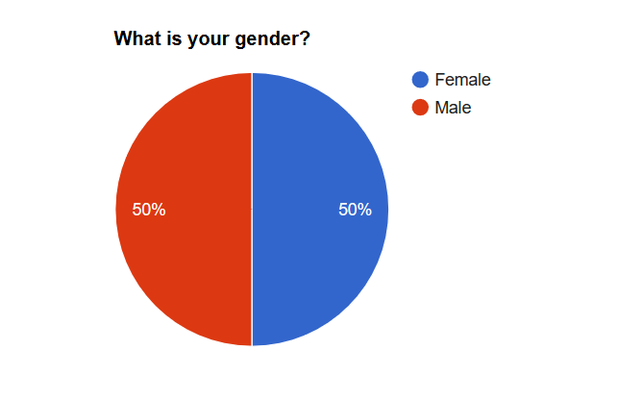

Figure 5.5 Gender Ratio

It is striking that all probands are between 20 and 29 years old. Though, this is due to the fact that the target group was defined in advance and the volunteers were invited accordingly. The average age of all subjects is 24,5 years.

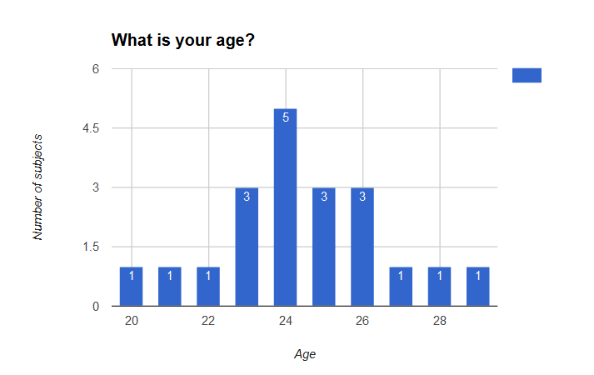

Figure 5.6 Gender histogram

A crosstab is the tabular representation of the frequencies that occur when the variables of two or more variables are combined. In this experiment variables were combined - woman and man. The values of the variables A (age) are entered from left to right in columns and the values of the variables B (gender) are entered in rows from top to bottom. In each individual cell, the specific frequency of the respective combination expression of the variable A with the expression of the variable B is then noted. The results can be interpreted more easily, even if the relative frequencies are determined. In this case, the crosstab only serves as an overview. This is why the research renounces on the calculation of the frequencies and the verification of the correlations with the Chi-square test. This would be inappropriate at this point.

|  |  |  |  |  |  |  |  |  |  |  |  |  |
| --- | --- | --- | --- | --- | --- | --- | --- | --- | --- | --- | --- | --- |
|  | | Age | | | | | | | | | | Total |
| 20 | 21 | 22 | 23 | 24 | 25 | 26 | 27 | 28 | 29 |
| Gender | w[[30]](#footnote-30) | - | - | - | 2 | 3 | 2 | 2 | 1 | - | - | 10 |
| m[[31]](#footnote-31) | 1 | 1 | 1 | 1 | 2 | 1 | 1 | - | 1 | 1 | 10 |
| Total | | 1 | 1 | 1 | 3 | 5 | 3 | 3 | 1 | 1 | 1 | 20 |

Table 5.24 Gender distribution

Each subject has indicated that he is studying computer science. Here test subjects can be separated to the following courses of study - web science, computer science, computational visualistics and computer science/mathematics.

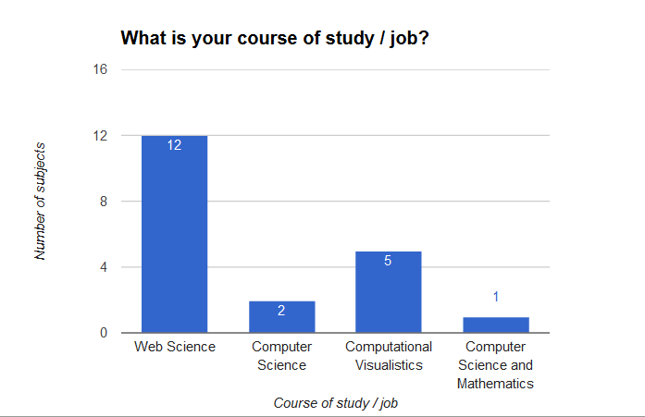

Figure 5.7 Job's histogram

Therefore, it can be assumed that each volunteer is technically knowledgeable and possess good IT user knowledge. But this does not mean that he is an expert in controlling an application through the gaze only. Therefore, it was necessary to ask them, if they used an eye tracker before the experiment. With these answers, the conclusion about their experience can be estimated. Unfortunately, test subjects have not been asked how often they have already used an eye tracker. Therefore it is only possible to determine whether they are novices or more experienced persons in this area.

Nearly half of all probands (45%, 9 subjects) have already used an eye tracker. In comparison, exactly 50% (10 subjects) have never used one and only one person (5%) does not know if he has ever used one before.

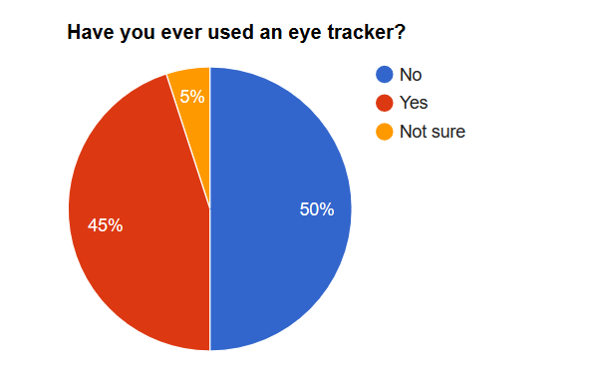

Figure 5.8 Eye-tracker user's ratio

About 55,6% (5 subjects) of the persons who have used one, specified that they used SMI only and ca.11,1% (1 subjects) of them specified that they used Tobi and SMI. One subject (ca. 11,1%) used one before but was not able to identify it. The remaining two subjects (ca. 22,2%) have used an eye tracker but did not specify which one(s).

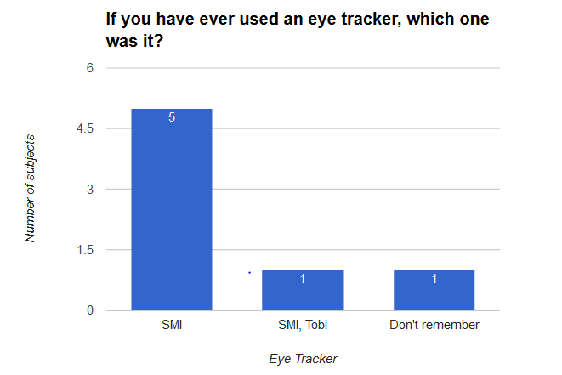

Figure 5.9 Eye-tracker user's histogram

For the calibration of the eye tracker and for problems e. g. with the calculation of fixation points or similarity during the experiment, it was also important to know, if a person has eye diseases (e. g. squint). Only 20% (4 subjects) answered that they suffer from a visual weakness (short-sightedness). Three of four short-sighted persons are wearing contact lenses. It is noticeable that three people have indicated that they wear glasses or contact lenses but have not registered any eye diseases.

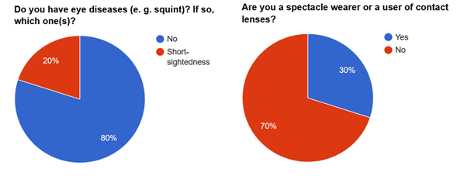

Figure 5.10 Eye diseases and spectacle wearer ratios

13 subjects have indicated that they do not wear glasses or contact lenses and have no eye problems either.

The Table 5.25 describes the combination of the results of the two questions and it is separated into these cases:

1. Spectacle wearer / wearer of contact lenses
2. Eye diseases
3. Spectacle wearer / wearer of contact lenses, but no eye diseases
4. No spectacle wearer / wearer of contact lenses, but eye diseases
5. No spectacle wearer / wearer of contact lenses and no eye diseases
6. Spectacle wearer / wearer of contact lenses and eye diseases

|  |  |  |  |  |  |  |  |
| --- | --- | --- | --- | --- | --- | --- | --- |
|  |  | 1. | 2. | 3. | 4. | 5. | 6. |
| Gender | w | 8 | 2 | - | 1 | 7 | 2 |
| m | 6 | 1 | 3 | 0 | 6 | 1 |
| Total | | 14 | 3 | 3 | 1 | 13 | 3 |

Table 5.25 Eye diseases and spectacle wearer ratios

The cases three and four are questionable, because normally a person wears glasses or contact lenses if a weakness or eye disease has been observed. And it is not clear why somebody do not wear glasses even though he has eye diseases. On the basis of these facts it can be stated that the questions may have been formulated unclearly and the result is misunderstandings.

Test subjects were asked what kind of genres they prefer. For this, was made a selection, which is limited to six categories (action, adventure, comedy, horror, science fiction, westerns). That question was asked with multiple provided answers because a person can like several genres and not specially one. The following diagram shows the answers.

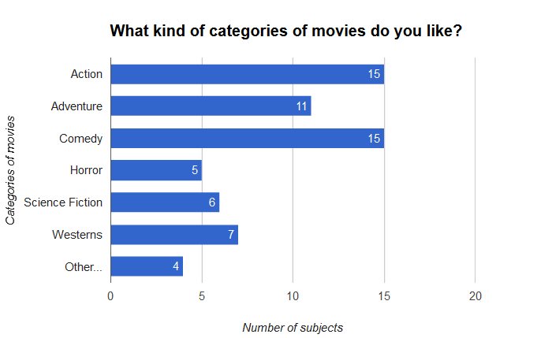

Figure 5.11 Movie preferences ratio

|  |  |  |  |  |
| --- | --- | --- | --- | --- |
|  | | Gender | | Total |
| w | m |
| Genre | Action | 6 | 9 | 15 |
| Adventure | 6 | 5 | 11 |
| Comedy | 10 | 5 | 15 |
| Horror | 2 | 3 | 5 |
| Science Fiction | 3 | 3 | 6 |
| Westerns | 0 | 7 | 7 |
| Other…:   * Fantasy * Drama * Thriller * Detective | 1  -  -  - | 2  1  1  1 | 3  1  1  1 |

Figure 5.12 Movie preferences

The most popular genres of the target group are Action and Comedy with 15 answers each. The second popular category is Adventure with 11 answers. Only four subjects have added other genres. One of these four persons has added the three categories Thriller, Detective and Drama and the other three subjects have added Fantasy only.

## Discussion

Both new types of data being used for similarity measurement had low correlation with each other or control data. Comparison of emotion-based similarity and the rating-based similarity resulted in 60 percent overlapping when one user was recognized as highly similar to another. Comparison of emotion-based similarity and gaze-based similarity returned the following results: 7 had overlapping similarities in both models. Those are User 1 having highest similarity with users 17 and 18; 2 to 14; 17 to 18 and vice versa; user 20 to users 1 and 18.

Comparing of rating-based and gaze-based similarities resulted into 9 instances of overlapping high similarity. Overall result for all three models given in a Table 5.26.

|  |  |  |  |  |  |  |  |  |  |  |  |  |  |  |
| --- | --- | --- | --- | --- | --- | --- | --- | --- | --- | --- | --- | --- | --- | --- |
| **Emotional similarity** | | | | | | | | | | | | | | |
| UserID | 1 | 2 | 3 | 4 | 5 | 6 | 7 | | 8 | | 9 | | 10 | |
| Most similar users | 18; 17; 2 | 8; 13; 14 | 9; 19; 18 | 10; 14; 15 | 19; 8; 13 | 19; 14; 3 | 20; 18; 10 | | 2; 5; 3 | | 3; 4; 1 | | 4; 7; 17 | |
| UserID | 11 | 12 | 13 | 14 | 15 | 16 | 17 | | 18 | | 19 | | 20 | |
| Most similar users |  |  | 5; 2; 4 | 4; 2; 8 | 19; 4; 9 | 8; 15; 3 | 1; 18; 20 | | 1; 20; 17 | | 5; 15; 6 | | 18; 7; 1 | |
| **Gaze similarity** | | | | | | | | | | | | | | |
| UserID | 1 | 2 | 3 | 4 | 5 | 6 | 7 | 8 | | 9 | | 10 | |
| Most similar users | 18; 20; 13 | 12; 3; 8 | 11; 8; 5 | 10; 15; 5 | 14; 19; 15 | 12; 14; 8; | 11; 18; 20 | 2; 3; 12 | | 12; 13; 8 | | 4; 17; 18 | |
| UserID | 11 | 12 | 13 | 14 | 15 | 16 | 17 | 18 | | 19 | | 20 | |
| Most similar users |  | 14; 16; 17; 2 |  | 12; 17; 19 | 16; 17; 12 | 12, 17, 18 | 16;12; 14; 18 | 16; 17; 14; 12; 9 | | 14; 12; 2 | | 1; 5; 14; 17;18 | |
| **Rating similarity** | | | | | | | | | | | | | | |
| UserID | 1 | 2 | 3 | 4 | 5 | 6 | 7 | 8 | | 9 | | 10 | |
| Most similar users | 18; 20; 13 | 12; 3; 8 | 11; 8; 5 | 10; 15; 5 | 14; 19; 15 | 12; 14; 8; | 11; 18; 20 | 2; 3; 12 | | 12; 13; 8 | | 4; 17; 18 | |
| UserID | 11 | 12 | 13 | 14 | 15 | 16 | 17 | 18 | | 19 | | 20 | |
| Most similar users | 5; 3; 14 | 6; 8; 9; 15 | 1; 9; 18 | 5; 11; 6 | 5; 19; 14 | 8; 12; 6 | 18; 20; 1 | 1; 20; 17 | | 5; 15; 14 | | 1; 18; 17 | |

Table 5.26 Comparison of user pairs

Multiple factors, including the equipment malfunctioning, affected the quality of the recording and caused partial or complete loss of data of three test subjects. For 3 out of 20 test subjects data was partially or fully corrupted.

The reason for that is a very big range of possible values each variable in both given datatypes can have compared to the rating-based system. In order to overcome this problem additional pre and post processing steps required.

At the current stage, the recorded and processed data rejects the formulated hypothesis that the similarity measurements based on the fixation points and emotions provide relevant similarity rates with accuracy close to similarity measurements based on rating. Both new models have an insufficient correlation with each and with the control model based on the rating.

Emotion recognition proved to be unreliable in this experiment. Accuracy evaluation demonstrated match rate around 57 percent but data for several users was lost or was evidently inaccurate. For the improvement of emotion based recommendation models a system of weights should assigned to the emotions. Another possible way of improvement may be the concept of applying the specific emotional states (e.g. Stress) for specific videos (e.g. Horror) since not all videos require the recognition of all emotions in order to understand the user’s reaction.

However, both new types of user-data can be used for measuring similarity and evaluating the specific behavior of users and need to be studied further.

## Further Improvements

Various aspects and stages of the EBCI data collection and processing can be improved.

1. Development and implementation of alternative algorithms for raw gaze-data processing. Additional study and tuning of the fixation point recognition technologies required.
2. Emotions recognition was based on the proprietary algorithms developed by Emotiv. Development of alternative algorithms may improve the accuracy of recognition.
3. Advancement of tracking devices reliability.
4. Applying different strategies of similarity calculation for all three types of data.
5. Possibility to advance the accuracy of emotion recognition using patterns in gaze movements caused by particular emotions.
6. Alternative methods of emotion’s validation should be explored since the feedback provided by users themselves may not always be accurate.
7. In order to assess the full potential of the similarity models, larger sets of test subjects and videos should be involved in the experiment.
8. Further development supposes generation of recommendations based on measured similarities including videos previously unseen.
9. Development of scaling recommender system based on gaze and emotion data.



# Conclusion



Over the course of the project various methods of interaction with eye and brain computer interfaces were discovered and analyzed.

For correct implementation the features of gaze controlled interfaces had to be investigated and applied in development of the web-application. Limitations of the eye tracker like the visual angle, calibration errors, drift, and inherent eye jitter were studied and respective corrections in the user interface development process were studied and used. General concept of user interaction with the video hosting service was analysed. Both backend and front end architectures were significantly affected by the special conditions and features of the invoronment in which the eye tracking and brain computer interfaces are used.

The concept of fixation points was studied and fixation recognition methodology was implemented. After the analysis of the experiment results several conclusions regarding the gaze based metrics were made.

Eye tracking and emotion recognition had been used to understand user behaviors in context of video-content interaction. The analysis of the recorded gaze fixations and emotions had shown that both similarity models have low match rate when compared to the rating-based similarity model. Multiple factors, including the equipment malfunctioning, affected the quality of the recording and caused partial or complete loss of data of three test subjects. Additionally, the assumption that a high number or duration of the fixations is an indicator for interest or liking was rejected.

Both new sources of user-data can be used for measuring similarity and evaluating the specific behavior of users. Major efforts in further research and development should focus on improving the accuracy of recording and correct recognition of data from eye tracking and brain computer interfaces.

The study, conducted over the course of project established that the reliability of eye tracking and emotion recognition is not good enough for implementation in mainstream computer-user interaction platforms and services instead of conventional input interfaces. Therefore it can be concluded that these methods of interaction can provide unique experience to the users on their analysis to deliver a personalized experience and adapt to user’s behavior. Further investigation of user metrics involving larger-scale experiments may help to define new patterns of content consumption and may be applied for improvement of user-experience.



# List of Figures



[Figure 2.1 Pupil and corneal reflections 9](#_Toc487805907)

[Figure 2.2 Algorithm of an image processing for eye tracking. 10](#_Toc487805908)

[Figure 2.3 EEG visualization 11](#_Toc487805909)

[Figure 3.1 Connections between tables, including primary and foreign keys 14](#_Toc487805910)

[Figure 3.2 Databases to store user-actions 16](#_Toc487805911)

[Figure 3.3 Finding important parts of a video based on BCI data 18](#_Toc487805912)

[Figure 3.4 Visualization of fixation-points 19](#_Toc487805913)

[Figure 3.5 Project architecture 20](#_Toc487805914)

[Figure 3.6 Project infrastructure 21](#_Toc487805915)

[Figure 3.7 Application “player” structure 22](#_Toc487805916)

[Figure 3.8 Front-end structure 23](#_Toc487805917)

[Figure 3.9 Database structure 24](#_Toc487805918)

[Figure 3.10 Logo 26](file:///D:\uni-koblenz\semester%202\Eye%20tracking%20and%20BCI\final\report-final-version.docx#_Toc487805919)

[Figure 3.11 Color schemes 27](#_Toc487805920)

[Figure 3.12 Top Navigation Bar 27](#_Toc487805921)

[Figure 3.13 Bottom Navigation Bar 28](#_Toc487805922)

[Figure 3.14 Play bar 29](#_Toc487805923)

[Figure 3.15 Sound bar 29](#_Toc487805924)

[Figure 3.16 Login page 29](file:///D:\uni-koblenz\semester%202\Eye%20tracking%20and%20BCI\final\report-final-version.docx#_Toc487805925)

[Figure 3.17 Admin login 30](#_Toc487805926)

[Figure 3.18 Admin page 30](#_Toc487805927)

[Figure 3.19 Main page 31](#_Toc487805928)

[Figure 3.20 Search page 33](#_Toc487805929)

[Figure 3.21 Player Page 35](#_Toc487805930)

[Figure 3.22 Rating menu 36](#_Toc487805931)

[Figure 4.1 Overview of the general approach: Calculate user similarity based on eye tracking data 38](#_Toc487805932)

[Figure 4.2 Step 1 collecting the gaze data for different Videos 39](#_Toc487805933)

[Figure 4.3 Pictures shows difference between fixation and saccade 39](#_Toc487805934)

[Figure 4.4 Step 2 Transformation of raw data to fixation 40](#_Toc487805935)

[Figure 4.5 Pseudo Code for transformation of raw data to fixation 40](#_Toc487805936)

[Figure 4.6 Representation of the fixations in a list of json objects 41](#_Toc487805937)

[Figure 4.7 Common fixation 41](#_Toc487805938)

[Figure 4.8 Common Fixation of two users (U1, U2) over time (t). 42](#_Toc487805939)

[Figure 4.9 Step 3 Calculation of common Fixations for one Video 42](#_Toc487805940)

[Figure 4.10 Step 4 Calculation of arithmetic mean of Amount and Duration of Fixations 43](#_Toc487805941)

[Figure 4.11 Step 4 Calculate the average of fixation per person and the duration time of fixations 44](#_Toc487805942)

[Figure 4.12 Step 5 Calculation of Video similarity for two users 44](#_Toc487805943)

[Figure 4.13 Step 6 Calculation of the overall similarity for two users 46](#_Toc487805944)

[Figure 4.14 Summary of all 6 individual steps for calculation of user similarity based on gaze data 47](#_Toc487805945)

[Figure 4.15 Visualization tool 1 48](#_Toc487805946)

[Figure 4.16 Visualization tool 2 49](#_Toc487805947)

[Figure 5.1 iViewRED 55](#_Toc487805948)

[Figure 5.2 Example of good calibration 55](#_Toc487805949)

[Figure 5.3 EmotivXavierControlpanel 56](#_Toc487805950)

[Figure 5.4 Acceptable input 56](#_Toc487805951)

[Figure 5.5 Gender Ratio 79](#_Toc487805952)

[Figure 5.6 Gender histogram 80](#_Toc487805953)

[Figure 5.7 Job's histogram 81](#_Toc487805954)

[Figure 5.8 Eye-tracker user's ratio 81](#_Toc487805955)

[Figure 5.9 Eye-tracker user's histogram 82](#_Toc487805956)

[Figure 5.10 Eye diseases and spectacle wearer ratios 82](#_Toc487805957)

[Figure 5.11 Movie preferences ratio 83](#_Toc487805958)

[Figure 5.12 Movie preferences 84](#_Toc487805959)



# List of Tables



[Table 3.1 Chart of suggested data structures. 13](#_Toc487816134)

[Table 3.2 Literature review summary 17](#_Toc487816135)

[Table 3.3 Top navigation bar content 27](#_Toc487816136)

[Table 3.4 Bottom navigation bar content 28](#_Toc487816137)

[Table 4.1 Division of the weight of similarity 45](#_Toc487816138)

[Table 5.1 Experiment Parameters 54](#_Toc487816139)

[Table 5.2 Experiment steps 58](#_Toc487816140)

[Table 5.3 Latin Square movie numbers 59](#_Toc487816141)

[Table 5.4 Latin Square 59](#_Toc487816142)

[Table 5.5 Likert-scale 61](#_Toc487816143)

[Table 5.6 Rating-based similarity 62](#_Toc487816144)

[Table 5.7 Gaze-based similarity 64](#_Toc487816145)

[Table 5.8 Similarity for user 16 66](#_Toc487816146)

[Table 5.9 Significant test data for movie category horror 66](#_Toc487816147)

[Table 5.10 Significant test data for movie category drama 67](#_Toc487816148)

[Table 5.11 Significant test data for movie category comedy 67](#_Toc487816149)

[Table 5.12 Average fixation statistics per movie 68](#_Toc487816150)

[Table 5.13 Amount of highest fixation values per gender 69](#_Toc487816151)

[Table 5.14 Gender specific average rating for all movies 69](#_Toc487816152)

[Table 5.15 Emotions summary for each movie 70](#_Toc487816153)

[Table 5.16 Emotion accuracy evaluation summary 71](#_Toc487816154)

[Table 5.17 Emotion-based similarities 72](#_Toc487816155)

[Table 5.18 Excitement based user similarity 73](#_Toc487816156)

[Table 5.19 Interest based user similarity 74](#_Toc487816157)

[Table 5.20 Stress based user similarity 75](#_Toc487816158)

[Table 5.21 Engagement based user similarity 76](#_Toc487816159)

[Table 5.22 Focus based user similarity 77](#_Toc487816160)

[Table 5.23 Relaxation based user similarity 78](#_Toc487816161)

[Table 5.24 Gender distribution 80](#_Toc487816162)

[Table 5.25 Eye diseases and spectacle wearer ratios 83](#_Toc487816163)

[Table 5.26 Comparison of user pairs 85](#_Toc487816164)



# List of References



Al-Rahayfeh, Amer, and Miad Faezipour. 2013. “Eye Tracking and Head Movement Detection: A State-of-Art Survey.” *IEEE Journal of Translational Engineering in Health and Medicine* 1 (October): 2100212–2100212.

Blascheck, T, K Kurzhals, M Raschke, M Burch, D Weiskopf, and T Ertl. 2014. “State-of-the-Art of Visualization for Eye Tracking Data.” *Eurographics Conference on Visualization (EuroVis)*, 1–20.

Davidson, James, Blake Livingston, Dasarathi Sampath, Benjamin Liebald, Junning Liu, Palash Nandy, Taylor Van Vleet, et al. 2010. “The YouTube Video Recommendation System.” *Proceedings of the Fourth ACM Conference on Recommender Systems - RecSys ’10*, 293.

Davies, Scott. 2016. “VIDEO RECOMMENDATION ALGORITHM,” 0–9.

Duchowski, Andrew T. 2007. *Eye Tracking Methodology*. *Vasa*.

Granka, Laura A., Thorsten Joachims, and Geri Gay. 2004. “Eye-Tracking Analysis of User Behavior in WWW Search.” *Proceedings of the 27th Annual International Conference on Research and Development in Information Retrieval - SIGIR ’04*, 478.

Hiemstra, Djoerd, Stephen Robertson, and Hugo Zaragoza. 2004. “Parsimonious Language Models for Information Retrieval.” *Sigir-2004*, 178–185..

Jacob, Robert J K. 1995. “Eye Tracking in Advanced Interface Design.” *Virtual Environments and Advanced Interface Design*, 258–90.

Jing, Yushi, Yushi Jing, Shumeet Baluja, Shumeet Baluja, Rohan Seth, Rohan Seth, Jay Yagnik, et al. 2008. “Video Suggestion and Discovery for YouTube: Taking Random Walks Through the View Graph.” *Proceeding of the 17th International Conference on World Wide Web*, 895–904.

Nyström, Marcus, and Kenneth Holmqvist. 2010. “An Adaptive Algorithm for Fixation, Saccade, and Glissade Detection in Eyetracking Data.” *Behavior Research Methods* 42 (1): 188–204.

Rosenbaum, D. A. 1991. Human motor control. New York: Academic Press.

Salvucci, Dario D., and Joseph H. Goldberg. 2000. “Identifying Fixations and Saccades in Eye-Tracking Protocols.” *Proceedings of the Symposium on Eye Tracking Research & Applications - ETRA ’00*, 71–78.

Strandvall, Tommy. “Eye Tracking in Human-Computer Interaction and Usability Research,” 2–3.

Valenzi, Stefano, Tanvir Islam, Peter Jurica, and Andrezj Cichocki. 2014. “Individual Classification of Emotions Using EEG.” *Journal of Biomedical Science …*, no. June: 604–20. doi:10.4236/jbise.2014.78061.

Xu, Songhua, Hao Jiang, and Francis C.M. Lau. 2008. “Personalized Online Document, Image and Video Recommendation via Commodity Eye-Tracking.” *Proceedings of the 2008 ACM Conference on Recommender Systems - RecSys ’08*, 83.

Yazdani, Ashkan, Jong-Seok Lee, and Touradj Ebrahimi. 2009. “Implicit Emotional Tagging of Multimedia Using EEG Signals and Brain Computer Interface.” *Proceedings of the First SIGMM Workshop on Social Media - WSM ’09*, 81.



# Appendix



## Demographic Questionnaire





## Post-Task Questionnaire













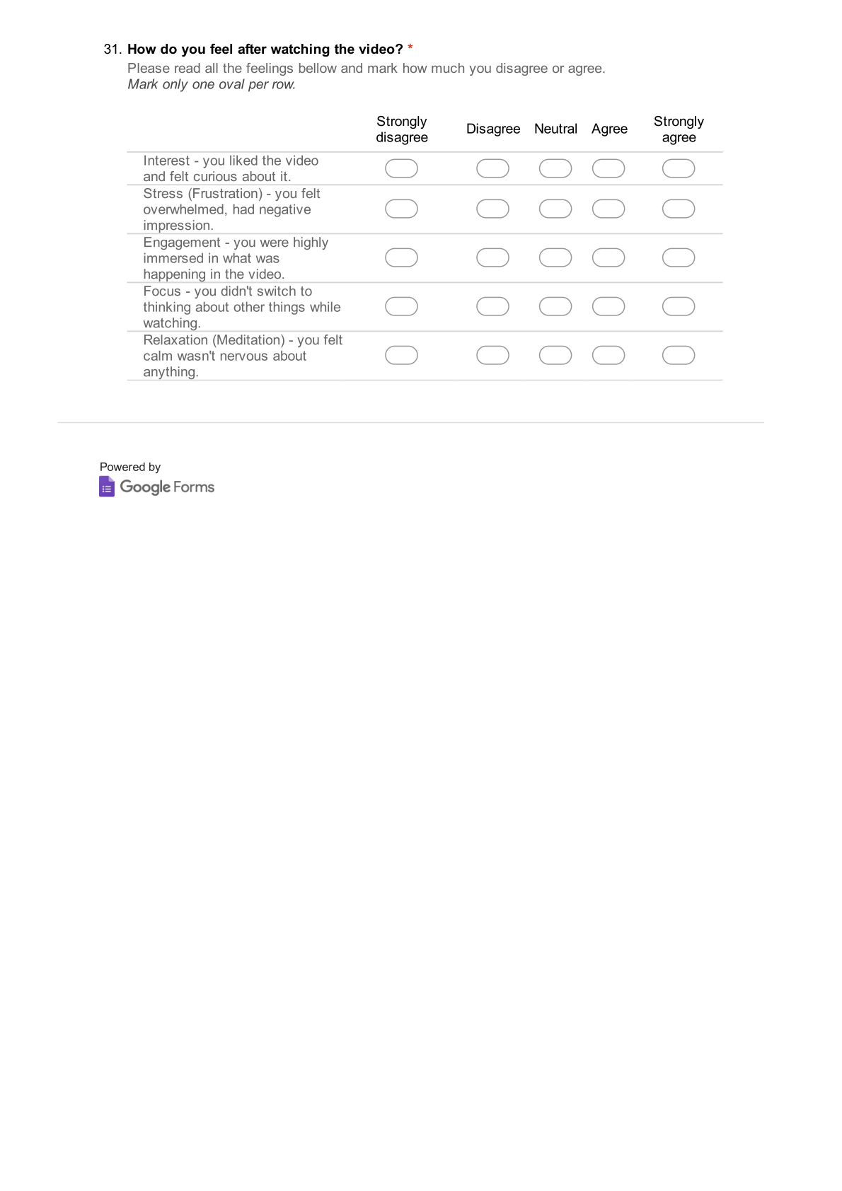



1. <http://getbootstrap.com/> [↑](#footnote-ref-1)
2. <https://www.w3schools.com/html> [↑](#footnote-ref-2)
3. [https://www.w3schools.com/css](https://www.w3schools.com/css/) [↑](#footnote-ref-3)
4. <https://www.w3schools.com/js> [↑](#footnote-ref-4)
5. <https://www.w3schools.com/js/js_ajax_intro.asp> [↑](#footnote-ref-5)
6. <https://developers.google.com/youtube/> [↑](#footnote-ref-6)
7. MySQL (<https://www.mysql.com/about/)> [↑](#footnote-ref-7)
8. David Medine (<https://github.com/sccn/labstreaminglayer/wiki>) [↑](#footnote-ref-8)
9. <https://www.smivision.com/eye-tracking/product/redn-scientific-eye-tracker/> [↑](#footnote-ref-9)
10. <https://www.emotiv.com/epoc/> [↑](#footnote-ref-10)
11. Raphael Menges, Korok Sengputa, Chandan Kumar, Steffen Staab, eyeGui: A Novel Framework for Eye.Controlled User Intefaces. 2 www.mamem.eu/wp-content/uploads/2016/09/eyeGUI-NordiCHI16-1.pdf [↑](#footnote-ref-11)
12. <https://github.com/MAMEM/prototype-interfaces-training> [↑](#footnote-ref-12)
13. Granka, Laura A., Thorsten Joachims, and Geri Gay. "Eye-tracking analysis of user behavior in WWW search." [↑](#footnote-ref-13)
14. (Hiemstra, Robertson, and Zaragoza 2004) Proceedings of the 27th annual international ACM SIGIR conference on Research and development in information retrieval. ACM, 2004. [↑](#footnote-ref-14)
15. (Xu, Jiang, and Lau 2008),. "Personalized online document, image and video recommendation via commodity eye-tracking." *Proceedings of the 2008 ACM conference on Recommender systems*. ACM, 2008. [↑](#footnote-ref-15)
16. (Al-Rahayfeh and Faezipour 2013), "Eye tracking and head movement detection: A state-of-art survey." *IEEE journal of translational engineering in health and medicine* 1 (2013): 2100212-2100212. [↑](#footnote-ref-16)
17. (Strandvall, n.d.). "Eye tracking in human-computer interaction and usability research: Ready to deliver the promises." *Mind* 2.3 (2003): 4. [↑](#footnote-ref-17)
18. (Jacob 1995). "Eye tracking in advanced interface design." *Virtual environments and advanced interface design* (1995): 258-288. [↑](#footnote-ref-18)
19. <http://eyetracking.ch/wissen/was-ist-eye-tracking/> (november 2016) [↑](#footnote-ref-19)
20. (Duchowski 2007). *Eye tracking methodology: Theory and practice*. Vol. 373. Springer Science & Business Media, 2007. [↑](#footnote-ref-20)
21. (Salvucci and Goldberg 2000). "Identifying fixations and saccades in eye-tracking protocols." *Proceedings of the 2000 symposium on Eye tracking research & applications*. ACM, 2000. [↑](#footnote-ref-21)
22. (Blascheck et al. 2014), et al. "State-of-the-art of visualization for eye tracking data." *Proceedings of EuroVis*. Vol. 2014.. [↑](#footnote-ref-22)
23. (Nyström and Holmqvist 2010). "An adaptive algorithm for fixation, saccade, and glissade detection in *Eye tracking* data." *Behavior research methods* 42.1 (2010): 188-204. [↑](#footnote-ref-23)
24. (Duchowski 2007). *Eye tracking methodology: Theory and practice*. Vol. 373. Springer Science & Business Media, 2007. [↑](#footnote-ref-24)
25. (Duchowski 2007). *Eye tracking methodology: Theory and practice*. Vol. 373. Springer Science & Business Media, 2007. [↑](#footnote-ref-25)
26. Video:: https://www.youtube.com/watch?v=sXiRZhDEo8A [↑](#footnote-ref-26)
27. <https://docs.google.com/forms/d/e/1FAIpQLScbZscuNahRAjouYL7SAob5r58oye644yx2mFVNeHu5xttgJw/viewform> [↑](#footnote-ref-27)
28. <https://docs.google.com/forms/d/e/1FAIpQLSdBvuvViW0uJxsxLl9bklV-EuFLEENzEwsDszx-LFlDlhOmLg/viewform> [↑](#footnote-ref-28)
29. <https://www.google.com/forms/about/> [↑](#footnote-ref-29)
30. Women [↑](#footnote-ref-30)
31. Men [↑](#footnote-ref-31)